CHAPTER IV

RESULTS AND DISCUSSION

1. Results
The resulting product is a bilingual travel guidebook entitled "Tuban For Relaxing." This guide is designed to introduce the tourism potential in Tuban Regency and to make it easier for travelers who intend to visit these newest tourist attractions. To convey the concept of the message, this guidebook presents comprehensive information that is easy for readers to understand. In addition, this guide also includes photo illustrations to support the information presented, allowing readers to experience firsthand the tourist spots they wish to visit. The images in this guidebook give a deep impression to readers and offer tourists a peaceful vacation, away from the noise.
For more details, this book uses a two-language concept. The title of this booklet is "Bilingual Booklet Object Tourism; Tuban For Relaxing" using A4 size (210 x 297), using booklet method, the type of paper on the cover is "Hard Cover", with a total of 42 pages, and the contents of the book consist of the cover, the content, and are closed with the cover.

Research and Information Collecting
The first step carried out to create a bilingual tourism booklet containing tourist attractions in Tuban Regency is Research and Information Collecting, explained as follows

      - Research
The first stage definitely involves searching for and gathering information related to potential problems at tourist attractions in Tuban Regency. It begins with the stage of observing several tourist spots that have great potential to be visited by tourists but are sparsely visited. In this observation process, it was found that many tourist attractions are still neglected by both the government and the local community. These obstacles were nothing other than the fact that several tourist attractions were still under renovation, causing some tourist spots to remain temporarily closed. In addition, there was a lack of government involvement in promoting tourist attractions in Tuban Regency through the official social media accounts of Tuban Regency.
      - Information Collecting
After research the problem, the researchers collect the informations from local community about tourism object in Tuban Regency. However, under the leadership of the current Regent of Tuban Regency, Aditya Halindra Faridzky, S. E., a major overhaul of the tourist attractions in Tuban Regency has taken place. Regarding this potential issue, a book has been created that includes two languages and features the tourist attractions of Tuban Regency. Considering that Tuban Regency is also an industrial city, which has several workers from outside the area as part of its population. Tourist destinations are divided into 4 types of tourism, namely nature tourism, religious tourism, shopping tourism, and historical tourism. In nature tourism, there are Ngerong Cave, Nganten Cave, Akbar Cave, Bom Beach, Semilir Beach, Nglirip Waterfall, and Bektiharjo Bathing Place. In religious tourism, there are Sunan Bonang, Al-Maghribi, and Kwan Sing Bio Temple. In shopping tourism, there are Sunan Bonang Market, Tuban Fish Market, and “Hanik” Souvenir Shop. Lastly, historical tourism includes the Grand Mosque, Kambang Putih Museum, and the Town Square. It is also worth adding hidden gem tourism to simply make readers curious about the hidden tourist spots in Tuban Regency.

Planning
At this stage, the researcher prioritizes the comfort of the booklet readers. It is important to understand the basic concept of creating a tourist booklet that can attract tourists. In addition to prioritizing informative aspects, this booklet also upholds aesthetic values such as photography, font selection, and the colors used.
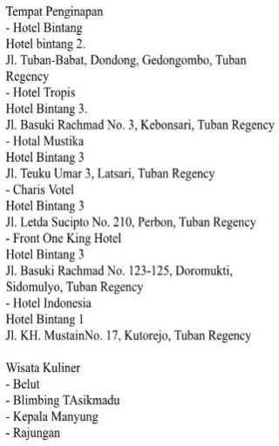
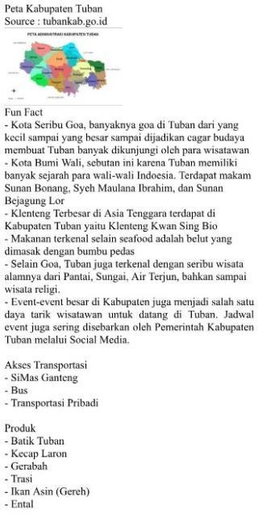
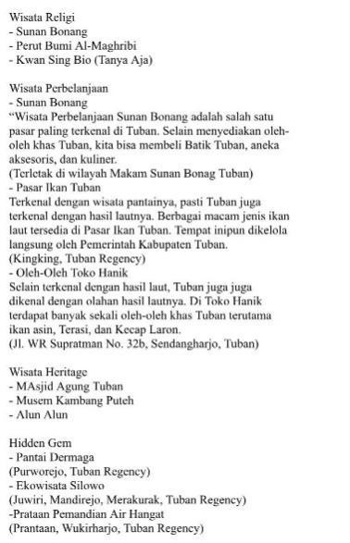
Figure 4. 1 Booklet Draft Making

Develop Preliminary Form of Product
At this stage, the researcher prioritizes the reader's comfort in reading this booklet. It is not easy to create a bilingual booklet that can be entertaining and make readers understand the content presented. Therefore, readers highly value aesthetics in this booklet, such as font selection that helps readers understand the content of the booklet and also the consideration of colors used so that the booklet can still be read comfortably due to good color choices.

The Preparation Stage of the Materia
The parts contained in the tour booklet are explained as follows:
        - In the introduction section there is an official map of Tuban Regency, a table of contents, and a brief introduction to Tuban Regency.
        - The material in the booklet includes Ngerong Cave, Nganten Cave, Akbar Cave, Bom Beach, Semilir Beach, Nglirip Waterfall, and Bektiharjo Bathing Place, Sunan Bonang, Al-Maghribi, and Kwan Sing Bio Temple, Sunan Bonang Market, Tuban Fish Market, and “Hanik” Souvenir Shop, Grand Mosque, Kambang Putih Museum, and the Town Square.
        - Closing, including about lodging, culinary, other destination, product, and Thank You.
At this stage, research was conducted on materials related to tourist attractions in Tuban Regency. This material was selected from various tourist attractions in Tuban Regency, and these interesting attractions were used as content for the guidebook. Furthermore, various sources and reference materials relevant to the Tourist Guidebook were collected.

Product Deisgn Preparation Stage
Before creating this bilingual booklet, the researcher attempted to observe each tourist attraction in Tuban Regency that had an attraction for tourists. Next, the researcher tried to visit each of the tourist attractions that would become the contents of the booklet. The researcher also continued to look for tourist attractions that had the potential to improve tourist attractions that were quiet but still worthy of being visited by tourists. At this stage, the researcher began creating design illustrations with the aim of ensuring that tourists who read this booklet would remain comfortable with the design the researcher created. After that, they developed a booklet concept that was in accordance with the information obtained through observations at the tourist attractions that had been visited. The following is the stage of determining the contents of the booklet with the concept that had been thought out by the researcher.

Afterward, a bilingual tourism booklet design for Tuban Regency was created using A4 paper (210 x 297 cm) and then converted to a PDF file. The booklet was created using Canva, an online graphic design application. Software like Canva helps bring the draft content to life, including selecting design templates and other illustrations. After selecting the booklet design template, the next step was to determine the fonts, colors, and design details.
The booklet, titled "Bilingual Booklet Tourism Object Tuban For Relaxing," contains a total of 42 pages and several chapters containing comprehensive information about tourist attractions in Tuban Regency. The book uses hardcover paper for the cover and art paper for the content. The following is an example of an illustration contained in the bilingual booklet.

Cover Display
On the product display, there is a picture of Dermaga Beach at sunset because usually the hours of sunset are the most favored by tourists to visit Dermaga Beach. Besides having beautiful scenery, Dermaga Beach also boosts the local community's economy with the arrival of tourists.
This beach has only recently become popular considering the large number of tourists who visited from 2023 until now.

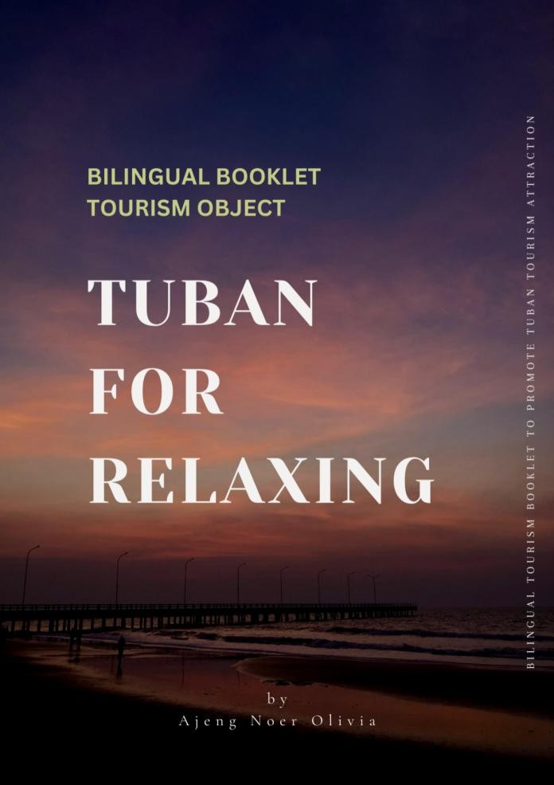
Figure 4. 2 Cover Display Booklet

Display Tuban District Maps
On the very first page, an administrative map of Tuban Regency will be displayed, sourced from the official account of Tuban Regency, tuban.go.id. This Administrative Map depicts the layout of Tuban with a total of 20 Districts in Tuban Regency.

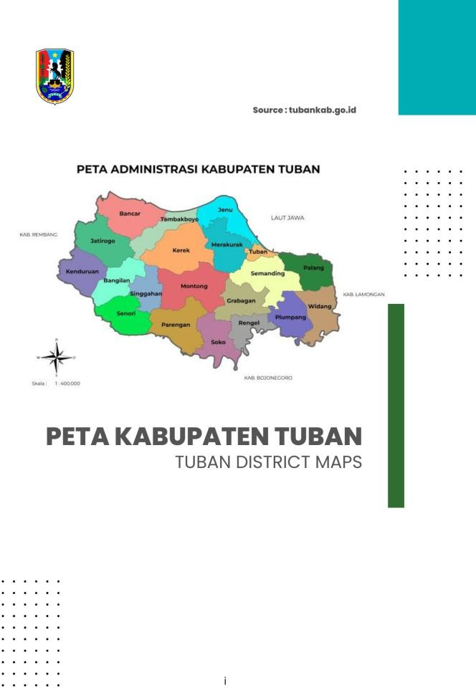

Figure 4. 3 Display Tuban District Maps

Display Table of Content
The table of contents contains all the content of the bilingual booklet, from the initial introduction to the conclusion. This table of contents is an implementation of the product overview using two languages, namely Indonesian and English. It starts with a Map of Tuban Regency, followed by an Introduction to Tuban Regency, Transportation Access, Unique Facts, and Tourist Attractions in Tuban Regency such as Goa Akbar, Goa Ngerong, Goa Nganten, Boom Beach, Semilir Beach, Nglirip Waterfall, Al-Maghribi, Sunan Bonang, Kwan Sing Bio, Kambang Putih Museum, and Tuban Square. In addition, there is additional information about Accommodation, Culinary, Other Tourism, Hidden Gems, and Local Products of Tuban Regency.
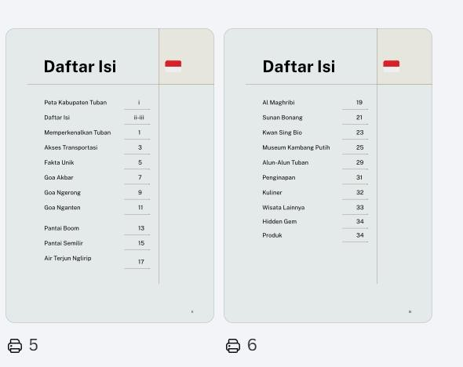
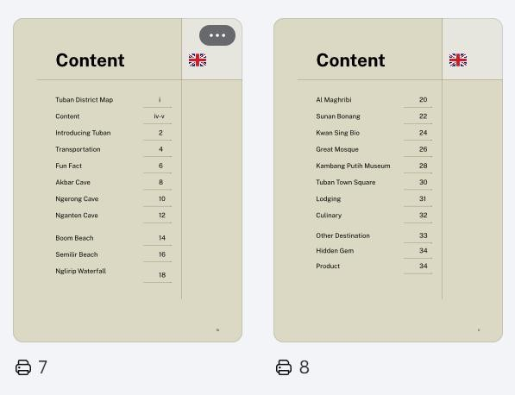
Figure 4. 4 Display Table of Content

Display Introducing Tuban
This Introducing Tuban display is included in the first section before the introduction of the contents of tourist attractions. It contains two main paragraphs, in which the first paragraph includes various tourist attractions in Tuban Regency, such as natural tourism, religious tourism, and typical Tuban Regency culinary. The second paragraph contains the purpose and objective of creating a bilingual tourism booklet with the hope that more tourists will visit the tourist attractions in Tuban Regency.
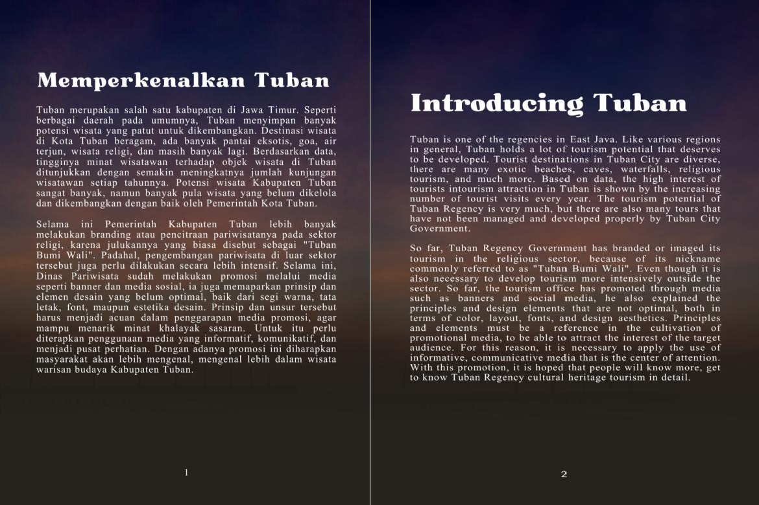
Figure 4. 5 Display Introducing Tuban

Display Transportation Access
In the transportation access display section, there are 3 public transports that tourists can use to visit Tuban Regency. In this section, it

actually aims to show the Tuban city bus (SiMasGanteng) so that tourists do not need to feel confused just to stroll around Tuban Regency because the city bus transportation facility is very helpful for both residents and tourists..
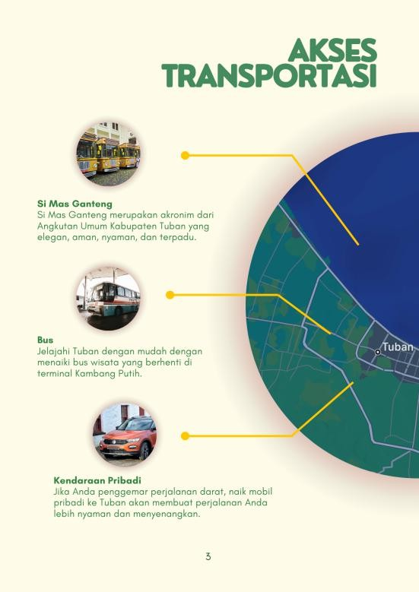
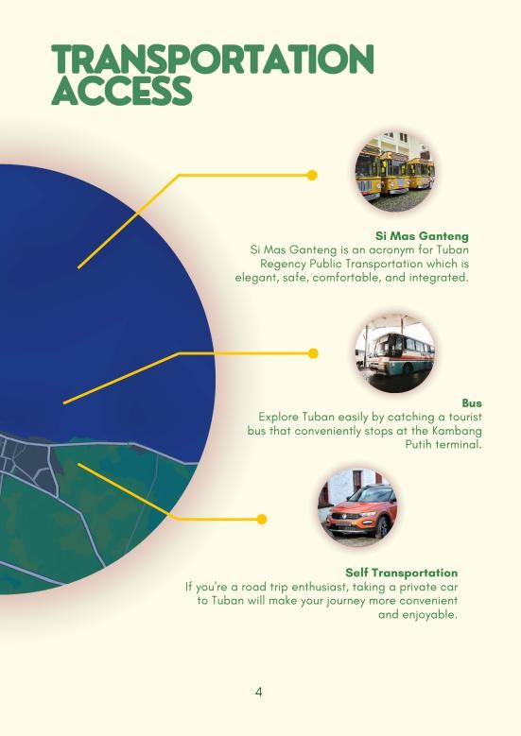
Figure 4. 6 Display Transportation Access

Display Fun Fact
In the fun fact display section, there are 6 fun facts about Tuban Regency that can make prospective tourists increasingly interested in visiting Tuban Regency. These unique facts were obtained by observing phenomena that occurred in Tuban Regency over the past year. These unique facts about Tuban Regency are:
          - Kota Seribu Goa

          - Kota Bumi Wali
          - Klenteng Terbesar di Asia Tenggara
          - Kuliner Laut
          - Seribu Wisata Alam
          - Event-event Kabupaten Tuban
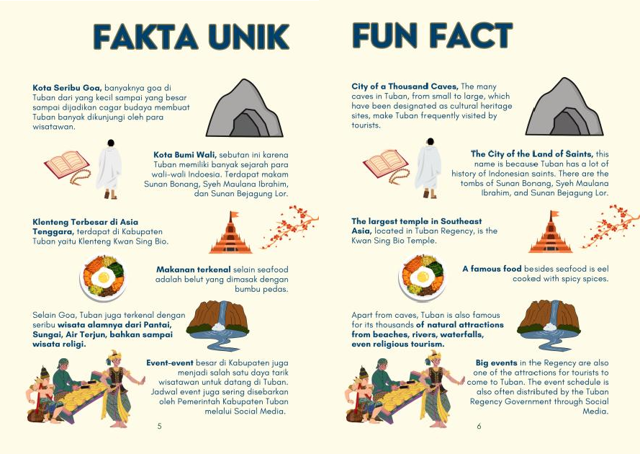
Figure 4. 7 Display Fun Fact

Display Tourism Object
The tourism object display contains 11 tourist attractions in Tuban Regency which are explained in the booklet. After studying several tourist attractions in Tuban Regency, the researcher determined 11 tourist

attractions, namely Goa Akbar, Goa Ngerong, Goa Nganten, Boom Beach, Semilir Beach, Nglirip Waterfall, Al-Maghribi, Sunan Bonang, Kwan Sing Bio, Kambang Putih Museum, and Tuban Square. All of these tourist attractions are described in 2 languages, namely Indonesian and English. There are also explanations about the tourist attractions, addresses, facilities, maps, transportation, and entrance fees. In addition, there are photos of the intended tourist sites. The following is a display of Tuban Regency's tourist attractions in the booklet.
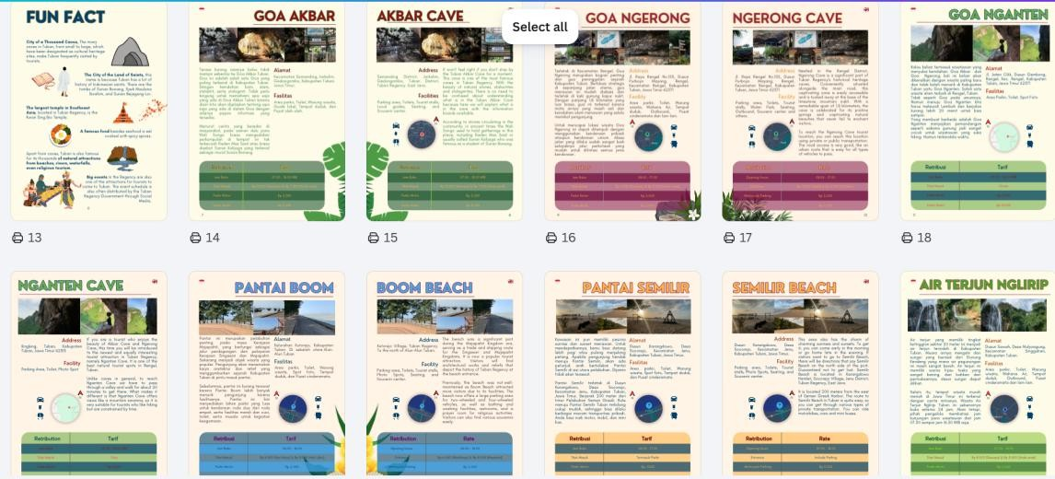
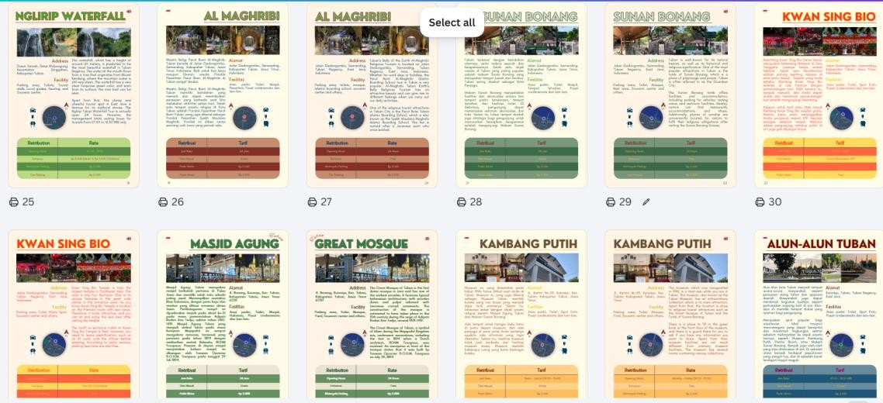
Figure 4. 8 Display Tourism Object

Display Lodging
The lodging display contains accommodations available in Tuban Regency. The selection of these accommodations is based on distance and the facilities needed by tourists according to their classification. There are 6 recommended hotels that have 3-star to 4-star facilities. This lodging display also includes the addresses of the hotels shown.
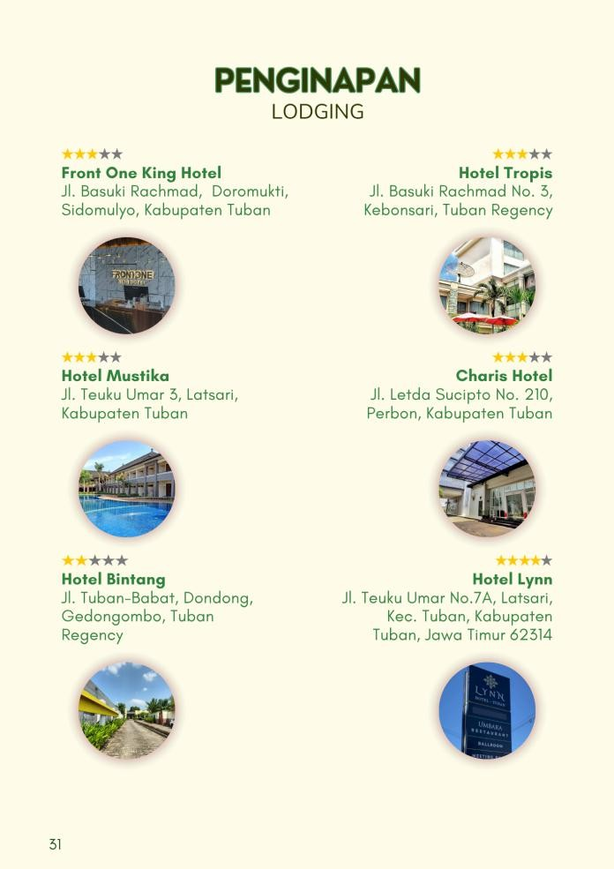
Figure 4. 9 Display Lodging

Display Culinary
On the culinary display, there are 3 recommended local foods from Tuban Regency that tourists can try, such as: Eel, Garang Asem with

Manyung Fish Head, and Legen (Siwalan Juice). There are also various recommended restaurants that tourists can visit, along with the addresses and pictures of the mentioned foods. Below is the display of the culinary offerings..
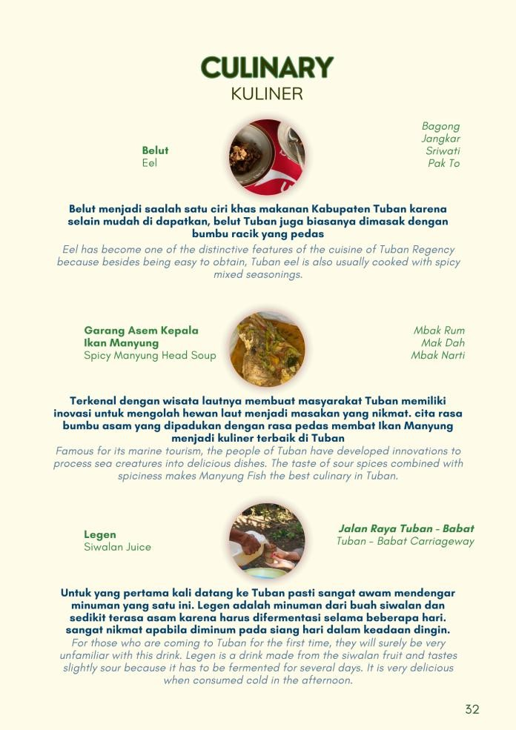
Figure 4. 10 Display Culinary

Display Other Destination
In the other tourist display, there are 3 shopping tourism options around Tuban Regency. Shopping tourism is also one of the must-visit destinations for tourists after traveling in Tuban Regency. Famous shopping destinations in Tuban Regency include Sunan Bonang Market,

Tuban Fish Market, and Hanik Store. In this other destination display, the addresses and product images of each shopping destination are also included..
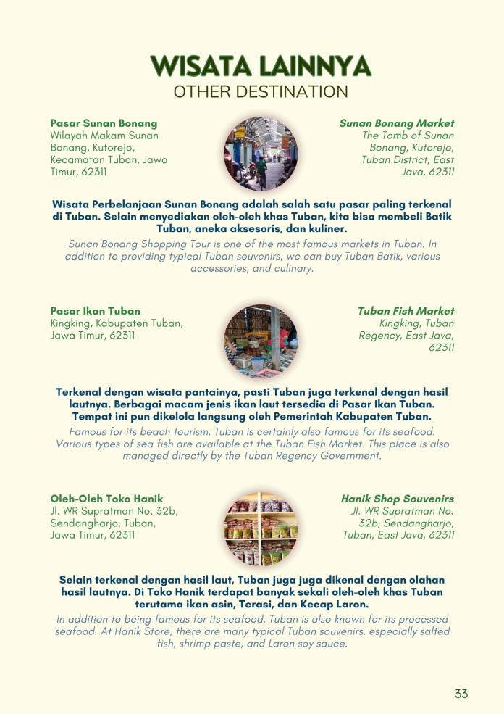
Figure 4. 11 Display Other Destination

Display Shopping Destination
The shopping destination display features three shopping destinations to choose from after visiting the attractions in Tuban Regency. These include Sunan Bonang Market, the Fish Market, and the Hanik Shop souvenir shop. The shopping destinations featured in the booklet are popular destinations in Tuban Regency for tourists to purchase souvenirs.

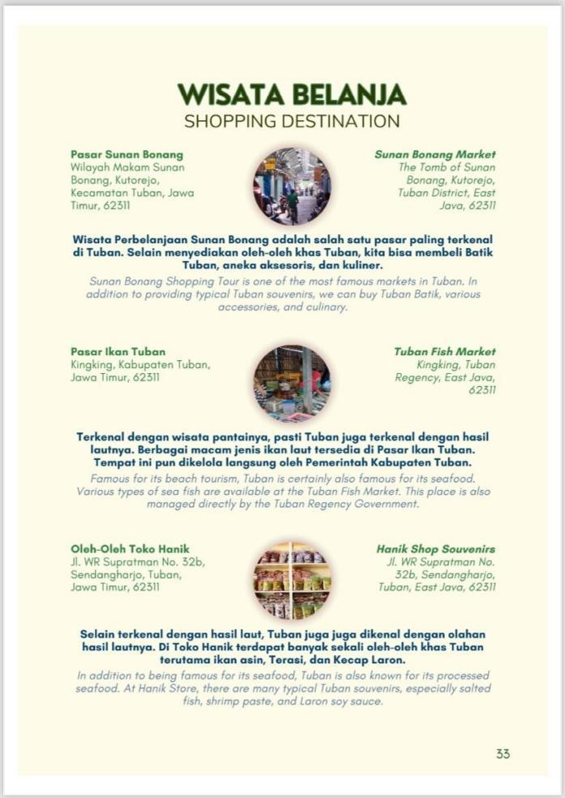
Figure 4.12 Display Shopping Destination

Display Hidden Gem and Product
On the hidden gem and product display, there are 2 pieces of information on one page, namely hidden gems and products. In the hidden gem section, information is provided about hidden places that tourists can visit which are not well known outside Tuban Regency, such as Dermaga Beach, “Prataan” Hot Springs, and Silowo Ecotourism. The second part is the products from Tuban Regency that can be taken as souvenirs by tourists after enjoying sightseeing or simply appreciating the beauty of Tuban Regency. There are 6 famous products in Tuban Regency, namely

Laron Soy Sauce, Pottery, Salted Fish, Batik, Shrimp Paste, and Ental Fruit.
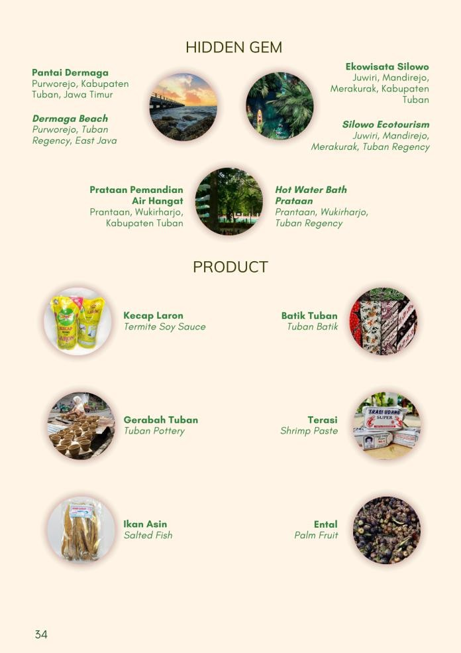
Figure 4. 13 Display Hidden Gem and Product

Display Closing
The closing display is the final part of this bilingual booklet. On the closing display, there are the words “Thank You” and “Terima Kasih,” keeping in mind that this is a bilingual booklet, so both English and Indonesian are included. There is also a holiday quote as a closing, “Wishing You Love, Happiness, and Peace. Happy Holiday!!” with the hope that this booklet can make readers interested in visiting tourist
attractions in Tuban Regency after learning the information contained in the booklet.
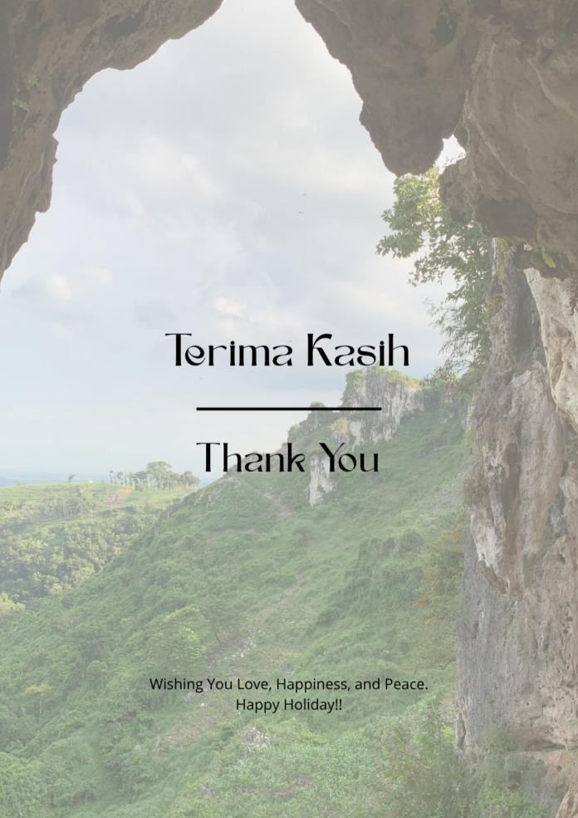
Figure 4. 14 Display Closing
After designing the booklet, the next step is to create the script in English because this booklet is a bilingual booklet, in Indonesian and English. The content of this booklet also includes information on tourist attractions, entrance tickets, facilities at the tourist attractions, addresses, and transportation that can be used to reach the tourist attractions. After the English script is created, a grammar check is conducted using Grammarly to show readability and grammatical accuracy. Checking through Grammarly is intended so that foreign tourists can comfortably

read the booklet without any reading errors in the information. It is also intended to attract foreign tourists to visit the tourist attractions in Tuban Regency. Here is an example of the English translation.
Table 4. 1 Example of English Translation
No. | Indonesia | Inggris
1. | Tuban merupakan salah satu kabupaten di Jawa Timur. Seperti berbagai daerah pada umumnya, Tuban menyimpan banyak potensi wisata yang patut untuk dikembangkan. Destinasi wisata di Kota Tuban beragam, ada banyak pantai eksotis, goa, air terjun, wisata religi, dan masih banyak lagi. Berdasarkan data, tingginya minat wisatawan terhadap objek wisata di Tuban ditunjukkan dengan semakin meningkatnya jumlah kunjungan wisatawan setiap tahunnya. Potensi wisata Kabupaten Tuban sangat banyak, namun banyak pula wisata  yang belum dikelola dan | Tuban is one of the regencies in East Java. Like various regions in general, Tuban holds a lot of tourism potential that deserves to be developed. Tourist destinations in Tuban City are diverse, there are many exotic beaches, caves, waterfalls, religious tourism, and much more. Based on data, the high interest of tourists intourism attraction in Tuban is shown by the increasing number of tourist visits every year. The tourism potential of Tuban Regency is very much, but there are also many tours that have not been managed and developed  properly by Tuban City

 | dikembangkan dengan baik oleh Pemerintah Kota Tuban. | Government.
2. | Selama ini Pemerintah Kabupaten Tuban lebih banyak melakukan branding atau pencitraan pariwisatanya pada sektor religi, karena julukannya yang biasa disebut sebagai "Tuban Bumi Wali". Padahal, pengembangan pariwisata di luar sektor tersebut juga perlu dilakukan secara lebih intensif. Selama ini, Dinas Pariwisata sudah melakukan promosi melalui media seperti banner dan media sosial, ia juga memaparkan prinsip dan elemen desain yang belum optimal, baik dari segi warna, tata letak, font, maupun estetika desain. Prinsip dan unsur tersebut harus menjadi acuan dalam penggarapan media promosi, agar mampu menarik minat khalayak sasaran. Untuk itu perlu  diterapkan penggunaan media yang | So far, Tuban Regency Government has branded or imaged its tourism in the religious sector, because of its nickname commonly referred to as "Tuban Bumi Wali". Even though it is also necessary to develop tourism more intensively outside the sector. So far, the tourism office has promoted through media such as banners and social media, he also explained the principles and design elements that are not optimal, both in terms of color, layout, fonts, and design aesthetics. Principles and elements must be a reference in the cultivation of promotional media, to be able to attract the interest of the target audience. For this reason, it is necessary to apply the use of informative, communicative media  that is the center of attention. With

 | informatif, komunikatif, dan menjadi pusat perhatian. Dengan adanya promosi ini diharapkan masyarakat akan lebih mengenal, mengenal lebih dalam wisata warisan budaya  Kabupaten Tuban. | this promotion, it is hoped that people will know more, get to know Tuban Regency cultural heritage tourism in detail.
3. | Terasa kurang rasanya kalau tidak mampir sebentar ke Goa Akbar Tuban. Goa ini adalah salah satu Goa yang paling terkenal di Kabupaten Tuban. Dengan keindahan batu alam, stalaktit, serta stalagmit. Tidak perlu bingung untuk memahami apa saja yang ada di Goa Akbar Tuban karena disini kita akan dijelaskan tentang apa saja yang ada di dalam Goa dengan adanya papan  informasi yang tersedia. | It won't feel right if you don't stop by the Tuban Akbar Cave for a moment. This cave is one of the most famous caves in Tuban Regency. With the beauty of natural stones, stalactites and stalagmites. There is no need to be confused about understanding what is in the Tuban Akbar Cave because here we will explain what is in the cave with the information boards available.
 | Menurut cerita yang beredar di masyarakat, pada zaman dulu para Wali Songo biasa mengadakan perkumpulan di tempat ini tak | According to stories circulating in the community, in ancient times the Wali Songo used to hold gatherings in this place, including Raden Mas  Said or usually called Sunan

 | terkecuali Raden Mas Said atau | Kalijaga who was famous as a
 | biasa disebut Sunan Kalijaga yang | student of Sunan Bonang
 | terkenal sebagai murid Sunan
 | Bonang.

In the writing process, it is assisted by Google Translate and Language Tool. Google Translate helps in arranging words to be translated, while Language Tool is used for grammar checking to help make the word arrangement more acceptable to readers. Grammar checking using Language Tool can also help the researcher to make words neater because in the grammar checking process there are alternative vocabulary options that can be chosen for reading comfort.
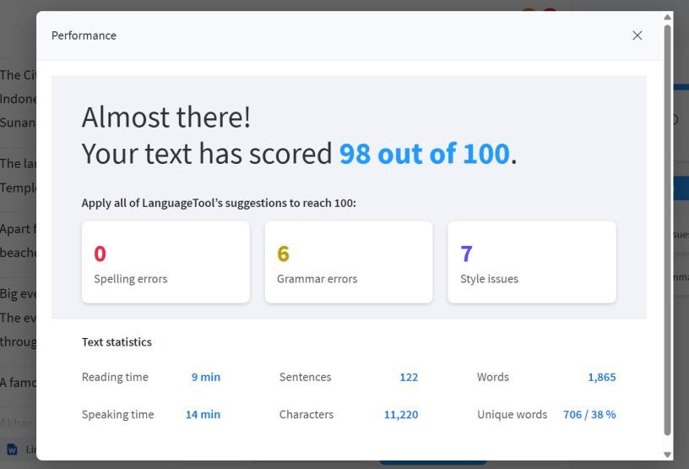
Figure 4. 15 Result of Checking Grammar

Preliminary Field Testing
Based on the research objectives, this study uses a research and development (R&D) method approach, which is a process used to develop and validate educational products. The results of R&D not only develop existing products but also discover knowledge or answers to practical problems (Borg and Gall, 1989, p. 351). Research and development (R&D) essentially has two main goals: producing or developing specific products and testing their effectiveness (Sugiono, 2011, p. 297). Furthermore, R&D is a powerful research strategy or method for improving practice (Sukmadinata, 2009, p. 5). R&D is also defined as a process or steps to develop a new product or refine an existing product that can be accounted for (Sujadi, 2003, p. 164).
The material expert validation stage in this study was carried out three times. At the media expert validation stage, data from media experts was obtained by providing an initial product in the form of a Three-Language Booklet "Bilingual Booklet Tourism Object: Tuban For Relaxing". Subsequently, the media experts evaluated and provided suggestions for revising the booklet.
In the first phase, a preliminary product guidebook was submitted to validators on April 28, 2026. The validators provided feedback on the product guidebook, including background selection, color balance of the cover text, image placement, accuracy of font selection, appropriateness of type and size, consistency of font size, readability of font type and size, and harmony of text color with the background. In stage II, an initial evaluation for the booklet product was held on June 7, 2026. The validator provided feedback on the booklet product, including: Accuracy of Writing, Arrangement of Booklet Content, and Clarity of the Purpose of Images. In stage III, the evaluation of the first submitted product manual was given to the validator on June 8, 2026. The validator gave a positive assessment and indicated that the Bilingual Media Book is suitable for testing.
For the language test, use Language Tool by paying attention to word arrangements that are easy to understand by readers. For the design test, the researcher asked for assistance from Fuady Kresna as a Tuban Tourism Activist. There are several languages and designs that were revised by the validators for the bilingual booklet.

Main Product Revision
After going through the product design and design validation stages, the next stage is product revision. Main Product revision is a large-scale field trial is a trial to assess the feasibility and effectiveness of a product (such as a curriculum or software) in a real-world environment. This step is crucial in the Research and Development (R&D) process to ensure the product is ready for widespread use.. This revision is based on corrections of proper and correct grammar using the Language Tool application. At this stage, there is an adjustment of the language structure in accordance with the applicable language rules.

Here is the grammar revision based on Language Tool:
Table 4.2 Main Product Revision
No. | Before Revision | After Revision
1. | 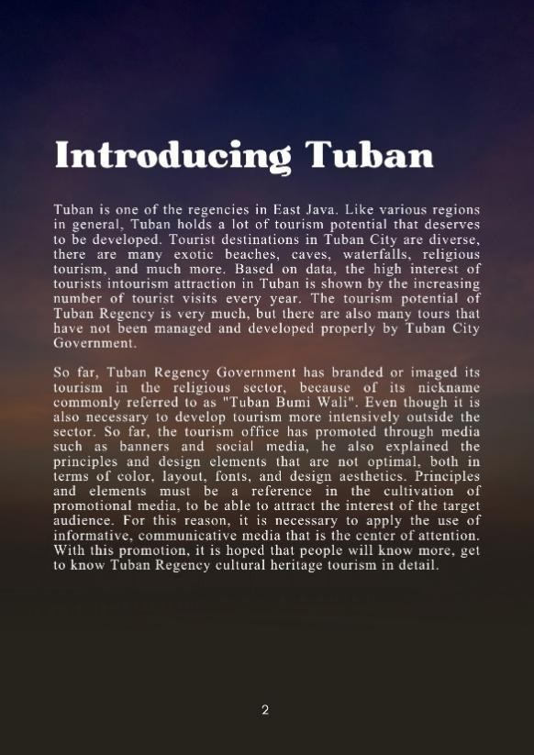 | 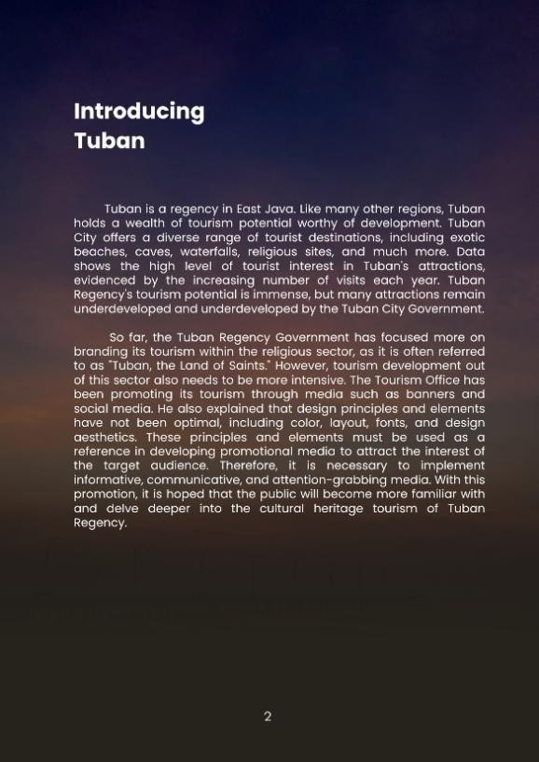

In that column, there are changes in the language structure from Indonesian to English according to the corrections from Language Tool. The changes in grammar are from “Tuban is one of the regencies in East Java. Like various regions in general, Tuban holds a lot of tourism potential that deserves to be developed. Tourist destinations in Tuban City are diverse, tourism, and much more Bached on data, the high interigious and much more. Based tourists intourism attraction in Tuban is shown by the increasing number of tourist visits every year. The tourism potential of Tuban Regency is very much, but there are also many tours that have not been managed and developed properly by Tuban City Government. So far, Tuban Regency Government has branded or imaged its tourism in the religious sector because of its nickname commonly referred to as "Tuban Bumi Wali". Even though it is also necessary to develop tourism more intensively outside the sector. So far, the tourism office has promoted through media such as banners and social media, he also explained the principles and design elements that are not optimal, both in and of color, layout for eter desien esthetics. Painciplen and elements must reference the cultivation promotional media, to be able to attract the interest of the target audience. For this reason, it is necessary to apply the use of informative, communicative media that is the center of attention. With this promotion, it is hoped that people will know more, get to know Tuban Regency cultural heritage tourism in detail.” changed for the better to “Tuban is a regency in East Java. Like many other regions, Tuban holds a wealth of tourism potential worthy of development. Tuban City offers a diverse range of tourist destinations, including exotic beaches, caves, waterfalls, religious sites, and much more. Data shows the high level of tourist interest in Tuban's attractions, evidenced by the increasing number of visits each year. Tuban Regency's tourism potential is immense, but many attractions remain underdeveloped and underdeveloped by the Tuban City Government. So far, the Tuban Regency Government has focused more on branding its tourism within the religious sector, as it is often referred to as "Tuban Bumi Wali." However, tourism development out of this sector also needs to be more intensive. The Tourism Office has been promoting its tourism through media such as banners and social media. They also explained that design principles and elements have not been optimal, including color, layout, fonts, and design aesthetics. These principles and elements must be used as a reference in developing promotional media to attract the interest of the target audience. Therefore, it is necessary to implement informative, communicative, and attention-grabbing media. With this promotion, it is hoped that the public will become more familiar with and delve deeper into the cultural heritage tourism of Tuban Regency.”

Main Field Testing
The product that has been created was then field-tested, mainly with experts who have a better understanding of commercial products in Tuban Regency. At this stage, the researcher asked Fuady Kresna, as a Tuban Tourism Activist, to correct the design, font, and content of the product. The expert was given examples of illustrations from the bilingual booklet and then asked to provide assessments or changes regarding the bilingual booklet that will be read by tourists.

Operational Product Revision
After going through the product design and design validation stages, the next stage is product revision. After the product has been implemented or piloted in a wider area, if deficiencies are still found in the product based on observations, teacher suggestions, and validators, revisions are made. This is done to correct any deficiencies found in the implementation of the developed product. The goal is to correct weaknesses based on field data so that the product is ready to enter the final operational trial stage. This revision is based on the product design expert from Fuady Kresna as a Tourism Activist in Tuban. In this revision stage, there are several things that are revised such as the font and book cover image.
Here is the revised table of Operational Product:
Table 4.3 Operational product Revision
No. | Before Revision | After Revision
1. | 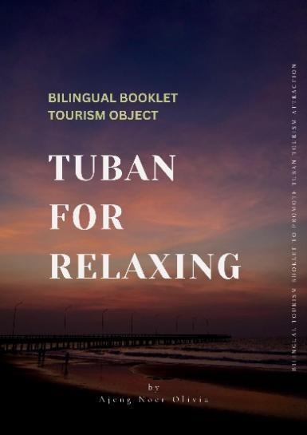 | 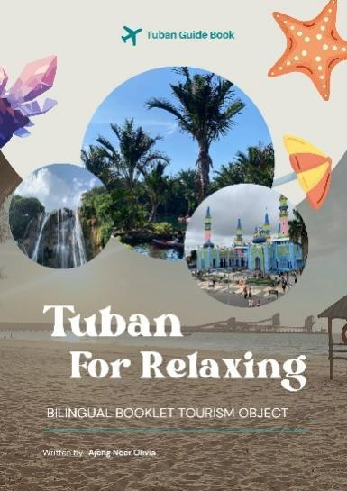

2. | 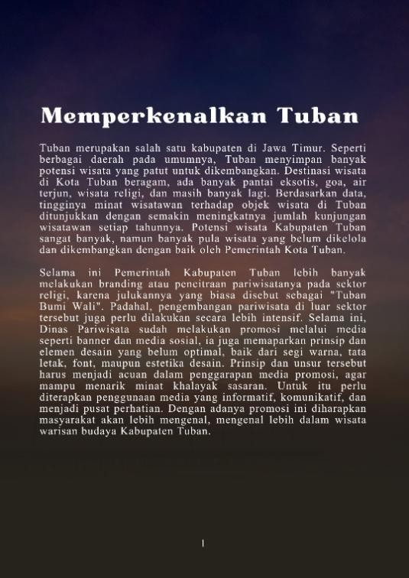 | 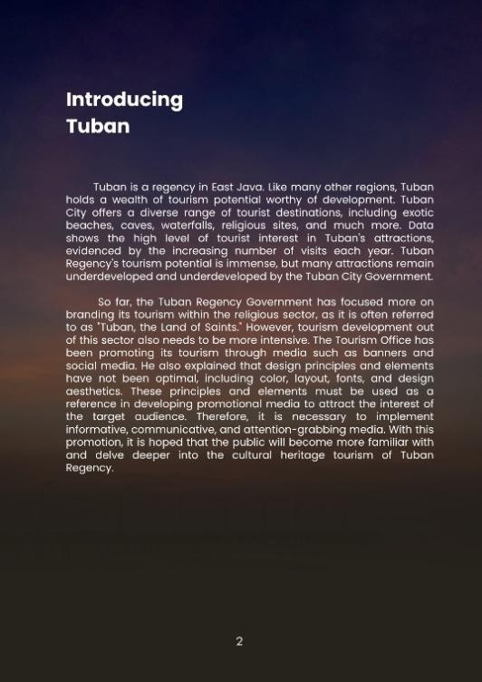
3. | 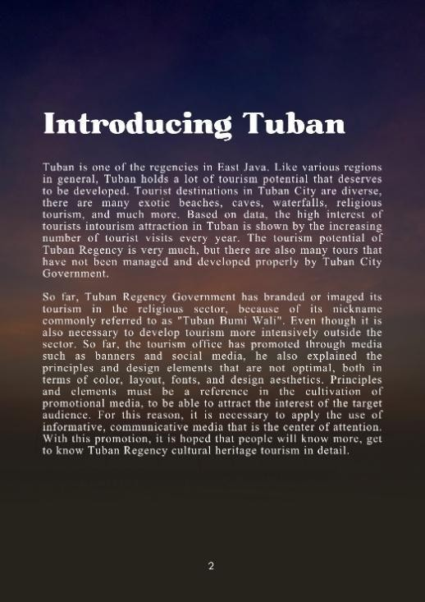 | 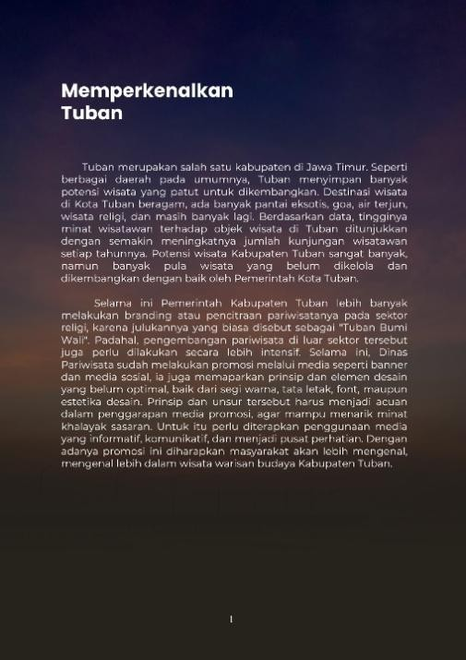

      - In the first column, before the revision, the background theme was a picture of Dermaga Beach at sunset, giving the book cover a dark look. Therefore, after the revision, it was changed to a background image of Semilir Beach during the day, making it look brighter with three additional images of tourist attractions and supporting image ornaments.
      - In the second column, there are font changes for the subheadings and content. As can be seen, the revised page looks more comfortable to read than the pre-revised page.
      - The third column, similar to the changes in the second column, changes the font to make it more readable. According to the validator, font choice also impacts reader comfort, so it's recommended to use two or three different fonts on a single page.

4.1.8 Operational Field Testing
A large-scale field trial is a trial to assess the feasibility and effectiveness of a product (such as a curriculum or software) in a real-world environment. This step is crucial in the Research and Development (R&D) process to ensure the product is ready for widespread use.
After the booklet product has been validated by material experts, media experts, and assessed by users and received a score indicating a "very good" qualification, the booklet product is ready to be tested on a large scale, namely 16 respondents Based on the trial results, the 16 questionnaire results indicated that

the product was suitable for use as a promotional and informational medium. This effectiveness was based on due diligence by subject matter experts, who obtained a due diligence score of 93%, categorized as "Very Feasible," indicating that the product was completed and produced as a promotional and informational medium. The following is an explanation of the booklet's effectiveness.
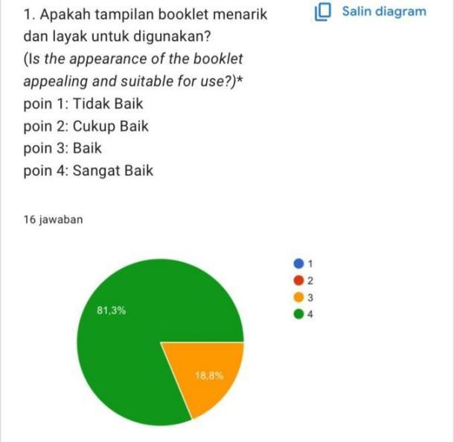
Figure 4.16 The result of the picture of the booklet display diagram
Based on the data, the diagram indicates that the booklet's appearance is attractive and suitable for use. The following is an explanation of the diagram above. Thirteen respondents answered "very good" and three respondents answered "fairly good." Therefore, it can be concluded that the calculation results show an average of "3.8." Therefore, it is stated that the first question is qualified as "good" and "fairly good."

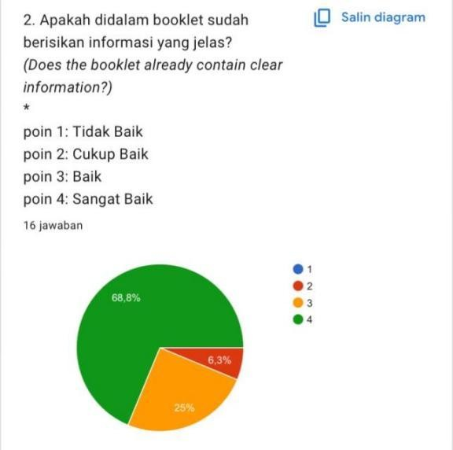
Figure 4.17 The result of the image of the information diagram in the booklet
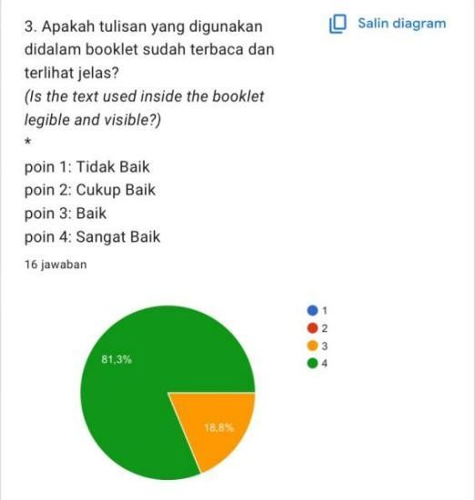
Based on the data, the diagram indicates that the booklet contains clear information. The following is an explanation of the diagram above. Eleven respondents answered "very good," four respondents answered "fairly good," and one respondent answered "fairly good." Therefore, it can be concluded that the calculation results show an average of "3.6." Therefore, it is stated that the second question is qualified as "good" and "fairly good."

Figure 4.18 The result of the drawing of the writing diagram used in the booklet
Based on the data, the diagram indicates that the writing on the booklet is legible and clearly visible. The following is an explanation of the diagram above. Thirteen respondents answered "very good" and three respondents answered "fairly good." Therefore, it can be concluded that the calculation results show an average of "3.8." Therefore, it is stated that the third question is qualified as "good" and "fairly good."
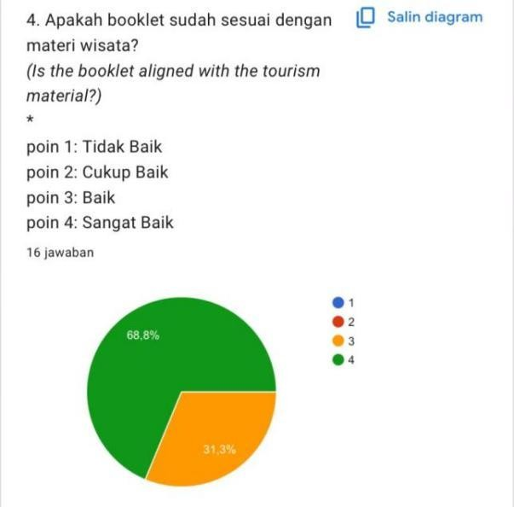

Figure 4. 19 The result of the diagram of the contents of the booklet material are appropriate
Based on the data, the diagram indicates that the booklet's layout is appropriate for the tourism material. The following is an explanation of the diagram above. Eleven respondents answered "very good" and five respondents answered "fairly good." Therefore, the calculation results show an average of "3.7." Therefore, the fourth question is classified as "good" and "fairly good."

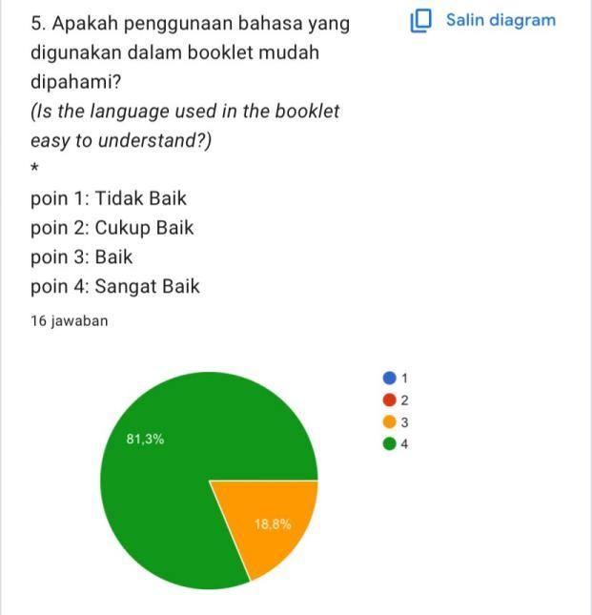
Figure 4.20 The result of drawing a diagram of the use of languages can be understood

Based on the data, the diagram indicates that the language used in the booklet is easy to understand. The following is an explanation of the diagram above. Thirteen respondents answered "very good" and three respondents answered "fair." Therefore, the calculation results show an average of "3.8." Therefore, the fifth question is classified as "good" and "fair."

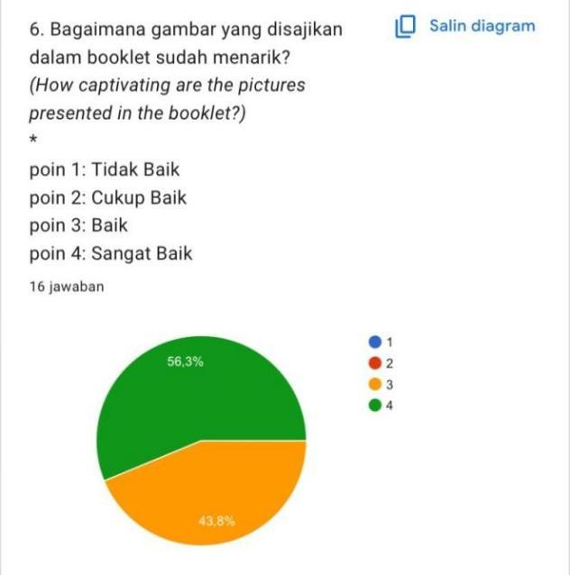

Figure 4.21 The result of the picture presentation diagram of the picture in the booklet

Based on the data, the diagram indicates that the images presented in the booklet are attractive. The following is an explanation of the diagram above. Nine respondents answered "very good" and seven respondents answered "fair." Therefore, the calculation results show an average of "3.6." Therefore, the sixth question is classified as "good" and "fair."

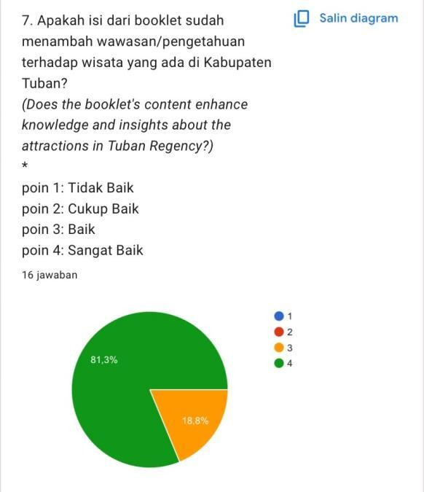

Figure 4.22 The result of drawing a diagram of the contents of the booklet can add insight/knowledge
Based on the data, the diagram indicates that the booklet has increased insight/knowledge about tourism in Tuban Regency. The following is an explanation of the diagram above. Thirteen respondents answered "very good" and three respondents answered "fairly good." Therefore, the calculation results show an average of "3.8." Therefore, the seventh question is classified as "good" and "fairly good."

4.1.9 Final Product Revision
After testing the use of the next stage of final product revision. Final product revision is the final stage of improvement or refinement of a product before it is mass-published or used by a wider audience. This stage is a crucial step to ensure the product is accurate, feasible, and free from defects based on the results of field trials. Several revisions were made by experts and respondents based on criticism and suggestions. The final product revision is shown in the following image.
Table 4.4 Final product revision
No. | Before Revision | After Revision
1. | There is no District Maps
2. | There’s no Inner Cover | 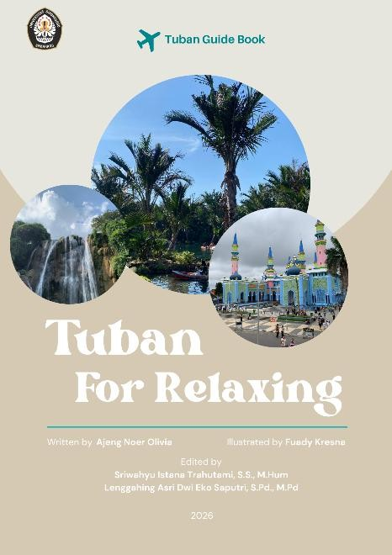

3. | There’s no Acknowledgment | 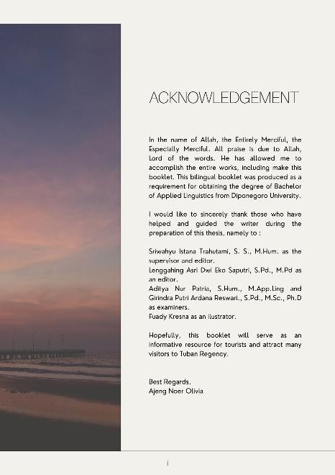
4. | There is no Shopping Destination | 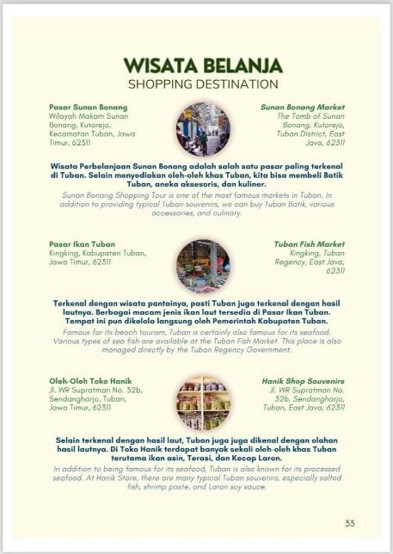

5. |  | 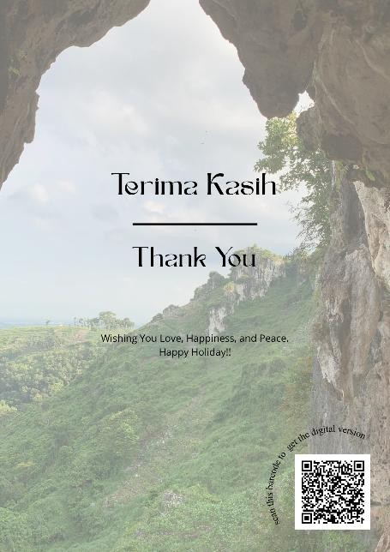
- The first column explains that the initial booklet product did not include a district map. The validator suggested creating a district map display to inform readers of the location or layout of several sub-districts in Tuban Regency.
- In the second column, there was no inner cover before the revision. Following the revision, the booklet now features an inner cover containing the book title, as well as the names of the author, editor, and illustrator; the publication year was also included..
- In the third column, there was no acknowledgment before the revision. Following the revision, the booklet product now includes an acknowledgment on the second page to express gratitude to the various parties involved in its creation.

- The fourth column explains that shopping tours were not included in the initial booklet design. Shopping tours are a crucial aspect of any guidebook. Information about shopping tours is intended to make it easier for tourists to purchase gifts or souvenirs after visiting Tuban Regency's tourist attractions.
- In the fifth column, before the product revision, there was no QR Code to access the Tuban Regency Bilingual Object Tourism Booklet digital product. Therefore, a QR Code was created so that readers could also access Google Drive from the booklet. Due to the current digital era, QR Codes make it easier for tourists to find out information about Tuban Regency through digital platforms. The QR Code is placed on the bottom right side of the closing display.

4.1.10. Dissemination and Implementation
Dissemination and implementation is the final stage of product development, where the tested innovation is disseminated and implemented in real-world settings to the wider community, organizations, or target users so that it can be successfully adopted. In this booklet, the product will be distributed to the public through social media, study program heads, supervisor, and the Tuban Regency public library.

2. Discussion
The bilingual booklet, titled "Bilingual Booklet Tourism Object; Tuban for Relaxing," uses two languages, commonly referred to as bilingual, namely Indonesian and English. The booklet's creation required a harmonious theme,
including an understanding of the tourist attractions, which include natural attractions, religious attractions, architectural attractions, and other information, such as hidden gems. The book is printed with a theme dominated by bright colors to focus readers on the information and images provided.
It can be concluded that, based on the assessment of 16 respondents, an average of 93% fell into the "Sangat Baik" or "Very Good" category. Overall, the promotion of media and book information in the form of guidebooks was categorized as "Very Good" in terms of content and design. The explanation above can be concluded that the bilingual booklet that was created late can provide information about tourist attractions in Tuban Regency.
The advanteges of this bilingual booklet is that it can be used anytime and anywhere (Ashari, 2026). It also include a QR Code makes it easy for tourists to access the booklet via smartphone (Marselina et al., 2024). The illustrations and images used will also keep readers engaged while searching for tourist attractions in Tuban Regency. This bilingual booklet is easily accessible via smartphone, meaning it can be easily printed by readers. Despite its advantages, booklets also have disadvantages: the booklet's creation requires a considerable amount of time for editing and printing. Furthermore, if the booklet is printed on low-quality paper, it will diminish its primary function. Therefore, you must be careful when using the booklet to prevent it from being easily damaged or torn.

