CHAPTER II
DESCRIPTION OF RESEARCH OBJECT

2.1 Sukkhacitta Brand
SukkhaCitta is an Indonesian sustainable fashion brand founded in 2016 by Denica Riadini-Flesch, who serves as the Founder and Chief Executive Officer of the company. The brand was established to create a more responsible fashion system by connecting consumers with women artisans, farmers, and craft communities in rural areas of Indonesia. SukkhaCitta positions itself as a regenerative fashion brand through its farm-to-closet approach, which emphasizes traceability from raw materials to finished garments.
Unlike conventional fashion brands that commonly rely on mass production, SukkhaCitta emphasizes handmade production, heritage craftsmanship, natural materials, and social impact. Its products are created by women artisans, referred to by the brand as Ibus, using traditional techniques and locally rooted knowledge. The brand also incorporates regenerative farming practices, particularly through the Tumpang Sari approach, which is intended to restore soil health, improve biodiversity, and support sustainable livelihoods for smallholder farmers.
SukkhaCitta uses plant-based fibres, natural dyes, handwoven fabrics, and artisanal production processes in its collections. The brand’s sustainability concept is not limited to product materials but also includes environmental responsibility, artisan empowerment, traceability, and circularity. In addition, SukkhaCitta provides lifetime repair and redye services to encourage consumers to extend the use of their garments rather than dispose of them prematurely.
This positioning makes SukkhaCitta relevant as the research object of this study. Its business model combines sustainability-oriented marketing activities with a distinctive brand identity. Therefore, Green Marketing and Brand Image are considered relevant variables for explaining consumers’ Purchase Decisions toward Sukkhacitta products.

Figure 2. 1 Sukkhacitta’s Logo
SukkhaCitta’s official materials describe its model as artisan-made regenerative fashion, supported by a farm-to-closet supply chain, plant-based materials and dyes, and women’s empowerment.
Table 2. 1 SukkhaCitta Brand Profile
Aspect | Description
Brand Name | SukkhaCitta
Founder | Denica Riadini-Flesch
Year of Establishment | 2016
Business Type | Indonesian sustainable and regenerative fashion brand
Main Concept | Farm-to-closet fashion model
Main Materials | Natural fibres, regenerative cotton, plant-based dyes, and handcrafted textiles
Production Approach | Handmade production using traditional craftsmanship, hand weaving, embroidery, batik, and artisan-based production
Environmental Value | Regenerative farming, plant-based dyes, traceable materials, low-impact production, and circularity practices
Social Value | Empowerment of women artisans and smallholder farmers in rural Indonesian communities
Product Categories | Tops and shirts, dresses, outerwear, kebaya and kain, pants and skirts, accessories, shirts, and gender-neutral items
Customer Services | Official online store, boutiques, selected stockists, worldwide shipping, repair services, and redye services
Market Positioning | Premium sustainable fashion brand with handcrafted and socially responsible products
Source: Compiled by the researcher based on SukkhaCitta Official Website (2026).

2.1.1 Product Offerings and Price Positioning
SukkhaCitta offers various fashion products for women and men. Its women’s collections include tops and shirts, dresses, outerwear, kebaya and kain, pants and skirts, and accessories. The brand also offers gender-neutral products and selected menswear categories, including shirts, outerwear, pants, and shorts.
The selling price of SukkhaCitta products varies depending on the material, craftsmanship, production process, and collection. The relatively premium price positioning reflects the use of handmade production, heritage craftsmanship, traceable natural materials, and efforts to provide fair compensation throughout the supply chain.
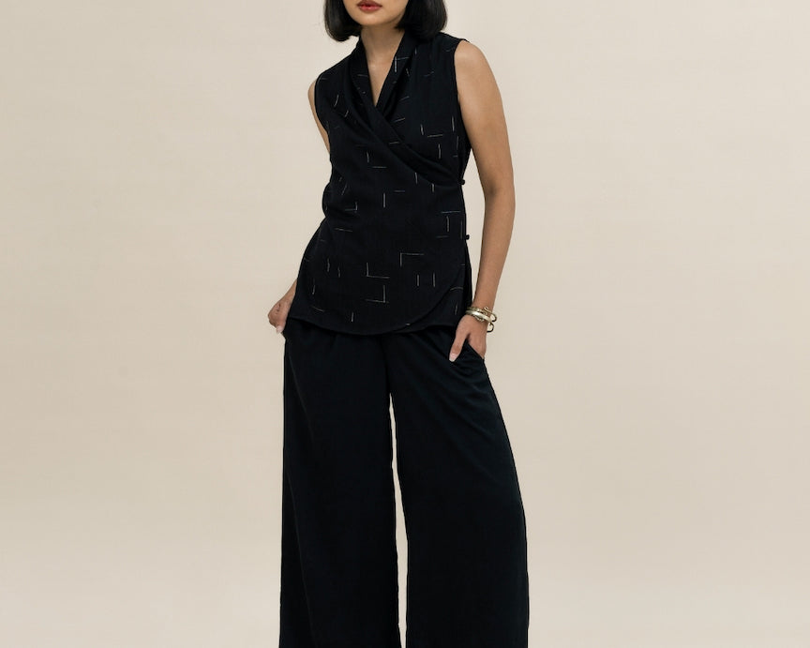
Figure 2. 2 Example of a SukkhaCitta Ready-to-Wear Product

Table 2. 2 Representative SukkhaCitta Product Prices
No. | Product | Product Category | Listed Price
1 | Camisole in Ikatan | Top | IDR 890,000
2 | Classic Wrap Top in Ikatan | Top | From IDR 1,790,000
3 | Hand-Stitched Pearl Top in Kapas | Top | IDR 1,890,000
4 | Relaxed Shirt in Ikatan | Gender-Neutral Shirt | From IDR 2,190,000
5 | Canvas Overshirt in Ikatan | Gender-Neutral Outerwear | From IDR 3,990,000
Source: SukkhaCitta Official Website, accessed on July 3, 2026.
2.1.2 Distribution Channels and Customer Access
SukkhaCitta distributes its products through its official online platform, physical boutiques, and selected stockists. The official website lists Rumah SukkhaCitta at ASHTA District 8 Jakarta, selected stockists, and worldwide shipping services. These distribution channels provide consumers with several alternatives for accessing and purchasing SukkhaCitta products.
The availability of both online and offline purchasing channels is relevant to this study because consumers may consider the credibility of sellers, product accessibility, purchasing location, and convenience before making a Purchase Decision. Furthermore, the availability of official channels can strengthen consumer trust and reduce perceived risk when purchasing premium fashion products.
SukkhaCitta’s official site lists product categories, boutiques, selected stockists, and worldwide shipping; it also explains that pricing reflects handmade heritage craftsmanship, production time, natural materials, and living wages across the supply chain.

2.2 Demographic Statistics
In conducting the research, this study obtained data from 104 respondents who met the criteria, namely having bought sukkhacitta products. The demographic characteristics of the respondents can be seen in the following table.
Table 2. 3 Demographic Statistics
Demographic Data |  | Total | Percentage
Gender | Male | 45 | 43.3%
Gender | Female | 59 | 56.7%
Age | < 17 | 2 | 1.9%
Age | > 45 | 1 | 1.0%
Age | 17 - 25 | 41 | 39.4%
Age | 26 - 35 | 38 | 36.5%
Age | 36 - 45 | 22 | 21.2%
Job | Freelancers | 11 | 10.6%
Job | Civil Servants (ASN/TNI/Polri) | 14 | 13.5%
Job | Private Sector Employees | 36 | 34.6%
Job | Students | 30 | 28.8%
Job | Entrepreneurs | 13 | 12.5%
Income | < IDR 4 million | 36 | 34.6%
Income | > IDR. 12 million | 3 | 2.9%
Income | IDR. 5 - 8 million | 42 | 40.4%
Income | IDR. 9 - 12 million | 23 | 22.1%
Intensity to buy | 2–3 | 59 | 56.7%
Intensity to buy | 4–5 | 22 | 21.2%
Intensity to buy | 6–7 | 12 | 11.5%
Intensity to buy | At least 1 | 11 | 10.6%
Place to buy | Offline Store | 75 | 72.1%
Place to buy | Online Store | 29 | 27.9%

Respondent demographic data shows that the majority of respondents are women as many as 59 people (56.7%), while men are 45 people (43.3%). This composition shows that Sukkhacitta Brand products are more responsive to women groups who generally have a higher interest in fashion products based on aesthetic and sustainability values. Based on age, respondents were dominated by the age groups of 17–25 years (39.4%) and 26–35 years (36.5%). This shows that the main consumers come from young productive age to early adulthood who tend to be more aware of fashion trends as well as environmental issues. The age group of 36–45 years (21.2%) is still quite significant, while the age under 17 years (1.9%) and over 45 years (1.0%) have a very small proportion.
Based on occupation, the most respondents came from private sector employees (34.6%) and students (28.8%), followed by ASN/TNI/Polri (13.5%), entrepreneurs (12.5%), and freelancers (10.6%). This shows that interest in Sukkhacitta products is spread among groups with diverse work backgrounds, but it is dominated by workers and students who have high exposure to sustainable fashion trends . Based on income, most respondents were in the range of IDR 5–8 million (40.4%) and below IDR 4 million (34.6%). These results show that Sukkhacitta products are widely reached by the middle class. The intensity of purchases is dominated by the frequency of 2-3 times (56.7%), while the place of purchase is more done in offline stores (72.1%) than online stores (27.9%). This shows that first-hand experience of the product is still an important factor in purchasing decisions.

