

ROMANCE AS RESISTANCE WITHIN CAPITALIST LOGIC IN MATERIALISTS (2025)

A THESIS
In partial Fulfillment of the Requirements
for S-1 Degree Majoring American Studies in the English Department, Faculty of Humanities

Submitted by: Najla Nurazizah 13020122140116

FACULTY OF HUMANITIES DIPONEGORO UNIVERSITY SEMARANG
2026

PRONOUNCEMENT

I honestly state that this thesis is written by myself without taking any works from other researchers in any unversity, in diploma degree, S-1, S-2, and S-3 degree. I also ascertain that I do not take any material from other works except from the references mentioned.

Semarang, 18th June 2026

Najla Nurazizah

ii

MOTTO AND DEDICATION

Truth without love is brutality, and love without truth is hypocrisy.

Warren Wiersbe

As we express our gratitude, we must never forget that the highest appreciation is not to utter words, but to live by them.
John F. Kennedy

This thesis is dedicated to those who are the hopeless romantic
and the survivors in this capitalist society.

iii

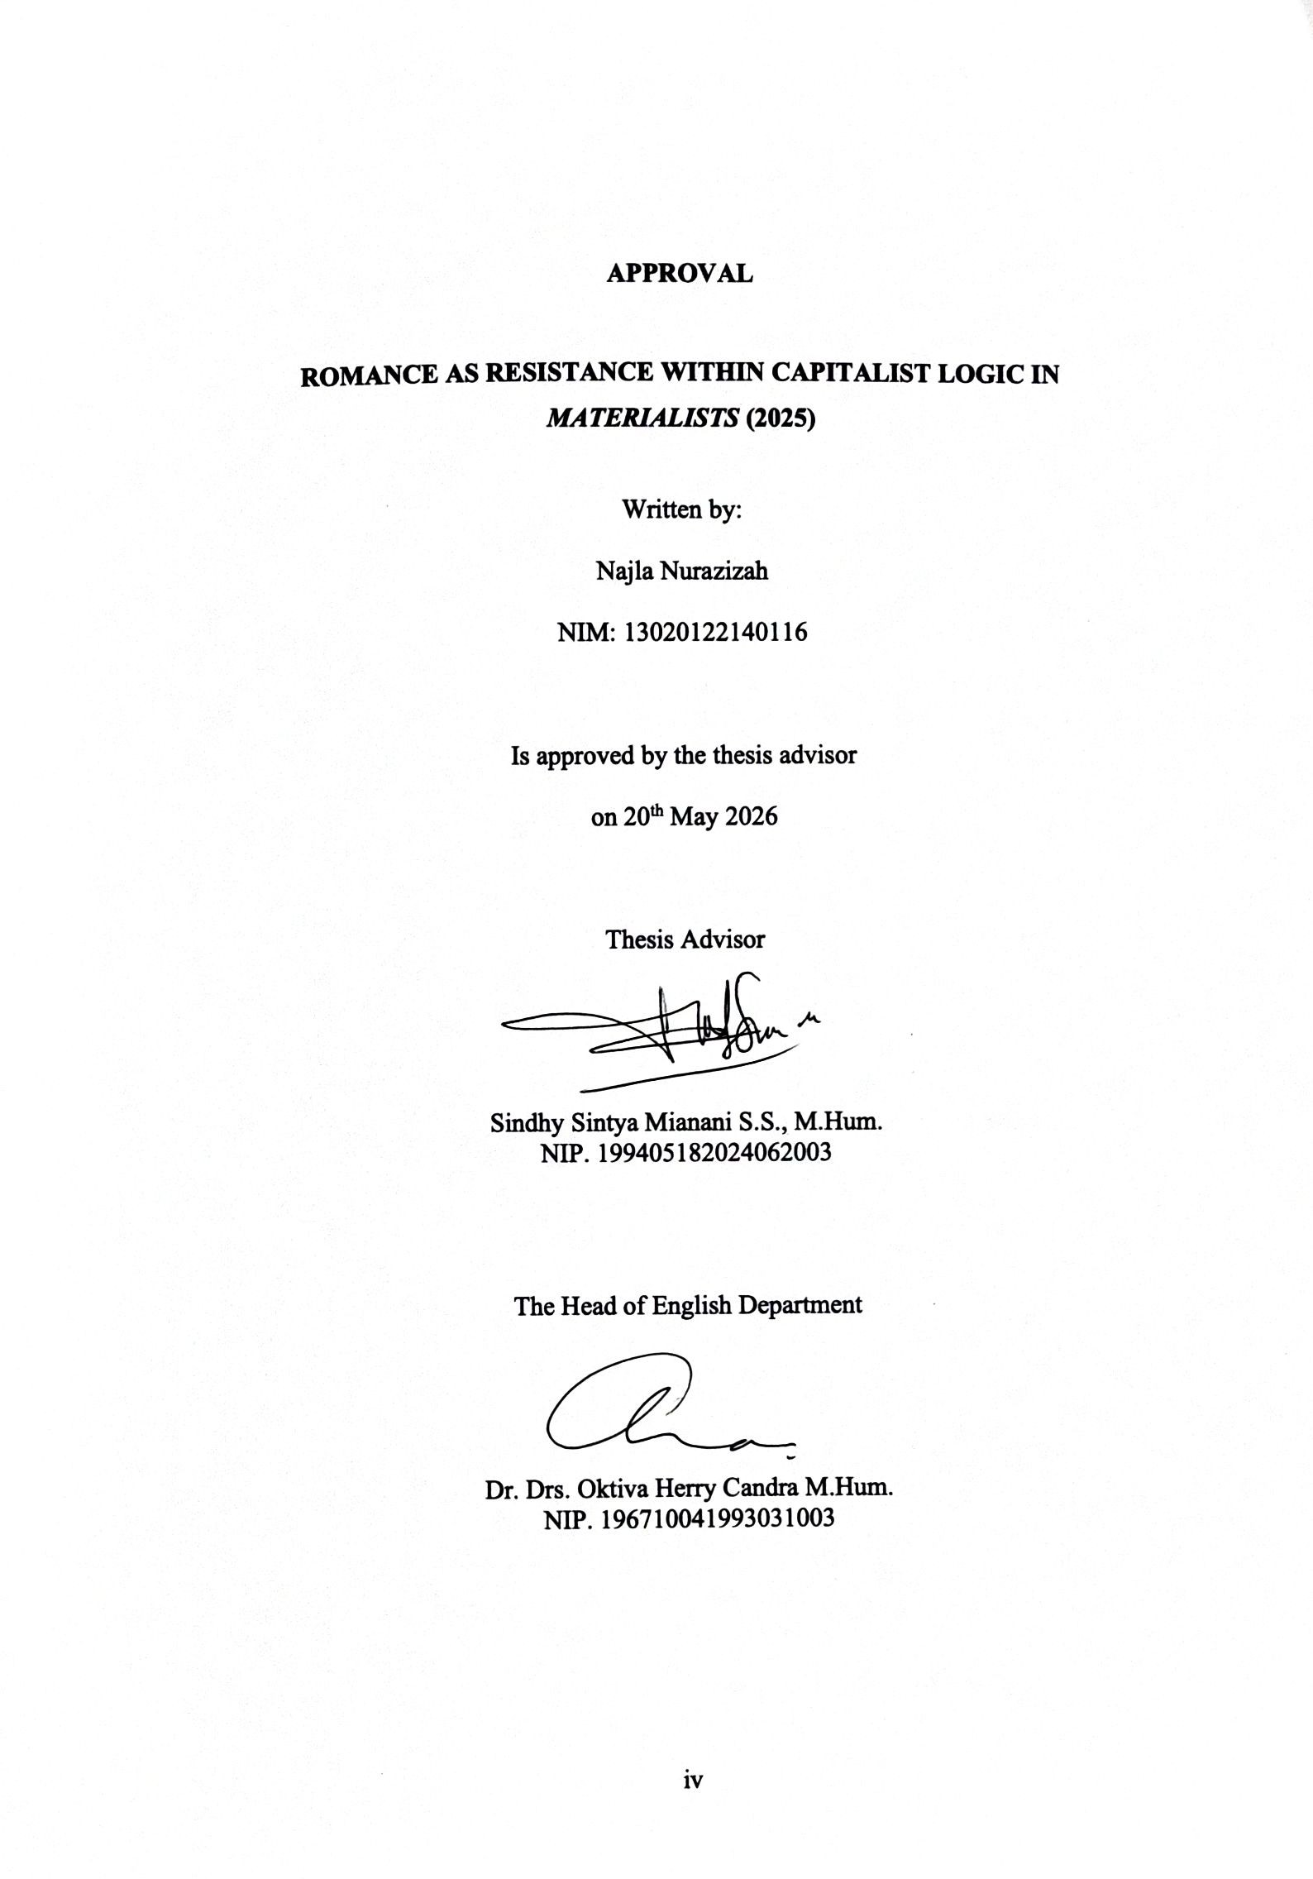

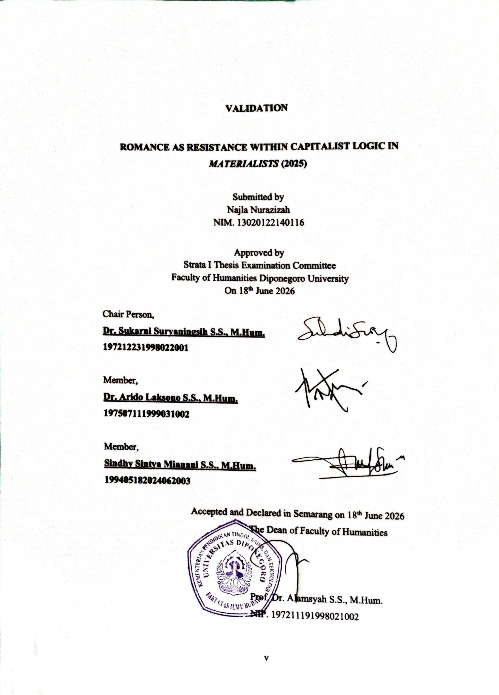

ACKNOWLEDGEMENT

Praise be to Allah SWT, who has given me His countless blessing and great mercy, so this thesis came to a completion. This part is presented to thank all people who have given their in the accomplishment of this thesis. This gratitude might never be equal to their help and support.
The deepest appreciation and gratitude are extended to Sindhy Sintya Mianani S.S., M.Hum., my advisor, who has spared his valuable time to patiently give his constructive suggestion and continuous guidance without which I would be doubtful to accomplish this thesis successfully.
My greatest thank also goes to the following;

- Prof. Dr. Alamsyah S.S., M.Hum., as the Dean of Faculty of Humanities, Diponegoro University.
- Dr. Drs. Oktiva Herry Candra M.Hum., as the Head of the English Department of the Faculty of Humanities, Diponegoro University.
- All lecturers of English Department Diponegoro University. Precious knowledge and their advice would be unforgettable for the writer.
- My parents, my grandmother, and family who are the biggest reasons and motivations for the writer to finish her education.
- All my beloved Diponegoro University friends: Sherenita Widya Rahmi, Septya Dwi, Caroline Melodee, and Dava Aqillah; My beloved all-time best friends: Fahriza Agustriana, Sahira Faza, Ghina Shofa, ans Ibnu Surya, their supports are meant a lot for the writer during her college life.

vi

While recognizing the inherent limitations of this study, the writer has put forth utmost effort to ensure its academic rigor. Thus, any recommendation and constructive suggestion would always be welcomed and appreciated. Finally, I hope that this thesis would be helpful for those who want to learn about cleft palate deviation or any related field in general.

Semarang, 18th June 2026

Najla Nurazizah

vii

TABLE OF CONTENTS

CHAPTER 1 INTRODUCTION 1
  - Background of The Study 1
  - Research Questions 3
  - Objectives of The Study 4
  - Scope of The Study 4
  - Previous Studies 4
  - Research Methods 10
    - Data and The Source of Data 10
    - Method of Data Collection 10
    - Method of Approach 11
  - Organization of The Writing 11
CHAPTER 2 INTRINSIC THEORETICAL FRAMEWORKS 13
  - Narrative Elements 13
    - Theme 13
    - Character & Characterization 13
    - Settings 14
    - Conflicts 14
    - Plot 14
  - Cinematic Elements 15
    - Camera Distance 15
    - Sounds 17
CHAPTER 3 EXTRINSIC THEORITICAL FRAMEWORKS 19
  - Extrinsic Aspects 19
    - The History of Capitalism in America 19
    - Romantic Life within Capitalist Logic 21
    - The Socio-Economic Conditions 22
viii
CHAPTER 4 RESULTS AND DISCUSSION 24
  - Intrinsic Aspects 24
    - Theme 24
    - Character and Characterization 25
    - Settings 27
    - Conflicts 29
    - Plot 32
  - Extrinsic Aspects 33
    - The Rationalization in Modern Capitalism 33
    - Romantic Life in Capitalist Logic as The Cultural Contradiction 37
CHAPTER 5 CONCLUSION 42
REFERENCES 44

ix

TABLE OF PICTURE
Picture 1 The Visual of Camera Distance 17
Picture 2 Lucy Talking about Her Perspective with Her Colleague 25
Picture 3 Harry Greetings the Exclusive Guests 26
Picture 4 The Way John Lives 27
Picture 5 Lucy in A Yellow Taxi Cab 28
Picture 6 Lucy Holding Her Phone 28
Picture 7 Lucy’s Internal Tension in Workplace 29
Picture 8 The Flashback when Lucy and John Broke Up 30
Picture 9 The External Conflict within Lucy’s Client 31
Picture 10 Lucy Findings on Harry 33
Picture 11 Expensive Dinner Harry and Lucy 35

x

ABSTRACT

This thesis examines how romance appears in Celine Song's Materialists (2025) as an argument against capitalist logic. This study argues that the film both depicts and resists the capitalist structuring of romantic life by analyzing its intrinsic and extrinsic parts using Max Weber's idea of capitalist rationalization as its theoretical framework. Harry and John are the idealized capitalist partner and the emotionally genuine but financially unstable choice, in contrast, while Lucy, a high-end matchmaker in New York City, represents the rationalized subject of capitalism by viewing relationships through material calculation. Lucy's final choice of John over Harry and her resignation from a lucrative job promotion are acts of resistance, a rejection of capitalist rationality in favor of emotional truth. The thesis claims that Materialists (2025) depicts love as an object of opposition and reinterpretation of capitalist logic rather than as an extension of it, building on Weber's idea of the "iron cage" in capitalist society.

Keywords: capitalism, rationalization, resistance, romance.

xi

CHAPTER 1 INTRODUCTION

Background of The Study

Relationship between people is basic human needs, whether it’s with family, friends, society, or even the deeper and personal like romantic relationship. The desire of need connection with other people is linked with survival and emotional belongings within human beings. This makes human naturally is a social beings. “A social instinct is implated in all men by nature” (Aristotle, 1908, p. 29). Otherwise, the social beings in human first formed through family where emotional support and belongings are exist furthermore into friends, society, and romantic relationship. “The need to belong is a fundamental human motivation. Human beings have a pervasive drive to form and maintain at least a minimum quantity of lasting, positive, and significant interpersonal relationships,” (Baumeister, R. F., & Leary, M. R., 1995, p. 497). In consequence, the romantic relationship is one of necessery for human social beings because it connected to the family where individual seeking for emotional belongings, intimacy, and also it formed individual identity within social expectation.
In this modern era, romance is something crucial for individual matter. Romance often acknowledged as an intimate relationship that seen in reality through emotional attachment between individuals. It has been concerned by society since it is part of a social construction that shaped from cultural expectations especially to women. “Ideals of romantic love have long affected the aspirations of women more than those of men, although of course men have not been uninfluenced

by them,” (Giddens, 1992, p. 2). Therefore, romance becomes social concerned rather than a personal perception.
This social construction shaped romance into social expectations that connected to capitalist society where the ideal of romance influenced through material stability and economic rationality. In consequence, the seeking for the ideal of romance within capitalist society is something decisive for individuals in looking for partner of their life. Rather than separated from economic system romance is deeply connected to capitalist values through its system.
Moreover, while romance connected to economic system it can be said that romance connected to capitalism. “When spouses and lovers succed in sustaining each other’s lives, they don’t do it with love alone, but with concrete contributions to their joint material walfare,” (Zelizer, 2005, p. 34). Where in capitalist modernity, it bring up the pressure within individuals in the long run affects to their romance sphere by shaping the desires, expectations, and emotional tendencies. Capitalism influenced how society think about romance as an investment or a tool for self-development although capitalism is rooted from religion sphare especially in Western (European and America) and it continiously develops into modern capitalism. “The moral energy of the Puritans, brought about the rise of Modern Western capitalism,” (Giddens, as cited in Weber, 2005, p. xvii).
This is where the cultural conflict appears in Celine Song's Materialists (2025). The movie is played by Dakota Johnson as Lucy which is a woman who got more affected ideals of romantic love in this capitalism society. Otherwise, the movie focusses on Lucy who is a high-end matchmaker in New York area and she

is stucked in confusion relationship between two men. Those are John who is a poor cater waiter who symbolises economic instability and Harry who is a successful rich man who works for private equity under his family company. The capitalist expectation that American women will associate romantic desire with financial security is challenged by Lucy's final decision on her life partner choice. Therefore, rather than shifting romance as an example of capitalist rationality, the film delivers an opposition manner that breaks the cultural logic of American capitalism.
Purpose of this study is to examine romance under capitalism system that lead us to see how intimate life is constructed by broader social structure along with personal emotional choice through Materialists (2025). “Capitalism went hand in hand with the making of intensely specialized emotional culture,” (Illouz, 2007, p. 11). Therefore, Materialists (2025) is both entertainment and a literary work that merges into the redefining of life choices and romance in a capitalist society. Using a sociological approach, this thesis explores how romance goes against society's beliefs by exploring how romance becomes a form of resistance with sociological approach; Max Weber theoritical framework that focused on capitalism. The study also explores on the way Materialists (2025) redefine romantic life beyond capitalist ideology.

Research Questions
This study analyzed the questions below:
- How do the intrinsic elements in Materialists (2025) depict capitalism?

- How does Materialists (2025) portray romance as a form of resistance against capitalist logic and offer a redefinition of romance beyond its ideology?

Objectives of The Study
This study will follow the following objectives:
- To explain how Materialists (2025) depicts capitalism through intrinsic elements.
- To analyze how Materalists (2025) redefines romance as a form of resistance in capitalist society.

Scope of The Study

The study limits itself to a qualitative sociological approach analysis of the movie Materialists (2025) as a cultural text. The primary focus is on romance and how it symbolize resistance against capitalist culture in America. Furthermore, the analysis does not attempt to explain general of the American romance film's history, nor attempt a broad overview of American capitalism. It is instead focused on intrinsic and extrinsic elements those are representation of individual’s choices, romance, and form of resistance in Materialists (2025) that influenced by capitalist ideology.

Previous Studies

Materialists (2025) is a new object of study, the studies before that discussed about the movie as its object is not available, alternatively the previous studies focused on the same topic as this thesis. The studies that have analyzed the merging of resistance, Max Weber concept, and cultural identity that serves as platform for exploring the movie.
First, Max Weber’s Concept on Social Class as Reflected in Crazy Rich Asian

Movie by Yuni Cinthya (2020). This thesis applies Max Weber’s class theory,

status and power to analyse the representation of social stratification in the 2018 film Crazy Rich Asians. The film represents three of Weber’s four social classes; upper class, middle class and working class, while the lowest class is absent. This is the result of the study with the library research method and a prudent text analysis of movie scenes. This analysis shows a large influence of position and income on relationships. The main character Rachel Chu is bothered by the discrimination and inferiority complexes caused by the class differences in the family of her boyfriend who is a person of high status.
Second, the study by Jonathan Dave P. Ayala and Louie B Villanueva on A Marxist analysis of the movie Third World Romance (2025) that used Marxist theory to analyze issues of class struggle, labor exploitation, and socio-economic inequality within Philippine society. From the study, it was discovered that the movie reveals the reality of life faced by the working class, which includes exploitation through unjust labor practices, low pay, unsafe working environment, and lack of workers' autonomy under capitalism. Through the use of characters Alvin and Britney in the movie, the researchers pointed out that the movie romanticizes resilience as a way of survival in spite of the continued existence of inequalities. Using qualitative thematic analysis method, the researchers revealed how the movie reflects Marxist ideas such as alienation, false consciousness, and exploitation of workers who have to suffer oppression because of their economic weakness.
Third, Sara Mills’ Critical Discourse in Mother Movie: Deconstruction of Meaning by Sara Mills on Femininity and Women’s Resistance by Pratiwi et al.

(2021). This study using Sara Mills' critical discourse analysis theory to analyse how femininity and women's resistance are depicted in Bong Joon-ho's Mother (2009). Following a descriptive qualitative methodology, the study finds that Hye-ja, the female lead, is depicted as both an object through domestication, sexism, and subordination and a person who challenges patriarchal norms. According to the research, the movie deconstructs femininity by showing female strength, emotional depth, and acts of resistance where Hye-ja's attempt to protect her child when the media often objectifies women. The results also demonstrate how cinema is a medium that simultaneously produces and reflects societal perspectives.
Fourth, the next study lends to the discussion on women and resistance through Indonesian Women as Eastern Representation in Darah Garuda Movie by Evi Irawanti Br Saragih (2022). Drawing on Edward Said's Orientalism concept, the paper investigates how Indonesian women were viewed by Dutch colonial authorities as both victims and entities of resistance. The study found that Dutch views of Indonesians are mostly ones of inferiority and lust, which is in line with Orientalist stereotypes that depict the East as helpless, unreasonable, and obedient to the West. The movie also depicts women physically challenging these stereotypes by disguising themselves as males in order to pass for men and even using guns to defend off colonial soldiers. The study concludes that women, despite being represented as subaltern in colonial discourse, create their agency by resisting headon Western domination and Orientalist misrepresentation.
Fifth, De la Pava Vélez's (2017) doctoral thesis. Celluloid Love: Audiences and Representations of Romantic Love in Late Capitalism explored how

contemporary North American romantic films and diverse audiences in London construct cultural ideologies of love. Embedded in a feminist-informed, critical media with sociological framework that treats romantic love as a culturally constructed ideological phenomenon, the research makes three main arguments: neoliberal individualism has produced called "crisis of romantic love," mainstream film narratives capture this crisis, even exploit it, and audiences internalize and respond to these crisis narratives. Based on textual analysis of five films and 36 audience focus group interviews, de la Pava Vélez discovers that even though both films and viewers are responding to precarious and technology-mediated intimacy conditions, general claims over a love "crisis" are "greatly exaggerated" and tend to incorporate anxieties in companionship relationships into the mere commodification of relationships. Put simply, his thesis discussed how romance films reflect capitalist anxieties and yet reveal the perpetually personal–social dimension of love. The implication could be that film romance might be an avenue to interrogate or even subvert dominant capitalist narratives of intimacy (de la Pava Vélez, 2017).
Sixth, Love Them, but Get Them to Leave You – Neoliberal Ideals of Love, Romance and Family Life Imprinted on Contemporary US Cinema, a thesis by Mentis (2019) looks at Hollywood romantic comedies through the lens of neoliberal ideology whre he argues that the attachment of US culture to free-market values reshapes the love stories of these films. Using genre theory and ideological critique, Mentis contends that contemporary rom- coms increasingly encode themes of individualism, competition, and self-optimization into narratives of love. He finds

that the protagonists achieve their fulfillment not by challenging social norms but rather by adapting themselves to the logic of the market for example, by improving their position in the market through self help. Hence, the film endings find characters in marginally better socioeconomic or emotional positions, without the realization of a grand romantic ideal. In effect, Mentis concludes, such love plots are "powerful ideological tool[s]" that engage audiences with the neoliberal status quo. At any rate, Mentis's thesis focuses exclusively on how romance reinforces an already existing ideology and does not take into consideration romance as subversion.
Seventh, merely John G. Cawelti's views on convention and invention have been examined in The formula of romance in The Redeeming Love (2022) movie. In their analysis of the film Redeeming Love (2022), Jusrianti, Rasiah, and Arman (2024) find that while the film maintains its traditional elements such as the hero and heroine's first encounter, the development of conflict, the boy-wins-girl theme, and a happily-ever-after conclusion, it also innovates through the use of a mixed narration, an ordinary male hero, and a stubborn but well-liked heroine. They employed a descriptive qualitative study approach and Cawelti's formula theory to analyse how romantic formulas have changed in contemporary films. Additionally, they pointed out that the film uses narration and characters from.
Eight, the study by Yuri Yusnia Kartika, Andang Saehu, and Agry Pramita's (2022) titled Fantasy formula in romance movies: Beauty and the Beast (2017) and Aladdin (2019. This study used Joyce Saricks' fantasy genre theory and Wellek and Warren's comparative literature theory to analyse the fantasy formula in the

romance-fantasy films Beauty and the Beast and Aladdin. Characterisation, plot, framing, and pacing are the four primary areas where Beauty and the Beast and Aladdin have commonalities in the fantasy genre formula, according to a comparative descriptive qualitative study approach. It was observed that both films have strong heroines, Belle and Jasmine, who exhibit courageous and daring traits. Ninth, Javaria Farooqui on Women, representation, and romance: The magic space of What’s Love Got to Do With It? (2024) was studied on the movie What’s Love Got to Do with It? analysed with the feminist perspective, representation of women, romance and cultural identity in romantic comedy film. The study notes that the film attempts to espouse the values of diversity and female emancipation but is rather patriarchal and conservative in its approach. “It’s a story about the clash of Kaz’s orthodox views on arranged marriage and family responsibilities with Zoe’s western liberal ideals of freedom and romanticism,” says Farooqui. Thus, it was proved that in spite of the female characters appearing to be powerful initially, they are eventually forced to accept the traditional conception of happiness in marriage and dependence on males. Moreover, the film is said to depict the patriarchal system in a positive light and to imply that arranged marriage and cultural conservatism are preferable to western dating practices as more ethical and
stable.

Last, Bjarne M. Holmes in In search of my “one-and-only”: Romance-oriented media and beliefs in romantic relationship destiny examined the relationship between 294 undergraduates' beliefs in romantic destiny and their intake of romance-focused media. There is a strong correlation between mind-

reading behaviours and romance-based media because this study showed that people who enjoyed watching romance-focused films, TV shows, and magazines believed in predestined soul mates and that their partners could understand them even if they didn't communicate with them. The idea of cultivation theory and social cognitive theory were used to explain how media consumption affects people's irrational beliefs about romantic relationships and love. Furthermore, according to Bjarne M. Holmes, romance-focused media featured themes like fate and love at first sight.

Research Methods

Data and The Source of Data
The research approach for this thesis is based on both primary and secondary data sources in order to examine the chosen topic collectively. The study's main source of data is the film Materialists (2025) which was directed by Celine Song and produced by A24. As a cultural narrative, the film offers a deep audio-visual look into the intersection of romanticism and society in the American social landscape. This study uses secondary data sources such as e-books, research articles, journals, thesis papers, and earlier studies on sociological theory, capitalism, romance, and American society. These resources provide basic knowledge and academic viewpoints that placed the movie within larger theoretical contexts.

Method of Data Collection
This study data consists of selected scenes and dialogue from Materialists

(2025). The main source of evidence for the analysis is written and visual elements

that the writer executed from watching the movie, Materialists (2025), then assorted its scene and dialogue that relevant to support the thesis analysis. The information was collected through library research, which includes searching for, compiling, and combining relevant academic papers that offer understanding on the key topics of the study. George (2008) explains that library research is simplifying the process of finding materials that offer either factual information or critical analysis to support analysis. In this particular situation, secondary sources play important role to strengthen the author arguments that focused on several main sources, Max Weber ‘The Protestant Ethic and the Spirit of Capitalism’.

Method of Approach

This study applies a sociology approach to analyzing the extrinsic aspect that is connected to the current socio-economic condition in United States. It uses Max Weber’s theory to examine more specifically the social and cultural of romance and capitalism. Furthermore, the study also applies the objectives approach through the intrinsic elements that it is focussing on narrative structure including; theme, character and characterization, setting of place and setting of time, conflict, plot and cinematic elements.

Organization of The Writing

CHAPTER I: INTRODUCTION
This chapter provides overviews of background of the study, research questions, objectives of the study, previous studies, research methods and organization of the writing. This chapter explains the need for Materialists (2025)

to be examine through sociological approach, with a focus on romanticism as cultural resistance.
CHAPTER II: INTRINSIC ELEMENTS

This chapter examines the intrinsic elements of the film, such as narrative form, characterization, time and place context, and conflicts. With the objective approach, the chapter contrasts and examines how these formal aspects help in the meaning-construction of the film.
CHAPTER III: EXTRINSIC ELEMENTS

This chapter explains the extrinsic elements of the film those are social and cultural contexts. Using Max Weber's theory, the analysis considers how Materia lists captures and resists capitalist ideology in American culture. This chapter also uses relevant sociological and cultural theories to explain the film's representation of romance and resistance.
CHAPTER IV: RESULTS AND DISCUSSION
This chapter outlines the findings of the analysis and how the film reimagines romance as resistance to capitalist ideology. It weaves together the intrinsic and extrinsic analysis, with an emphasis on individual decision.
CHAPTER V: CONCLUSION

This final chapter summarizes the key findings, restates the significance of the research. It also provides implications for understanding romance beyond capitalist rationality as well as suggestions for additional research.

CHAPTER 2
INTRINSIC THEORETICAL FRAMEWORKS

Narrative Elements

The narrative elements are important since they lead the development of the story and how meaning is delivered to the audience. Narrative associated from an event to another event. “Such poems, however, typically incorporate verbal formulas—set words, word patterns, refrains, and set-pieces of description—which help a performer to improvise a narrative,” (Abrams & Harpham, 2013, p. 265). Furthermore, narrative components are the literature basic elements that also could be involved in film elements since film is one of literature works.

Theme
Theme is described as the major idea or some general meaning that a literary piece embodies, and it differs from plot and cannot merely be reduced to subject matter. “Theme is a general concept or doctrine, whether implicit or asserted, which an imaginative work is designed to incorporate and make persuasive to the reader,” (Abrams & Harpham, 2013, p. 230). This definition generally points out that theme tends to exist on a conceptual stage and cannot just explicitly proclaim its meaning through moral messages rather it can exist on an implicit level through some literary structures.

Character & Characterization
Characters are central to narrative analysis because they embody the moral, emotional and conceptual aspects of a story. Characters are defined as "The persons represented in a dramatic or narrative work, who are interpreted by the reader as

possessing particular moral, intellectual, and emotional qualities," (Abrams & Harpham, 2013, p. 48).

Settings

The setting places the characters and their conflicts into a larger cultural and social context. “Some writers followed Walpole’s example by setting their stories in the medieval period; others set them in a Catholic country, especially Italy or Spain” (Abrams & Harpham, 2013, p. 152) . In addition to creating time, location, social context, and mood, settings can occasionally operate separate from characters that impact events.

Conflicts

Conflict is the force behind behind all narratives, providing the dynamic that supports story and character development. Conflict is indicated in the concept of narrative as cause-and-effect where characters generate causes and register effects. “Where the protagonist gains a new perspective on the complexities, frustrations, and conflicts of the social world,” (Abrams & Harpham, 2013, p. 269). So conflict is the tension or opposition between forces, characters, or desires that drives the cause-andeffect chain.

Plot

The structure of the action and events in a work of narrative or fiction is called the plot. The plot is a structure that gives the story as a whole meaning, sequence, and power rather than a list of happenings. According to Abrams, “The plot in a dramatic or narrative work is constituted by its events and actions, as these are

rendered and ordered toward achieving particular artistic and emotional effects” (Abrams & Harpham, 2013, p. 293).

Cinematic Elements

The technical and visual components of a film which affect how a story is presented and how the viewer is given meaning are known as cinematic elements. “The recording process opens up a new area of choice and control; cinematography,” (Bordwell and Thompson, 2020, p. 159).

Camera Distance

Camera distance deals with the distance of the camera from the subject. Camera distance determines how a person will interpret a particular environment or figure. It is very essential since it determines emphasis and psychological proximity. “The framing of the image stations us relatively close ti the subject or farther away. This aspect of framing is usually called camera distance” (Bordwell et al, 2020, p. 189).

2.1.1.1 Long Shot

A long shot typically frames the human body from head to toe, allowing viewers to see both the character and significant portions of the surrounding space. Long shots balance the presence of a character with the environmental context. “In the long shot, figures are more prominent but the background still dominates,” (Bordwell et al, 2020, p. 189).

Medium Long Shot
Medium long shot is used to frame the body from the knees upwards. It allows for an amalgamation between spatial consciousness and detail. “Shots in which the

human figure is framed from about the knees up are called medium long shot” (Bordwell et al, 2020, p. 189). This type of shot is commonly used in scenes involving dialogues.

Medium Shot
Medium shot generally frames the subject from the waist up, closely aligning with everyday social distance and thereby making the framing particularly common in conversation scenes. This frame allows the viewer to observe facial expression while still registering body language. “The medium shot frames the human body from the waist up” (Bordwell et al, 2020, p. 189)

Medium Close-Up

In a medium close-up shot, the subject is framed from the chest up, and this provides a good mix of the intimate feeling of a close-up shot and the sense of awareness of the medium shot. The reason this shot stands out for dialogue shots is that it provides the audience with a chance to see the facial expressions of the person while also realizing the restricted body language. “The medium close-up frames the body from the chest up” (Bordwell et al, 2020, p. 189).

Close Up
A close-up isolates a face, object, or detail and intensifies emotional expression, directing the viewer's focus. It is one of the strongest devices for psychological emphasis in film. “The close-up is traditionally the shot showing just the head, hands, feet, or a small object. It emphasizes facial expression, the detais of a gesture, or a significant object,” (Bordwell et al, 2020, p. 189).

Extreme Close Up
An extreme close-up enlarges a very small detail that may include an eye, a hand, or sometimes an object that it is often out of context. The shot heightens intensity and may create tension, symbolism, or discomfort. “The extreme close-up singles out a portion of the face or isolates and magnifies an object,” (Bordwell et al, 2020, p. 189).
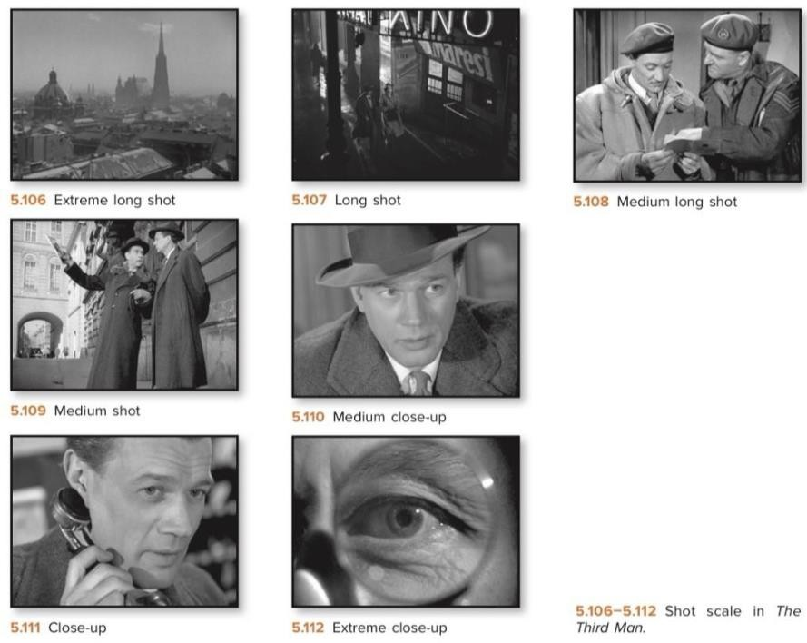

Picture 1 The Visual of Camera Distance (Bordwell et al, 2020, p. 189)

Sounds
In movies, sound is important for the audience to understand the emotion, mood and plot of the scene, “filmmaker judges what to pursue based on how they fit the overall form of the film and how they shape the viewer’s experience,” (Bordwell et al, 2024, p. 263). A film-maker can use a combination of speech,

background music and other noises to create atmosphere, build suspense and help the audience understand the scenario. “Sound is often treated as a lesser partner to the images, but we need to recognize that it can actively shape how we understand them” (Bordwell et al, 2024, p. 265). Thus music in film is not only an accompaniment to the visuals but also a storytelling device.

CHAPTER 3
EXTRINSIC THEORITICAL FRAMEWORKS

Extrinsic Aspects

This thesis implements theoritical frameworks through Weber in developing a conceptual perspective. Weber's theory is the framework for the present study to identifying the structural logic of capitalist rationalization, pointing to its wide cultural consequences where indirect resistance in modern life can be happened which is portrayed in Materialists (2025). The framework shows how capitalist ideology shapes both the outside social world of humans and the inside emotional world. Moreover, it merged the structure that analyze how romance, and emotional life more generally, it can be represent and resistant to capitalist rationality.

The History of Capitalism in America
Max Weber discussed in term of capitalism in America, not only see capitalism as an economic system but historically defining capitalism in America within a particular cultural context that follows moral and religious ethical standards. The religion spirit that linked to the modern capitalism is based from the action through a system that valued hard work and rational profit seeking.
The rational and ascetic element of Pietism outweighed the emotional, the ideas essential to our thesis maintained their place. These were: (1) that the methodical development of one’s own state of grace to a higher and higher degree of certaunty and perfection in terms of the law was a sign of grace and (2) that ‘God Providence works through those is such a state of perfection’, i.e. in that He gives

them His signs if they wait patiently and deliberate methodically, (Weber, 2005, p. 84).
However, Weber argues that this spirit exist before capitalism as a system developed, “in the country of Benjamin Franklin’s birth (Massachussetts), the spirit of capitalism (in the sense we have attched to it) was present before the capitalistic order,” (Weber, 2005, p. 20). In America, through its history of Puritan New England, economic behavior was functioned through religious beliefs that defined worker behavior based on moral pursuits and dyciplined labor as ethical tools. Thus, capitalism in America is defined by being a moralized system where economic success defines people from their moral worth.
In the modern of capitalism the religion beliefs which are the root of capitalism is no longer applicable where capitalism is all about business within the development of a rational bourgeois economic life. “The religious roots died out slowly, giving way to utilitarian worldliness,” (Weber, 2005, p. 119). This modern capitalism create what we called as ‘iron cage’ where individuals born and live stick to the capitalist economic system that developed asceticism to dominate wordly morality. “In Baxter’s view the care for external goods should only lie on the shoulders of the ‘saint like a light cloak, which can be thrown aside at any moment.’ But fate decreed that the cloak should become an iron cage,” (Weber, 2005, p. 123). Through this, individuals continuously live with rationalized economic demands through generation even with the absence of religious belief in modern era.

Romantic Life within Capitalist Logic

The term "romance" refers to a close connection in which two people remain committed to one another and share love and affection. According to Giddens (1992), romance is linked to a "pure relationship," which is described as "one that is entered into for its own sake, for what can be derived by each person from a sustained association with another". This suggests that romance is solely valued for the emotional fulfilment that comes from such connections.
It refers to a situation where a social relation is entered into for its own sake, for what can be derived by each person from a sustained association with another; and which is continued only in so far as it is thought by both parties to deliver enough satisfactions for each individual to stay within it (Giddens, 1992, p. 58).
However, Weber not explicitly discussed about romance rather he explained about marriage where also marriage is created from two people through romance. Through Puritans’ view, marriage is function as a tool that people have to work hard to deal with sexual desire. “For all sexual temptations as is used against religious doubts and a sense of moral unworthiness: ‘Work hard in your calling’,” (Weber, 2005, p. 105). Marriage is not about intimacy but it is about to control the sex desire through work hard, hence, sex is acceptable if the purpose to served God in having children and reproduction. This where the institution of family shaped as responsibility to provide a decent life. “St. Paul’s ‘He who will not work shall not eat’ holds unconditionally for everyone. Unwillingness to work is symptomatic of the lack of grace,” (Weber, 2005, p. 105). There is the contradiction between romance and capitalism view on relationship between two people.

The Socio-Economic Conditions

The phenomenon about marriage through Cherlin's (2004) theory that marriage's character shifts from being a "cornerstone" to a "capstone." The "cornerstone" theory focuss was that marriage marked the beginning of one's own family life and the transition into maturity. Marriage has changed from being a cornerstone to a capstone in today's culture, where people look forward to it after completing tasks like obtaining degrees, finding employment, purchasing real estate, and achieving financial independence. “Marriage’s place in the life course used to come before those investments were made, but now it often comes afterward. It used to be the foundation of adult personal life; now it is sometimes the capstone,” (Cherlin, 2004, p. 855). Therefore, marriage is viewed as a consequence of economic independence rather than just a means of earning a living. This development indicates shifts in how marriage is viewed in contemporary America. Marriage is no longer viewed as the cornerstone of adulthood, but rather as something people attain after reaching significant achievements, such as financial security, career growth, and education. Additionally, people are expected to exhibit financial security and stability before getting married because marriage is often viewed as a sign of personal success. These expectations show that marriage has been linked to economy in contemporary capitalist society. As a result, marriages are frequently founded on more than just love and passion; they are also influenced by economic considerations and other issues that people must take into account while getting married. For example, individuals take into account their financial stability when

getting married and try to determine whether they can provide a financially secure future to their children.

CHAPTER 4 RESULTS AND DISCUSSION

Intrinsic Aspects

Some of the intrinsic characteristics of Materialists (2025) can be examined to determine how capitalism is portrayed. These factors include the theme, character, place, conflicts, and storyline. The film defines modern romance as an affair that is influenced by social and economic issues, where a person's choices for a partner are influenced by their wealth and social standing. The three characters of Lucy, Harry, and John are used in the film to illustrate the realities of class differences and the unequal possibilities brought about by capitalism. Furthermore, the urban environment of New York City and struggles over wealth and social standing demonstrate how capitalism drives romance.

Theme

The movie theme is modern romance, where romance relationship influenced by rapid development of technology and globalization. In consequences, romance becomes something complex for individuals to achieve or even romance relationship is not a goal for some individuals. There are too many considerations on romance relationship within modern people; individualistic, personal growth, career, financial etc those are affect indivuals view on romance relationship.
Harry: So, you must know a lot about love Lucy: I know about dating
Harry: What’s the differences?
Lucy: Dating take a lot of effort, a lot of trial and error, bags of risk, pain. Love is easy
Harry: Is it? I find it be a most difficult thing in the world
Lucy: Not because we can’t help it, I just walk Cinderella and sometimes

Harry: Are you kidding on me?
Lucy: Definetely not, but I do thing that you would be a great match for a lot of our clients. We need more straight men in New York City. You look about 6” tall, how about money do you make?
Harry: Just straight up like that?
Lucy: I Make 80$ grand a year before taxes do you make more or not? Harry: More
Lucy: I know.
(Materialists, 2025, 1:20:03 — 1:21:10)

This dialogue between Lucy and Harry represents how complex romantic relationships in modern life that considering many things in life aspects to benefit individual which is the characteristic of the capitalism where individual value connected to economic, as seen on where Lucy asked about Harry’s income. This dialogue also the opening of the movie between Harry and Lucy where the story of romantic modern life begins.

Character and Characterization
      - Lucy
Lucy is a successful matchmaker in New York who works for the upperclass people those who are looking for life partner. She rised from poor family, yet, succeeded to be a career woman with her character that has rational values. Live in New York as capitalist society, she is a woman that hold to the capitalist ideology.


Picture 2 Lucy Talking about Her Perspective with Her Colleague (Materialists, 2025, 10:15 — 12:29).

In this scene, with long-shot and medium long-shot, Lucy talked to her colleague after they celebrated Lucy’s party achievement as a matchmaker with her succesfull on 9th wedding over her clients. She told her friend that for the future she planned to die alone or marry with a super rich guy, it reflects Lucy as American woman who influenced by capitalism ideology standards to marry a rich guy on purpose to fulfill her needs or she won’t nothing.

Harry
Harry is a finance man who works under his family company in private equity. His character as a decent man, kind, and has no bad historical experience with his parents and family shows the emotional security as born rich in capitalist society. In matchmaking industry, he called as “unicorn” because he is perfect and he could be the person of expectation in matchmaking market as a guy who is in every women’s dream.


Picture 3 Harry Greetings the Exclusive Guests (Materialists, 2025, 12:37 — 12:29)
The scene with long-shot cinematic shows Harry on his brother royal wedding party where upperclass in New York spread around the party. It reflects Harry’s connection and his class identity as a rich guy who is born rich. This reflects capitalist society when individual born rich they got privileged from their parents

and grandparents who were work hard to gain benefit not only for themselves but also for the next generation.

John

John is Lucy’s ex who works in a catering company as a staff. He is the opposite from Harry; rised poor, born poor, and live poor. Even though he is poor, he is a kind guy who experienced a hard life altogether as Lucy experienced.


Picture 4 The Way John Lives (Materialists, 2025, 49:08 — 50:55)
The scene with medium long-shot shows John woke up from his bed in his room and it also shows the way he lives in a narrow flat. It reflects his class as a poor guy who live in the middle of New York City. Compared with Harry, John represents the class gap that is the effect of capitalism.

Settings
      - Setting of Place: New York City

Setting of place Materialists (2025) placed in New York City as metropolitan area. It depicts American society with its hustle culture and rush hour. Additionally, New York City is familiar with its famous yellow cab.


Picture 5 Lucy in A Yellow Taxi Cab (Materialists, 2025, 1:23:06 — 1:23:16)
In this extreme close-up scene, Lucy was leaving from Harry’s apartment to come over to John’s place. She took the yellow taxi cab which is the icon of New York City. It strongly represents the setting of place of the movie that located in New York City which is the city of capitalist society.

Setting of Time

In the movie setting of time is not explicitly stated by its specific year but it could be seen through the phone that Lucy used. It represents modern life people nowadays, about 2024. She used iPhone 16 pro with black titanium color.


Picture 6 Lucy Holding Her Phone
(Materialists, 2025, 1:48:50 — 1:49:42)
This medium shot scene shows Lucy as the main character is on calling with her work partner while waiting on her boyfriend, John, to come. When he arrived, she turned off the call and her move showed the ultra wide camera with deep black titanium color that seen on iPhone 16 pro which the phone released on 2024.

However, this iPhone that Lucy used is one of luxury goods which is symbol of capitalism.

Conflicts

      - Internal Conflicts
        - Personal Conflict with A Client

Lucy works in matchmaker industry which she met many different people with different backgrounds. Her journey in her career is not easy, yet, the sexual harassment issue which conducted by her client to the other client as victim makes her think more about her career and her life.

Picture 7 Lucy’s Internal Tension in Workplace (Materialists, 2025, 57:03 — 57:38)
The long-shot and extreme close-up scenes show Lucy’s conflict within herself, when she got shocked and cried in the toilet after she informed that one of her client tangled into sexual harassment case. She was feeling guilty about what she did to match her client with the other client who is sex offender, the effect of capitalism when people tend to objectivied anything including indvidual. This conflict made her decide to take a break from the office.

Conflict from The Past Relationship

John is Lucy’s ex-boyfriend who is poor enough to always calculate almost everything. She broke up with him because she was not happy with the situation of

being broke and often got into a quarrel with John just because they did not have enough money to afford something they wanted.


Picture 8 The Flashback when Lucy and John Broke Up (Materialists, 2025, 31:54 — 33:42)
The long-shot and medium long-shot scenes show that Lucy got flashback long times ago when she involved in argument with John in the middle street of New York. She was get out from John’s car dramatically, she was expressing that she was done with their relationship.
John: I’m sorry, alright, I just don’t have any money and I forgot Lucy: What? What did you forget? That you love me?
John: Please back in the car
Lucy: I don’t want to hate you because you’re poor but right now I do and I hate myself
John: You know how hard it is to make you happy? And I want you to be happy and I’m trying, really am
Lucy: I know, and almost enough to make me happy. I wish that I didn’t care if we ate from halal cart on our five years anniversary but I do. And how much ever you hate me, I hate myself.
John: I don’t hate you
Lucy: You do, and it’s not because we’re not in love it’s because we’re broke (Materialists, 2025, 1:20:03 — 1:21:10)

This dialogue shows the tension between Lucy and John when they were still together. They fights over money because both of them are broke and poor and it’s make the relationship didn’t work out. New York is an expensive city the line where Lucy said, “I wish that I didn’t care if we ate from halal cart on our five years

anniversary but I do. And how much ever you hate me, I hate myself,” shows the gap between the society lifestyles that Lucy wished for and the reality she got. It makes them suffered enough with the capitalist society standards for only living.

External Conflicts

On the clients’ wedding day, Lucy got problem from the woman bride who won’t show up to the wedding hall. She locked herself in her room then Lucy came to solve the problem. Lucy found out the main problem is she scared about her sister jealousy over the man she would marry. This shows the capitalism through individual competition where individuals want to be as best as they can through society lens, and having a perfect partner who is satisfy the ideal standard of society is one of the characteristics, it caused jealousy despite in siblings.


Picture 9 The External Conflict within Lucy’s Client (Materialists, 2025, 14:37 — 18:51)
The long-shot scene shows Lucy succeed solve the problem with reassure her client to continue the wedding as a bride. Otherwise, she got lesson from this occurrence that is when woman decided to marry a man because the man makes her valuable as individual. This conflict influenced her life decision in the future to go on a date with Harry.

Plot
In the beginning of Materialists (2025), where it shows Lucy the succesful matchmaker that lead her 9th of married couple in the company. She talked with her colleague after the party on the balcony of office talking about her current client struggle.
Lucy: And she’s my favirite client right now. I mean she’s entitled like everyone but she’s sween and realistic. She’s not craze. She’s a nice girl. There’s gonna be a guy out there who wants a nice girl.
Colleague: What about Mark. P? He’s okay.
Lucy: I pitched him already. She’s afraid he’s not actually 5’8, and I’m like “can we please not care about couple inches right now? because you’re about to die alone.”
Colleague: You know, there’s a surgery for that.
Lucy: For dying alone?
Colleague: For getting taller up to 6 inches. You break your legs and extend it, let the bone heals it all.
Lucy: That’s a game changer Colleague: It cost $200K.
Lucy: 6 inches can double a man’s value in the market. If you can afford it, It’s definitely worth the investment.
Colleague: What they just saying, you’re not ugly you just don’t have money.
(Materialists, 2025, 10:58 — 12:03)

Through this conversation shows about how someone’s look is really matter in dating market. This is how capitalism affect the society, even someone’s body and personal worth are having a high cost of value. On the other hand, in the middle of story, where Lucy finally to make a decision to date with Harry which with him she would get the bigger opportunity to make her life better with his money and class, she found out Harry had a surgery on his legs.


Picture 10 Lucy Findings on Harry

(Materialists, 2025, 1:14:55 — 1:16:17)
On these extreme close-up scenes, Lucy found out two things; she found the ring from Harry’s luggage to marry her and she found out Harry’s surgery scars on his legs. Her situation at that time is on confussion feeling to continue the relationship with Harry or not, and her founding strengthen her decision to not continue the relationship with him. She realized that he really designed himself for the dating market to attract women. He is exactly the perfect guy for the dating market and he is very fulfilled the society expectation on individual.

Extrinsic Aspects

The Rationalization in Modern Capitalism
The rationalization of capitalism is based on logic and calculation rather than human’s emotions and feelings which is applied in modern economic systems. “Now this process of rationalization in the field of technique and economic organization undoubtedly determines an important part of the ideals of life of modern bourgeois society,” (weber, 2005, p. 36). People in modern era must to applied rationalization in order to survive the world where logic have to keep run. Also, rationalization the one that turns work into obligation for people. This rationalization is processt that shaped capitalist system.
However, in modern society, capitalism is no longer related to religion beliefs, even though the roots are from the Puritans movements but in practices it didn’t bring up about God rather asceticism undertook it. People in modern capitalism society are they who already have stucked with the capitalist system

where they have to follow the practices in eveyday life in term of work as an obligation not only practices meaning. This phenomenon called as ‘iron cage’ where people stick with the capitalist system as the cage and material goods have a big power in human’s life.
Since asceticism undertook to remodel the world and to work out its ideals in the world, material goods have gained an increasing and finally an inexorable power over the lives of men as at no previous period in history (Weber, 2005, p. 124). This work as an obligation for people shaped dissatisfaction among people who work restless to gain money and wealth even they had been enough money. This obsession of work and business are consequences of capitalism itself. As the wealth gets more and more it becomes inherited benefit across the generation for those individuals are privileged to be born wealthier.
If you ask them what is the meaning of their restless activity, why they are never satisfied with what they have, thus appearing so senseless to any purely worldly view of life, they would perhaps give the answer, if they know any at all: to provide for my children and grandchildren (Weber, 2005, p. 32).
Rationalization is not only affect the economic sphere but also in general of aspect of life including romantic life. “Hence rationalizations of the most varied character have existed in various departments of life and in all areas of culture,” (Giddens, cited in Weber, 2005, p. xxxix). As in Materialists (2025), rationalization is applied into choosing life partner where marriage or romantic relationship prioritizes calculation over benefit within individual rather than the emotional

feeling. Lucy as the main character in this film decided to date a very rich guy named Harry.
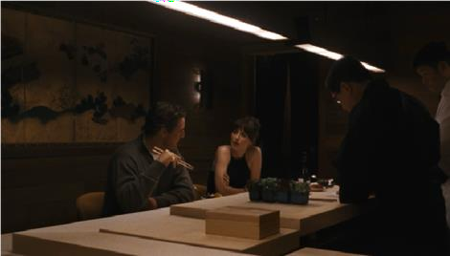
Picture 11 Expensive Dinner Harry and Lucy (Materialists, 2025, 37:07 — 39:12)
This scene shows Lucy and Harry are having a dinner in expensive restaurant in New York City. They’re just dating, to spent their times Harry often to bring Lucy to expensive restaurant to get to know each other deeper. Harry and Lucy are from different social classes; Harry born rich while, Lucy the opposite. Dating Harry is very rational for Lucy besides he’s very wealthy, work for private equity in family company, but he also has a good personality background that will benefit Lucy not only in material goods but in many aspects of life.
As modern people who affected not only by capitalism but also by technology and globalization where information and knowledges are easily acessed, in choosing life partner is one of big decision to decided the better or worse life. Lucy is one of luckiest one because she met someone like Harry who is meet the criteria of social expectations which is choosing Harry as a life partner is a rational decision.
Lucy: You can do better than me Harry: Can I?
Lucy: In my life of work, I met hundred desireable high quality men but you’re what we call in my industry a ‘unicorn’ impossible fantasy. Your

brother was a unicorn too. The reason my client not lower their expectations is because against all that’s man like you actually exist
Harry: There’s something wrong with me
Lucy: You’re perfect, you’re smart, have ideal income, ideal education, ideal lifestyle, ideal height, you’re good looking, you have a great body, you’re charming, you were born rich, raised rich, and you’re still rich. You own a penthouse in Tribeca. You can take a girl to a restaurant like this, it’s not even special ocassion. You don’t have drug habit or call girls habit. You even know how to cut your hair and how to dress. You have taste. You’re 10 out of 10 in every category. A complete package.
(Materialists, 2025, 41:03 — 42:35)

This dialogue shows Lucy through her career as matchmaker that she knows so many details what society expected in looking for a partner, and she finds the perfect one. Rationalization is calculating anything and she calculated many things through Harry as an individual and he is the perfect calculation not only by personal view but also through social view. When Lucy said, “You’re perfect, you’re smart, have ideal income, ideal education, ideal lifestyle, ideal height, you’re good looking, you have a great body, you’re charming, you were born rich, raised rich, and you’re still rich—,” it showed the rationalization that Lucy found in Harry as his individual value, where it is highly infuental in society for having a perfect partner.
On the other hand, Lucy and Harry are represent what ‘iron cage’ defined. Although, Lucy and Harry are from different social class but both of them were born and live in modern era where capitalism has been already worked as an unchanging system that practiced by people in the world.
In consequences, Lucy as a capitalist individual she calculates anything including choosing life partner. The individual growth within character Lucy is clearly affected by capitalist culture, she is the individual product of capitalism.

Nevertheless, Harry is also the product of capitalist system by served himself as someone who is fulfilled the social expectations to be an almost perfect individual. In highlighting Harry, he represents of a man who is born from wealthy family because their parents earn money not only to survive or fulfill their needs but something more than the basic needs. The restless work behavior that could earn money and wealth more than enough and it could inherited to their children, Harry
is a child who got wealth through his parents.

Romantic Life in Capitalist Logic as The Cultural Contradiction
In capitalist romantic life, family or marriage is not based or the original to shaped capitalism, nevertheless, it is one thing that necessary on developing rational economic system. Where family as institution to supports work discipline in term of capitalism. The basic of capitalism is rationalization that logic is have to be more practical rather than emotional feeling, this linked to romantic life in capitalist logic where marriage is not valued for love despite marriage without love could be a sexual control that supports individual to work harder rather than having sex that is inadvisable. “For sexual intercourse is permitted, even within marriage, only as the means willed by God for the increase of His glory according to the commandment, ‘be fruitful and multiply” (Weber, 2005, p. 105). Also, marriage and sex are tools for reproduction.
Socioeconomic considerations have a significant impact on marriages and love relationships in modern American society. Many people prefer to be financially comfortable before making long-term commitments due to the high cost of living, costly education, economic disparity, and unstable labour market. As a

result, marriage is now seen by many Americans as the outcome of their socioeconomic achievements rather than the beginning of maturity.
In Materialists (2025) practical romance at the end of the movie or the final decision that main character made is out of the line of the capitalist logic in term of romance and marriage which through inner resistance. Before Lucy made decision to back to his poor ex he broke up with Harry first with reason that she didn’t love him which is irrational reason to broke up with a perfect guy like Harry. Although, she is a capitalist woman with rational mind, that doesn’t make her to lose her sense as someone who lives in capitalist society.
Lucy: I don’t think you and I are a good match Harry: It’s because the surgery?
Lucy: No, knowing that just makes me feel like I got actually know you Harry: Then what? It’s really hard for me to feels not about the legs
Lucy: It’s not, when I realized what you had done it make me feel exactly how I felt about you before
Harry: Which is what?
Lucy: I’m not in love with you and you’re not in love with me. And there’s no amount of money that can fix that
Harry: But we’re such a good match. You’re exactly what I am looking for and I know I can make your life better
Lucy: Harry, you don’t wanna marry me, you want do business with me just like I wanna do business with you
Harry: Isn’t marry a business deal?
Lucy: Yes, it is but love has to be on the table (Materialists, 2025, 1:20:03 — 1:21:10)
This dialogue proof that Lucy decision to broke up with Harry is irrational decision because it is not incompatible with capitalist logic. She prioritized love over money. On the other hand, Harry stilll think rational that marriage is business wich is aligned with rationalization of capitalism where marriage is institutional to support discipline and hardship.

On the other day, Lucy received John proposal and decided to marry with him. She accepted that she will live poor and broke with John as long as she with him and this is irrational decision that could be called as a resistance. The inner resistance in capitalist logic that Lucy did on chose John over Harry. Not until then, she also resigned from her work when she already got promotion with crazy sallary offers.
Lucy: I’m sad you’re leave, V
Violet: Me too, they really need me in London office and I’m calling you first all of the Ador girls because the CEO ask me to who should be as step up and accommodate to New York head. And I said absolutely has to be you Lucy: Me?
Violet: Yes, you’re gonna get promotion, what’s so funny? Lucy: Well, I was goint to handed my resignation later tomorrow Violet: No you won’t
Lucy: Yap, I have printed out and everything Violet: You can’t quit, but what you do instead Lucy: Honestly, maybe marry someone who poor Violet: I don’t know what are you talking about (Materialists, 2025, 1:47:57 — 1:48:54)
Through this conversation between Lucy and the chief of company, Violet, is actually shows the redefinition of romance, where Lucy is prefer John who is her broke ex which has historical event with and has more emotional attachment with. Compared with Harry, a wealthy boyfriend, who is someone who was known by Lucy through matchmaker industry where she works that led her to him which less has emotional attachment with. In this situation, Lucy put aside the perfect ideal of partner rather she choose someone who can fulfill her emotional needs, no matter how broke he is, instead she tried to enter his world with living as a broke and leave her potential career. Furthermore, Harry as someone who she knows through matchmaker which is common system in U.S society to find perfect partner in

modern life and he is the perfect ideal with high profile, can’t determine he’s the
right one to fulfill the emotional needs and romantic love.
John: You asked me how I could love you. (Lucy nods).
John: just do.
John: It’s the easiest thing.
Lucy: I love you too. More than you know.
You’re the only reason I know I’m capable of love.
(They just stare at each other).
John: I’ve been doing some math.
Lucy: Yeah?
John: Yeah, and I’m ready to make an offer. Lucy: Okay.
John: This is the offer: I love you now, as I loved you before, and I’ll love you til I die. It’s a lifetime guarantee.
John: And I won’t forget it like I used to, even when things are shit - I’ll make a calendar item every day reminding myself that I love you.
John: I will be your certainty. That’s my final offer, and you can’t negotiate, only because I have
nothing else to offer you. (Lucy nods).
Lucy: It’s a deal.
(Lucy extends her arm. John takes her hand and shakes it). (Materialists, 2025, 1:45:27 — 1:45:44)
This dialogue is a proof the reason why Lucy choose John over Harry while she lives in metropolitan, New York City, when everything is expensive. This conversation happened after she called by her ex-client, Sophie, after an incident a man that she macthed to Sophie is actually a bad person on that day he came to Sophie’s apartment to invade her. After the accident, Lucy realized that materialist things in relationship is not the main goal, however, love on the table for the romantic life is necessary not only to fulfill emotional needs but also to build trust and safety, and John offered it to Lucy for her life-time guarantee. Furthermore, she could still live in expensive city even though she has too lowered her standards of living.

CHAPTER 5 CONCLUSION

This thesis has analyzed the representation of romance within the logic of capitalism, as proposed by Materialists (2025), and it focused on redefine of the logic of romantic choice as a form of resistance with the theoritical framework of capitalist rationality that propounded by Max Weber on capitalism and the rationalization process on modern capitalism as an ultimate framework that not only regulates the economy but also the domains of love and emotions based on calculation, efficiency, and materiality.
By its intrinsic components of narrative structure included, theme, settings, characters, conflicts, and plot, Materialists (2025) shows how capitalism has a role as a tacit, emphasized presence which influences individuals’ actions. Lucy, as the main character, represents the rational, purified subject of capitalism: she considers relationships in terms of earnings, life, and compatibility, linking with Weberian ideology wherein individuals exist under the “iron cage” of economic pressures. Harry symbolizes the perfect character of a capitalist, with inherited riches and prestige satisfying social demands of what constitutes a “perfect” partner, and John qualifies economic insecurity and emotional truth. However, the movie not only illustrates the capitalist logic; it resists that logic. Lucy's decision to pursue John and leave the lucrative profession goes against the logic of capitalism, which values intimacy and partnership. Weber's concept of rationalization and Lucy’s defiance of that rationalization explain how Lucy refuses to be bound by the rules of a rationalized and mechanized capitalist system that reduces love and personal

43

interactions to mere transactions. Thus, love becomes not the function of capitalism, which means certain things, especially pleasure and profit; rather, love becomes the location or zone where that logic may be subverted.
Last, Materialists (2025) presents a cultural critique of contemporary romance through a reading of the tension between capitalism and the realities of emotions. The movie presents a viewpoint where capitalism invades the space of romance. At the same time, it gives a message where romance can’t be reduced to the reality of capitalism. This means there is a space where romance gives meaning to living despite the reality of capitalism. This thesis presents a contribution in understanding romance and capitalism through a media perspective where popular film gives meaning to new visions of romance.

REFERENCES

Abrams, M. H., & Harpham, G. G. (2013). A glossary of literary terms (11th ed.).

Boston, MA: Wadsworth Cengage Learning. Aristotle. (1908). Metaphysics (W.D. Ross, Trans.).
Ayala, J. D. P., & Villanueva, L. B. (2025). A Marxist analysis of the movie Third World Romance. Diversitas Journal, 10(1), 411–
422. https://doi.org/10.48017/dj.v10i1.3157.

Baumeister, R. F., & Leary, M. R. (1995). The Need to Belong: Desire for Interpersonal Attachments as a Fundamental Human Motivation. Psychological Bulletin, vol. 117. The american Psychological Association. https://share.google/4J5OXf2Hy7raWoQbL.
Bordwell, D., & Thompson, K. (2020). Film art: An introduction (12th ed.).

McGraw-Hill Education.
Cherlin, A. J. (2004). The deinstitutionalization of American marriage. Journal of Marriage and Family, 66(4), 848–861.
Chintya, Y. (2020). Max Weber’s concept on social class as reflected in Crazy Rich Asians movie [Undergraduate thesis, Diponegoro University].
De la Pava Velez, B. (2017). Celluloid love: audiences and representations of romantic love in late capitalism (Doctoral dissertation, London School of Economics and Political Science).
Farooqui, J. (2024). Women, representation, and romance: The magic space of What’s Love Got to Do With It?. Journal of International Women’s Studies, 26(5).

44

George, M. W. (2008). The elements of library research. Princeton University Press.
Giddens, A. (1992). The transformation of intimacy: Sexuality, love, and eroticism in modern societies. Polity Press.
Holmes, B. M. (n.d.). In search of my “one-and-only”: Romance-oriented media and beliefs in romantic relationship destiny. Heriot-Watt University.
Illouz, E. (1997). Consuming The Romantic Utopia. University of California Press.
Illouz, E. (2007). Cold intimacies: The making of emotional capitalism. Polity Press.
Jusrianti, Rasiah, & Arman. (2024). The formula of romance in The Redeeming Love (2022) movie. ELITE Journal, 9(1).
Kartika, Y. Y., Saehu, A., & Pramita, A. (2022). Fantasy formula in romance movies: Beauty and the Beast (2017) and Aladdin (2019). SALEE: Study of Applied Linguistics and English Education, 3(2), 282–
295. https://doi.org/10.35961/salee.v3i2.508.

Mentis, P. (2019). Love Them, but Get Them to Leave You-Neoliberal Ideals of Love, Romance and Family Life Imprinted on Contemporary US Cinema. Romance and Family Life Imprinted on Contemporary US Cinema (March 7, 2019).
Pew Research Center. (2020, February 6). Americans’ personal experiences with online dating. Pew Research Center.

Pew Research Center. (2019, November 6). Marriage and cohabitation in the
U.S. Pew Research Center.
Pratiwi, R., Wahyuni, S., & Ananda, L. (2021). Sara Mills’ critical discourse in Mother movie: Deconstruction of meaning by Sara Mills on femininity and women’s resistance.
Saragih, E.I.B. (2022). Indonesian Women Resistance as Eastern Representation in Darah Garuda Movie [Undergraduate Thesis Gadjah Mada University].
U.S Census Bureau. (2025). Families and living arrangements. U.S. Census

Bureau.
Weber, M. (2005). The Protestant ethic and the spirit of capitalism (Parsons. T, Trans. Giddens. A, Introduction.). Taylor & Francis E-Library. (Original work published 1930) .
Zelizer, V. A. (2005). The purchase of intimacy. Princeton University Press.

