

**THE ENGLISH USAGE AT THE FRONT OFFICE OF *JAVA VILLAS***

# BOUTIQUE HOTEL AND RESTO YOGYAKARTA

**FINAL ASSIGNMENT**

# A Partial Fulfilment of the Requirements for the English Diploma III Degree

**By:**

Agustin Putri Wijayanti 40020118060019

# THE ENGLISH DIPLOMA III PROGRAM VOCATIONAL SCHOOL DIPONEGORO UNIVERSITY SEMARANG

**2021**

# APPROVAL

Approved by Supervisor:



(Ariya Jati, S.S., M.A.) NIP 197802282005021001

# ACCEPTANCE

Accepted by Board of Examiner

English Diploma III Program

Vocational School Diponegoro University

Day :

Date :

Chairman:



(Lenggahing Asri Dwi Eko Saputri, S.Pd., M.Pd.)

NIP 199006122018072001

Member:

(Ariya Jati, S.S., M.A.) NIP 197802282005021001

# ACKNOWLEDGEMENT

Foremostly, the writer would like to thank Allah SWT for giving her strength, health, and patience. Only because of this the writer could complete this Final Assignment entitled “The English Usage At The Front Office of *Java Villas* Boutique Hotel and Resto Yogyakarta”. In this occasion, the writer would like to express her special thanks to the following people:

1. Prof Dr. Ir. Budiyono, M. Si, the Dean of Vocational School Diponegoro University;
2. Dwi Wulandari, SS, M.A, the Head of English Diploma III Program, Faculty of Humanities, Diponegoro University;
3. Ariya Jati, S.S., M.A., and Lenggahing Asri Dwi Eko Saputri, S.Pd., M.Pd., her Academic Supervisor and Academic Examizer who always guided patiently in this final project’s process,
4. All the lectures of the English Diploma III Program Vocational School Diponegoro University who teach and giving motivation,
5. All the staff of the Faculty of Humanities and Vocational School Diponegoro University for helping the writer during the college period,
6. Verseveranda Martini, the administrator of the English Diploma III who assist the writer since the first semester,
7. Owner *Java Villas* Boutique Hotel and Resto Mr. Bobby Ardyanto, who always help the writer since internship program until this day,
8. Operational Manager *Java Villas* Boutique Hotel and Resto Mr. Triyanto who always help the writer since internship program until this day,
9. All staff of *Java Villas* Boutique Hotel and Resto, especially staff front office of Java Villas Boutique and Resto, Mr. Rosi Fatulloh who teach the writer during the internship in Java Villas Boutique and Resto,
10. Lovely parent, *Papah*, and *Mamah* who always being the best support system and give love, spirit and financial support and pray for the writer,
11. The other support also comes from Diah Sulistya, Dinda Fany, and Risma Salsabila, thank you for always encouraging the writer all the time.
12. Naufal Anas T who became the writer’s place to share happiness and sadness,
13. Rizki Arsita, Teduh Widayani, Avita Bella, and my senior sister Rani Nur Annisa who always cheers the writer’s during wrote this final assignment,
14. The writer friends in English Diploma Program for the unforgettable memories during three years together as classmates,
15. All friends and people who cannot be mentioned one by one, thank you for helping the writer until this time,

Semarang, 13 Agustus 2021

The Writer, Agustin Putri W

# ABSTRACT

*Java Villas* Boutique Hotel and Resto is one of the hotels located in the center of Yogyakarta. This hotel is visited by many foreign tourists because of its unique hotel interior and comfortable atmosphere, so the use of English is important to make it easier for international tourists to communicate with the hotel staff, especially the Front Office department staff. The front office department must be proficient in English for convenience and communication with the guests. This study focuses on the use of English in the Front Office to facilitate staff and foreign tourists at *Java Villas* Boutique Hotel and Resto Yogyakarta. Data collection methods used in this study were observation and interviews. The final result of this report is that the Front Office staff who are proficient in English can increase the comfort of foreign tourists visiting because it is easy to communicate with the staff, and it can add value to the hotel.

Keywords: *Java Villas* Boutique Hotel and Resto Yogyakarta, English usage, and Front Office Department

# TABLE OF CONTENTS

TITTLE i

APPROVAL ii

ACCEPTANCE iii

ACKNOWLEDGEMENT iv

ABSTRACT vi

TABLE OF CONTENTS vii

CHAPTER I INTRODUCTION 1

* 1. Background of the Study 1
  2. Scope of the Study 2
  3. Aims and Advantages of the Study 3
  4. Methods of Collecting Data 3
     1. Observation 3
     2. Interview 4
  5. Organization of the Report 5

CHAPTER II LITERATURE REVIEW 6

* 1. Definitions of A Hotel 6
  2. Definitions of Front Office 7
     1. The English Usage in the Front Office 8
  3. The Importance of English Language in Tourism 8

CHAPTER III DISCUSSION 11

* 1. Profile of *Java Villas* Boutique Hotel and Resto Yogyakarta .11
     1. Java Villas Boutique Hotel and Resto Facilities 12
     2. Scope of Java Villas Boutique Hotel and Resto 13
     3. The Organization Structure of *Java Villas* Boutique Hotel and Resto 15
  2. The Use of English By The Front Office of *Java Villas* Boutique Hotel and Resto Yogyakarta…………………………………………………………………………………….17
  3. The Problems in Using English at The Front Office of Java Villas Boutique Hotel and Resto…………………………………………………………...………………………………19
  4. Solutions To Come for The Front Office of Java Villas Boutique Hotel and Resto 20

CHAPTER IV CONCLUSION 24

* 1. Summary …….24
  2. Suggestion 24

REFERENCES 25

APPENDIX 27

# CHAPTER I INTRODUCTION

# Background of the Study

According to Bagyono (2012) the Front Office comes from the English words "front" and "office". In the context of the definition of a hotel, the hotel front office is a department in the hotel which is located at the front. The Front Office is an important part of the hotel, because what guests see for the first time when they are in the hotel is the Front Office. Therefore, the Front Office must create a good first impression to the guests by treating them well, and the front office must know all information related to the hotel to answer questions or provide information to the guests. The Front Office has important duties and functions, such as selling rooms, or, it can be called, renting rooms at the hotel to guests who come. In the hotel, it is the main function and task of the Front Office; things related to these tasks include receiving room orders; receiving guests’ orders who come directly (walk in guests); handling guests who have previously ordered (check ins); check outs; doing guest data collection; and determining which rooms will be used by the guests. In addition, the duties and functions of the Front Office are to deliver or answer all questions asked by the guests regarding hotel information, including all hotel service products and all facilities provided by the hotel. The Front Office must also compile a clear hotel room status reports and update the reports at any time in order to coordinate room availability with other departments, then record all finances from hotel guest transactions, such as room rental payments, cash or non-cash or deposits, compile a history of guest arrivals, and receiving all incoming communications or messages, either by telephone, internet, email, and so on. The Front Office cannot be separated from the world of hospitality as well as from that of *Java Villas* Boutique Hotel and Resto.

*Java Villas* Boutique Hotel and Resto flawlessly combines Colonial Elegance with Traditional Java style. The building is perfectly located on the central of the tourists’ village at Jl. Gerilya MG III/ 460 Prawirotaman 2, Yogyakarta, according to [javavillashotel.com .](http://www.javavillashotel.com/) Because Java *Villas Boutique* Hotel and Resto in Yogyakarta, which is also known as a tourist destination city, functions as a support city for tourist destinations, *Java Villas* Boutique Hotel and Resto needs to perform the function in the tourism industry in the city of Yogyakarta. All parts of the city need to work and synergize to the success of the tourism industry in the city of Yogyakarta in particular, or Indonesia in general. The Front Office cannot be separated from it; that is why the Front Office of *Java Villas* Boutique Hotel and Resto is important for the tourism industry in the city of Yogyakarta.

This explanation relates to the functions of the Front Office in the city of Yogyakarta. The tasks are obtained from the experience of following the job training conducted by the writer during her internship at *Java Villas* Boutique Hotel and Resto regarding the front office in general, and specifically, to get an overview on how English is spoken in the city.

It is hoped that this paper is especially useful for the campuses and the hotel. For the campus treasures are obtained not only from library books, or note books, or textbooks, but also from the hotel, which are recorded in the form of an internship report. For the hotel are inputs from the world of campus, so that the inputs also strengthen joint progress, especially in English usage for the sake of improving the quality of service in the hotel.

# Scope of the Study

The English usage at *Java Villas* Boutique and Resto is important because the hotel is a service provider, of which guests come from all over the world. Therefore, the hotel departments, especially the Front Office, must be able to speak English in order to serve the guests as satisfactorily as possible.

This studywill discuss the English usage in the hotel, and what are the common difficulties regarding the usage.

# Aims and Advantages of the Study

There are three aims of this study:

* + 1. To describe the Front Office in general;
    2. To describe the Front Office at *Java Villas* Boutique Hotel and Resto;
    3. To describe how English is used at *Java Villas* Boutique Hotel and Resto, especially by the Front Office.

There are three advantages of this study:

1. To give description about front office in general;
2. To give description about front office at Java Villas Boutique Hotel and Resto;
3. To give description how English use especially for front office of Java Villas Boutique Hotel and Resto.

# Methods of Collecting Data

# Observation

The observation technique is a method of collecting data byobserving directly on the spot. This process takes place with observations, including seeing, recording, counting, measuring, and recording events. Observation can be an activity which includes a systematic recording of events, behavior, objects seen, and other things needed to support the research being carried out. In the next stage, the researcher had to make focused observations; that is, begin to narrow the data or information needed so that researcher can find patterns of behavior and relationships which continue to occur.

According to Riyanto (2010:96), “Observation is a method of collecting data using direct and indirect observations.”

According to Kawulich (2012:150), “Observation is used in the so- cial sciences as a method for collecting data about people, processes, and cultures.”

According to Rachmat (2006:84), “The observation method is a data collection technique by conducting direct observations on the object under study.”

Observation was already done during an internship from 25 December 2020 until 25 February 2021 in *Java Villas* Boutique Hotel and Resto Yogyakarta. This study was using observation method. The researcher observed the international and domestic tourists who were staying at *Java Villas* Boutique Hotel and Resto Yogyakarta, the Front Office activity in *Java* Villas Boutique Hotel and Resto Yogyakarta, the activity of *Java Villas* Boutique Hotel and Resto Yogyakarta staff, and the environment of *Java Villas* Boutique Hotel and Resto Yogyakarta.

# Interview

This study also used the interview method to complete the data. The interview method is a method of collecting data by asking directly to the respondents. This study also used the interview method to complete the data.

Kabir (2016:275) states that in an interview a researcher can get data looked for by him/her asking individuals. The interview can be by, and essentially held, posing inquiries in the eye to eye contact to the individual or people and some cases through phone discussion. In this strategy, the researcher needs to utilize less expertise and information to get data s/he had looked for. The interview is known as a craft of getting relevant data. An interview can take as an orderly technique by an individual who enters pretty much creatively into the existence of an outsider.

According to Sudjarwo (2001:75), "The process of obtaining data for research purposes using direct questions and answers between the interviewer and the interviewee." From the text above, it tends to be presumed that an interview involves asking a question and noting to get the data. In gathering information, this study uses the interview method and interviewing the supervisor at the front office *Java Villas* Boutique Hotel, and

the Java Villas Boutique Hotel staff using face-to-face interviews.

# Organization of the Report

CHAPTER I: INTRODUCTION

Chapter I consist of Background of the Study, Scope of Study, Aim and Advantages of the Study, Methods of Data Collection, and Organization of the Report.

CHAPTER II: LITERATURE REVIEW

Chapter II consist of Definition of Definition Hotels, The Definition of Font Office, Definition of English Language in Tourism.

CHAPTER III: DISCUSSION

Chapter III consist of Profile of *Java Villas* Boutique Hotel and Resto Yogyakarta, The Importance of English Language for *Java Villas* Boutique Hotel and Resto Yogyakarta, English Difficulties In The Front Office.

CHAPTER IV: CONCLUSION

This chapter will discuss about conclusion and suggestion.

# CHAPTER II LITERATURE REVIEW

# Definitions of A Hotel

Hotels are one of the much-needed accommodations when traveling either for business or just a vacation. Hotels will much found in areas that have tourist attractions, such as the city of Yogyakarta. Usually, hotels that will be visited a lot have unique interiors or the friendliness of their staff. Therefore the hotel must make the atmosphere as comfortable as possible in terms of room and service so that many guests come to stay. Without comfort, friendliness, and uniqueness in a hotel, the hotel will undoubtedly be of little interest.

According to Widanaputra (2009:16), the definition of a hotel is a type of accommodation that is managed commercially by using part or all of the existing buildings to provide lodging, food, and beverage service facilities and other services where these facilities and services are provided for guests and the community public who want to visit.

The definition of a hotel according to the book Managing Front Office Operations from AHMA (American Hotel & Motel Association) written by Charles E. Steadman and Michael L. Kasavana (1998: 4) “Hotel can be defined as a commercially managed building by providing lodging facilities for with the following service facilities: food and drink service, room service, luggage service, washing clothes and being able to use the furniture facilities and enjoy the decorations in it.”

Sulastiyono (2011: 5) says that “Hotel is a company managed by the owner with providing food, beverage and room facilities for sleep to those who travel and can pay a reasonable amount following the services provided accepted without special agreement.”

From the above definitions, it can be concluded that Hotels are one of the much-needed accommodations when traveling either for business or just a vacation. Hotels will much found in areas that have tourist attractions, such as the city of Yogyakarta. Usually, hotels that will be visited a lot have unique interiors or the friendliness of their staff. Therefore the hotel must make the atmosphere as comfortable as possible in terms of room and service so that many guests come to stay.

Without comfort, friendliness, and uniqueness in a hotel, the hotel will undoubtedly be of little interest. the definition of a hotel is a type of accommodation that is managed commercially by using part or all of the existing buildings to provide lodging, food, and beverage service facilities and other services where these facilities and services are provided for guests and the community public who want to visit.

# Definitions of Front Office

The front office is where guests are greeted when they arrive at the hotel, where they are registered, and where they are assigned to a room. Telephone operators and other guests communication, reservation takes and tracks hotel’s future bookings usually fall under the Front Office Department.

According to Soenarno (2006:2), Front Office is one of the departments which handles the room procedures started from the reservation, receptionist, and check- in until check-out processes. It means that Front Office is the first and last impression of the guest.

According to Sihite (2000:58), the Front Office is the part or department responsible for selling hotel rooms either through previous reservations or without reservations, followed by registration and room assignments for guests. The Front Office is one of the departments in the hotel that is operationally in direct contact with guests who come to the hotel.

Sujatno (2008:30) describes that “the Front Office Department is handled the process of selling rooms, starting from booking rooms, welcoming guests, registering guests who will stay, to handling the system payment.”

From the above definitions, it can be concluded that the Front Office department is the department is at the front, precisely in the area which around the lobby in charge of sales and room reservations. The Front Office is also known as the first and the last impression of the guests. That means that this is the first and last part of the hotel. The guest will come to the hotel and will register first to the Front Office, and at the check-out time, the guests are also in touch with staff from the Front Office. It is natural if a deep

impression will be created in the Front Office. The Front Office is also an information center, and almost everything about the guest activities, such as receiving and sending goods, handling letters, hotel account payments, regarding lost items, accommodating guests’ complaints, and a place for providing information both inside and outside the hotel.

# The English Usage in the Front Office

At *Java Villas* Boutique Hotel and Resto, it is known that there are many guests who speak English because some of the guests are from abroad. Staff at the Front Office must be fluent in English and able to speak English fluently. Fluent of language is very important in establishing effective communication between speakers and recipients, between guests and front office staff.

According to Finocchiarno (1974), "language is an arbitrary system, vocal symbol which permits all people in a given culture to communicate or to interact."

By understanding the foreign language mastered by the guest, the Front Office staff will be able to describe and convey a message or information clearly using language that is easily understood by the recipient of the service. This will have an impact on the ability to provide services to guests according to their place of work.

# The Importance of English Language in Tourism

English has an important part in the world of tourism. As it is known that English is one of the international languages which is very commonly used in the world of tourism. The use of English in the tourism industry facilitates communication between tourism actors and tourists who come from all over the world.

Joseph, Munghate, Arts, & College mention 6 important parts of English in the tourism. The six roles are as follows

1. Communicative/Interactive Role

This is the most important role of English in the world of tourism. English is a intermediary of communication between tourism workers and tourists as well as between tourists. When people from various countries come and visit a tourist destination, the original language

can no longer be used because it will be difficult for others to understand. Likewise, tourism actors who are usually localpeople cannot use their local language either because the tourists will not understand it. The tourists need to use a language which both parties know. In cases like this, English has a very important role, namely as an intermediary for communication between the two parties.

1. Integrative Role

In addition to having a role as a medium of communication, English is a unifier. As is known, tourism activities involve many people from various countries, customs, cultures, races, and interests. English takes a role in integrating everyone regardless of the background of the people.

1. *Lingua*-*Franca* Role

The role of English as a *lingua*-*franca* is similar to the role of English as an intermediary for communication between parties in the world of tourism. One tourist does not only travel to one country, many of the tourists visit more than 1 country. This is a difficult thing if a tourist has to learn the language spoken in the destination country before he visits it. English is a bridge for tourists and tourism actors. *Lingua*-*franca* can be interpreted as the language of instruction or association for people who are in an environment with various languages.

1. Relation-Fostering Role

English helps humans to form or strengthen relationships among humans, especially relationships which are global in nature. In the world of tourism, English allows tourists to participate in local community activities or activities. This is because tourists can engage in dialogues and discussions with other communities using English.

1. Economic/Business

Role of globalization makes it easier for workers from various countries to come and work in a country. Even cross-border trade can be done easily nowadays. English is the medium of instruction in business, especially in the tourism business.

1. Functional Role

The last role of English in the world of tourism is a functional role. This role helps tourists and local communities in obtaining certain information, asking for help, and other functions needed in traveling activities.

# CHAPTER III DISCUSSION

* 1. **Profile of *Java Villas* Boutique Hotel and Resto Yogyakarta**

*Java* Villas Boutique Hotel and Resto is a privately owned hotel on behalf of Mr. Bobby Ardiyanto, Mr. Bobby Ardiyanto is also the owner of *Joglo Mandapa* Boutique Hotel and Merapi Tour and Travel. Java Villas Boutique Hotel and Resto is a 3-star hotel that started operating in 2017 located in the center of a tourist village, precisely on Jl. Guerrilla No. 460, Brontokusuman, Mergangsan Sub-District, Yogyakarta City, Special Region of Yogyakarta. Java Villas Boutique Hotel and Resto has an interior with a mix of modern classic and traditional Javanese styles, has 2 floors and 17 rooms with room numbers 101, 102, 103, 104, 105, 106, 107, 108, 109, 110, 111, 112, 113, 114, 115, 116,

and 117 .

*Java Villas* Boutique Hotel and Resto has 4 types of rooms, with the following explanations:

* + 1. Deluxe Double Room

Deluxe double room is a room that has one king size bed, bathroom with shower, sitting area, large table, small table, full body mirror, wardrobe, bed lamp, and is equipped with unique painting decorations.

* + 1. Deluxe Twin Room

Almost the same as the deluxe double room, the difference is that the deluxe twin room has two single size beds. Apart from that, such as a bathroom with a shower, a sitting area, a large table, a small table, a full body mirror, a wardrobe, a bed lamp, and equipped with unique painting decorations, the same as the Deluxe double room.

* + 1. Executive Room

The Executive Room is the same room as the Deluxe double room, only the size of the room is bigger. Apart from that, such as one king size bed, bath room with shower, sitting area, large table, small table, full body mirror, wardrobe, bed lamp, and equipped with unique painting decorations, the same as Deluxe double room.

* + 1. Junior Suite Room

Junior suite Room is the most special room among other room types because it has a very large size and very complete facilities, such as one king size bed, bathroom equipped with shower and bath up, hairdryer, hand dryer, seat, table large, small table, full body mirror, wardrobe, night lamp, and equipped with unique painting decorations.

*Java Villas* Boutique Hotel and Resto has spacious rooms of 30 square meters (Executive Room and Junior Suite Room) and 21 square meters (Deluxe Double Room and Deluxe Twin Room) with unique interiors and some modern and antique furniture with Javanese nuances.

* + 1. ***Java Villas* Boutique Hotel and Resto Facilities**

*Java Villas* Boutique Hotel and Resto has many facilities, namely : General Facilities of

*Java Villas* Boutique Hotel and Resto:

* + - 1. Wifi
      2. Parking
      3. Restaurant
      4. 24-hour front desk
      5. 24-hour room service
      6. Airport Transfer
      7. Meeting Facilities
      8. Swimming Pool
      9. Laundry
      10. Valet
      11. Security 24 hours
      12. Vehicle rental (motorcycle, car, bicycle)
      13. Spa

*Java Villas* Boutique Hotel and Resto Room Facilities:

1. AC
2. Television
3. Refrigerator
4. Wifi
5. Safety Deposit Box
6. Minibar
7. Hot and cold water
8. Slipper
9. Standing shower
10. Coffee and tea maker
11. Bath up (Junior Suite Room)
12. Direct dial telephone
13. Hair Dryer
    * 1. **Scope of *Java Villas* Boutique Hotel and Resto**

*Java Villas* Boutique Hotel and Resto is one of the famous hotels in Yogyakarta even though it has 17 rooms but Java Villas Boutique Hotel and Resto always has guests even during this pandemic. Java Villas Boutique Hotel and Resto is famous for tourist hotels because before the pandemic or guests who came 80% were foreign visitors from various countries, during the pandemic because there were tourists who came to Indonesia, 80% of *Java Villas* Boutique Hotel and Resto visitors were local residents

although there were still several foreign tourists who visit both those who have been in Indonesia for a long time and newcomers. *Java Villas* Boutique Hotel and Resto is located not far from the center of Yogyakarta, which is 10 minutes from Malioboro, making it easier for guests to walk around.

During the Covid-19 pandemic, *Java Villas* Boutique Hotel and Resto took various ways to promote its hotel rooms and facilities, such as making promotions for Valentine's Day packages, Chinese New Year packages, Honeymoon packages, swimming pool pack- ages, dinner packages, each of which has a different offer but true to its function. In addition, during the pandemic, every week *Java Villas* Boutique Hotel and Resto will make special promos for visitors who have visited frequently, such as special prices for 4 days 3 nights free breakfast, and special prices for guests who stay long term. Java Villas Boutique Hotel and Resto is also often chosen by several film media as a place to stay for crew and artists during filming in Yogyakarta, for example in February-March *Java Villas* Boutique Hotel and Resto was chosen by *Dapur Film* for hotels to stay for artists such as Rizky Nazar, Syifa Hadju, and Steffi Zamora.

# The Organization Structure of *Java Villas* Boutique Hotel and Resto

The Organization Structure of *Java Villas* Boutique Hotel and Resto as follows :

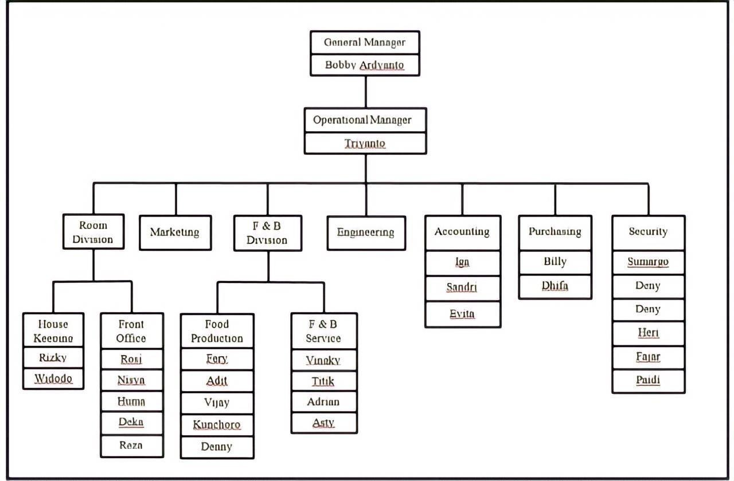

Picture 1. The Organization Structure of *Java Villas* Boutique Hotel and Resto.

Each division of *Java Villas* Boutique Hotel and Resto has a function there are:

1. General Manager

Positions which have crucial functions related to making rules, making decisions, assessing employee performance and managing hotel operating budgets. The general manager at *Java Villas* Boutique Hotel and Resto is the owner.

1. Operational Manager

A position held to control all operations of the hotel, a department which is specifically intended to maintain the quality and operation of the hotel in accordance with predetermined standards so that by providing the main benchmark all staff can work according to standards.

1. Front Office

The department that functions as receiving and sending letters, handling goods, payments hotel account, regarding lost items, accommodate guest complaints and also a place to provide all kinds of information both in the hotel and in the hotel outside the hotel. Every guest who comes to the hotel to stay, takes care of the arrival and departure of guests.

1. Housekeeping

A hotel department which functions to maintain the cleanliness of the hotel both indoors and public areas as well as cleaning various hotel facilities.

1. Marketing

This department serves to market the hotel to the public and customers so that every year there is an increase in the number of guests staying and using hotel facilities.

1. Food and Baverages (F&B)

The hotel department which functions to handle matters relating to processing, providing food and beverages and in charge of providing services to guests when eating at the restaurant.

1. Accounting

The department that functions to handle hotel administrationproblems, both expenses and financial income at the hotel. At Java Villas Boutique Hotel and Resto purchasing is part of accounting.

1. Purchasing

The part which functions to take care of the overall purchase of procurement as well as all hotel needs.

1. Engineering

The part which functions to handle maintenance and repair of all tools and machines in the hotel if they are damaged.

1. Security

The part which serves to maintain the security of the hotel and guests during their stay (24 hours).

# The Use of English By The Front Office of *Java Villas* Boutique Hotel and Resto Yogyakarta

In the world of hospitality, English is an unavoidable part of the service in communicating with guests. Of course hotel guests will not complain about the language weakness of the employees in communicating with them, but they will feel very appreciated and impressed if the employees can communicate in a very polite and appropriate language. The hotel and its employees, will get a positive value from the guests.

Java Villas Boutique Hotel and Resto is no exception, the use of english is also very important for all staff to make it easier for them to communicate with guests. The following is an interview conducted by the author with the manager and staff of Java Villas Boutique Hotel and Resto related to the use of English, especially in Java Villas Boutique Hotel and Resto.

Based on the writer’s interview with the operational manager and a staff of Front Office Department at *Java Villas* Boutique Hotel and Resto, how the use of English in the Java Villas Boutique Hotel and Resto.

“*Menurut saya penggunaan Bahasa Inggris sangat penting dalam dunia perhotelan, karena kita di tuntut agar dapat melayani tamu dengan baik dan tamu yang menginap di hotel tidak hanya warga lokal saja melainkan internasional juga jadi denganmenguasai Bahasa Inggris bias dibilang adalah suatu kewajiban, karena untuk melayani tamu dengan baik kita harus bisa berkomunikasi dengan bahasa yang dikuasai tamu tersebut agar tamu merasa nyaman dan merasa dimengerti. Terkhususnya di Java Villas Boutique Hotel and Resto yang berada di Yogyakarta yaitu salah satu pusat pariwisata, dan tamu yang datang hampir 80% turis asing sebelum adanya pan- demic Covid-19 ini, jadi Bahasa Inggris sangat diperlukan khususnya untuk bagian departemen Front Office*” (Interview with Mr.Rosi as the staff of Front Office Departement Java Villas Boutique Hotel and Resto, 2021)

Based on Mr.Rosi opinion English is very important in hospitality so that the staff can be comfortable when communicating with guests who only speak English. In addition, guests also feel more understood so they feel comfortable when they are at *Java Villas* Boutique Hotel and Resto.

*“Menurut saya pribadi penggunaan Bahasa Inggris sangat penting, karena pada jaman sekarang ini hampir semua hal menggunakan Bahasa Inggris seperti website, e-commerce, brosur, pamphlet dan masih banyak lagi, jadi Bahasa Inggris tidak hanya diperlukan untuk komunikasi dengan tamu internasional saja melainkan untuk banyak hal. Untuk Java Villas Boutique Hotel and Resto para staff seperti departemen Front Office dan F&B membutuhkan Bahasa Inggris untuk berkomunikasi dengan tamu, untuk staff marketing membutuhkan Bahasa Inggris untuk membuat website dan brosur hotel serta promo yang akan dipublikasikan, untuk saya sendiri Bahasa Inggris penting untuk berkerja sama dengan hotel lain atau perusahaan lain dari manca negara. Selain itu seseorang yang menguasai bahasa inggris mempunyai nilai tambah tersendiri dalam dunia kerja.”* (Interview with Mr. Triyanto as the Operational Manager of Java Villas Boutique Hotel and Resto.)

Based on Mr.Triyanto opinion English language is not only useful for communication but can be used for various things such as making promotions, websites, and

brochures. In addition, he also said that someone who is proficient in English also has its own value in the world of work.

# [The Problems in Using English at](https://docs.google.com/document/d/1ZCo0_zwuDxcyOVF1ylceFfIZbk4cMVzc/edit" \l "heading%3Dh.1y810tw) The Front Office of Java Villas Boutique Hotel and Resto.

As an international language, English is of course an obligation and a necessity for every individual who works in the hospitality industry. In addition to the fact that English is a universal language that is widely used as a communication standard in various parts of the world, surprisingly, it has also transformed into a symbol of professionalism, top service, and standardized quality.

But there are some problems in using English in hospitality, especially at Java Villas Boutique Hotel and Resto. Based onthe writer’s interview with the operational manager and a staff of Front Office Department at Java Villas Boutique Hotel and Resto, we will find out what difficulties the staff at Java Villas Boutique Hotel and Resto.

*“Menurut pengalaman yang saya alami, masalah yang sering saya temui dalam menggunakan bahasa inggris adalah cara mengucapkannya yang asing dilidah saya, jadi saat berbicara tidak terucap dengan jelas jadi sulit diartikan oleh orang yang mendengar.”* (Interview with Mr. Triyanto as the Operational Manager of Java Villas Boutique Hotel and Resto.)

*“Masalah saya adalah dalam menulis kata kata dan kalimat, karena beberapa kosa kata memiliki arti yang sama jadi harus sedikit menganalisa dahulu kata tersebut memiliki artian yang mana. Selain itu terkadang saya masih bingung mengartikan jika ada tamu yang berbicara karena bahasa inggris yang tamu gunakan lumayan berbeda, tamu yang seperti itu biasanya datang dari Negara yang bahasa aslinya tidak bahasa inggris.”* (Interview with Ms.Humaira as the staff of Front Office Departement Java Villas Boutique Hotel and Resto.)

*“Menurut saya masalah dalam berbahasa inggris adalah menghilangkan rasa malu dan takut salah saat mengucapkannya, lalu jika sudah berhadapan dengan tamu saya merasa tidak percaya diri saat ingin menjawab atau menanyakan*

*sesuatu karena takut jika jawaban atau pertanyaan saya tidak berkenan oleh tamu tersebut.”* (Interview with Mr.Reza as the staff of Front Office Department, *Java Villas* Boutique Hotel and Resto.)

Based on interviews with the operational manager and the *Java Villas* Boutique Hotel and Resto staff, it can be concluded that the difficulties often experienced by the staff in speaking English are: learning a lot of vocabulary, but they did not know how to use it in conversation, feeling embarrassed and afraid if wrong when speaking or writing, hard to understand what the guest is saying and feel not confident.

# 3.4 The Solutions To Come for The Front Office of Java Villas Boutique Hotel and Resto

English related to hospitality belongs to a specific domain, but the level of difficulty it has is not too complicated because hospitality uses more formal languages and does not have many thematic terms. Then it will be very easy to learn. Things that can support the fluency of the English language of the staff are as follows:

1. Conduct training for front office staff *Java Villas* Boutique Hotel on a regular and scheduled basis.

This training for staff has other benefits besides making staff more fluent in English, which are as follows:

* 1. Creating quality human resources

Having quality human resources is certainly the dream of every leader. Because, they can be a reflection of a company. Providing English language training is one of the steps to create quality human resources. Because, they will have the opportunity to improve skills and new knowledge about English communication in the world of work.

* 1. Increase the Trust of Foreign Clients or Investors

In today's era of global competition, of course, requires your employees to frequently meet with foreign workers. In addition, it will be easier for them to express ideas in English so that foreign clients or investors become more confident and interested in working with your company.

* 1. Adding Company Value

Along with the increasing communication skills of employees and the number of foreign clients who are willing to cooperate, the value of the company will also increase. This opportunity can be used to expand the network or develop a business. Companies can survive in this era of increasingly fierce global competition.

* 1. Can Communicate Effectively

Good command of English makes it possible to communicate effectively with foreign clients, making them more confident in your company or business, resulting in a strong and sustainable business relationship. In addition, people who use English for their daily work can use this ability for various purposes, for example for negotiations and meetings, writing reports, giving presentations, or other social situations.

* 1. Access to Wider Information

People who understand English can access more information online than those who do not. Access to extensive information can have a big impact on the lives of staff, because information obtained from an English website can provide more complete data or insight into a problem faced in the workplace. Therefore, those who master English have more resources than those who do not.

1. Make a day program using English for front office staff of *Java Villas* Boutique Hotel and Resto.

This program can be followed by all hotel staff, not only for the front office because it will be more effective if followed by all hotel staff. The advantages of this program are:

* 1. Make staff more confident.
  2. Make staff more familiar with English.
  3. Staff can learn English from other staff who are more fluent.
  4. The staff will be more comfortable and not afraid of making mis- takes if they often speak and practice English.

1. Make an English pocket book for front office staff of Java Villas Boutique Hotel and Resto.

The purpose of making this pocket book is to make it easier for front office staff who have not fluent in English and for backup in case they forget or do not understand.

The contents of this pocket book are more emphasized on the dialogues that are often encountered in the front office. Consisting of:

1. Greeting words, greeting words are used to greet guests for the first

time.

Example : "Good morning sir/madam".

1. Personal Pronouns, personal pronouns are used for words that are used to replace people, things, animals or other things.

Example :

|  |  |  |
| --- | --- | --- |
| **Personal Pronouns as a subjects** | **Personal Pronouns as a objects** | **Examples of Personal Pro-**  **nouns** |
| **I** | Me | I ask my dad to go to Farasya’s party.  My dad allows me to go. |

|  |  |  |
| --- | --- | --- |
|  | You | You are studying Mandarin.  I teach you Mandarin as a sec- ond language. |
| **We** | Us | We are all invited to Lulu’s birthdays party. |

1. Numbers, numbers in hospitality are used in room numbers, dates, telephone numbers also in payments.

Example : Contains how to spell phone numbers and pronounce room numbers correctly.

1. Date Writing, date writing is given because English date writing is different from Indonesian.

Example : In British English the dates are written in reasonable order. Day/month/year. Example: 30 August 2000 or 30th of August 2000 In American English the date is written using the month/day/year ar- rangement. Example: August 30, 2000

1. Dialogue, dialogue in this pocket book is a collection ofconversations that are often encountered in hotels. Which covers:
   1. Reservation Dialog, reservation dialog is a room reservation dialog in person or by telephone.

Example : “May I know this reservation under whose name?” “Exactly when in the next week you want to reserve, Sir ? For how

many days?”

* 1. Check-in dialog, check-in dialog is a dialog that contains when a guest will check in at the hotel.

Example : “Yes, we have reservation for Mr. Andreas Mckenzie for three nights starting from today. Is that right.” “Sorry Sir, under what name you booking is?”

* 1. Complaint dialogue, complaint dialogue is a dialogue where guests complain about the hotel's facilities.

Example : “Madam, forgive us, we will deliver someone to check it” “You can use a bathroom in the other room, our officer will pick

you up at the room.”

* 1. Change Room Dialog, room change dialog is a dialogue where guests want to change rooms with certain advantages such as a more beautiful view, dimmer.

Example : “What type of room do you want to change, sir?”

* 1. Room Service Dialog, room service dialog contains guest requests which are shown to room service such as room cleaning, washing clothes or morning calls.

Example : “Room service, this is Clara, how can I help you?”

* 1. Check Out Dialog, the check out dialog is a dialog when a guest is about to check out of the hotel.

Example : “Good afternoon. Do you want to check out now?” “Thank you, Sir. I hope you will be back to visit us again soon.”

# CHAPTER IV CONCLUSION

* 1. **Summary of The Report**

From the whole chapter and subchapter of this report, *Java Villas* Boutique Hotel and Resto is a hotel that has many guests who come from abroad. This is the impact of their hotel located in the center of the tourism city, namely Yogyakarta. Java Villas Boutique Hotel and Resto also has its charm in a hotel design which supports a classic modern Javanese theme; it makes the hotel's atmosphere feel comfortable and attracts foreign guests to stay. Therefore, English is essential, especially for the front office department, which has essential tasks because they are the first things guests see and meet when they arrive at the hotel.

The correct use of English will affect the quality of communication between the front office staff and guests. However, the staff experienced some difficulties in using English, which is known fromthe results of interviews by the author with the staff. There are several ways that the hotel can improve its staff's ability. The way they can do it is by doing training for the staff, holding a day using English, and making a pocketbook. In addition to staff who are proficient in English, it is also an investment for the hotel because it can establish good communication with guests who come and make the staff look more professional and convincing.

# Suggestion

In this part, the writer would like to give suggestions to *Java Villas* Boutique Hotel and Resto. Hotel managers must further improve the quality of their staff, especially in English language skills which are very important and often used. Managers can start by registering staff for English language courses. Another suggestion for the staff is to be more willing to learn English and be more confident. For suggestions beyond the linkage by English, it is for the hotel to take better care of existing public facilities because public facilities are sometimes not paid attention to, so they look less clean and tidy. Then to further tighten the health protocols at the hotel during the Covid-19 pandemic, such as not forgetting to check the temperature, urging guests to use hand sanitizer or wash their hands first when they arrive and keep their distance when check in or check out.

# REFERENCES

Riyanto, Y. (2010). *Metodologi Penelitian Pendidikan.* Surabaya: Penerbit SIC.

Kawulich, B. (2012). Collecting Data Through Observation. *The Journal Of Method of Collecting Data*. 150 p, doi: 978-007712640-7

Kriyantono Rachmat. 2006. *Teknik Praktis Riset Komunikasi.* Jakarta: PT Kencana Prenada Media

Kabir, S. M. S. (2016). *Methods of Data Collection.Basic Guidelines for Research*

(pp. 201-275). [https://www.researchgate.net](https://www.researchgate.net/)

Sudjarwo, H. 2001. *Metodelogi Penelitian Sosial*. Bandung : Mandar Maju Bagyono. (2012). *Teori dan Praktik: Hotel Front Office.* Bandung: CV. Alfabeta.

Resto, J. V. (2017). [*http://javavillashotel.com/resort-2/.* Retrieved](http://javavillashotel.com/resort-2/.%20Retrieved) March 2021, from javavillashotel.com; <http://www.javavillashotel.com/>

Widanaputra, A.A.GP dkk. 2009. *Akuntansi Perhotelan Pendekatan Sistem Informasi.* Yogyakarta : Graha Ilmu

Agus, Sulastiyono. (2011). *Manajemen Penyelanggaraan Hotel. Bandung: Alfabeta.*

Adi Soenarno.2006. *Front Office Manajement*. Andi Yogyakarta.

Sihite, Richard. 2000. *Tourism Industry (Kepariwisataan)*, Surabaya: Penerbit SIC. Sujatno, B. (2008). *Front Office Operations.* Yogyakarta: C.V Andi Offset.

Finocchiaro. 1974. *English as A Second Language: From Theory to Practice.* New York: Regent Publishing Company.

Rutherford, Denney G, [Michael J. O'Fallon.](https://id1lib.org/g/Michael%20J.%20O%27Fallon) 2006. *“Hotel Management and Oper- ations” Florida International University Hospitality*

Prabhu, A., & Wani, P. (2016). A study of Importance of English Language Profi- ciency in Hospitality Industry and the Role of Hospitality Educators in Enhancing the Same Amongst The Students. *ATITHYA: A Journal of Hospi- tality, 1(1).* <https://doi.org/10.21863/atithya/>2015.1.1.009

Joseph, T. C., Munghate, R. G., Arts, S. G. M., & College, S. (n.d.). *Role of English in Travel , Tourism and Hospitality Industry The Multi-faceted Role of English*

.

APPENDIX

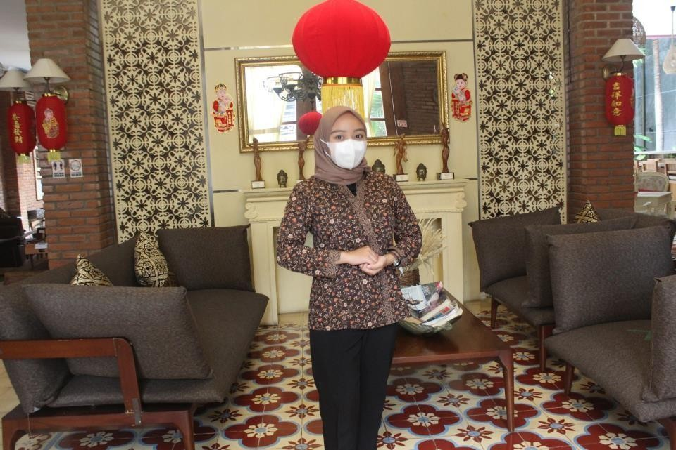

Picture 1. Welcoming Guest

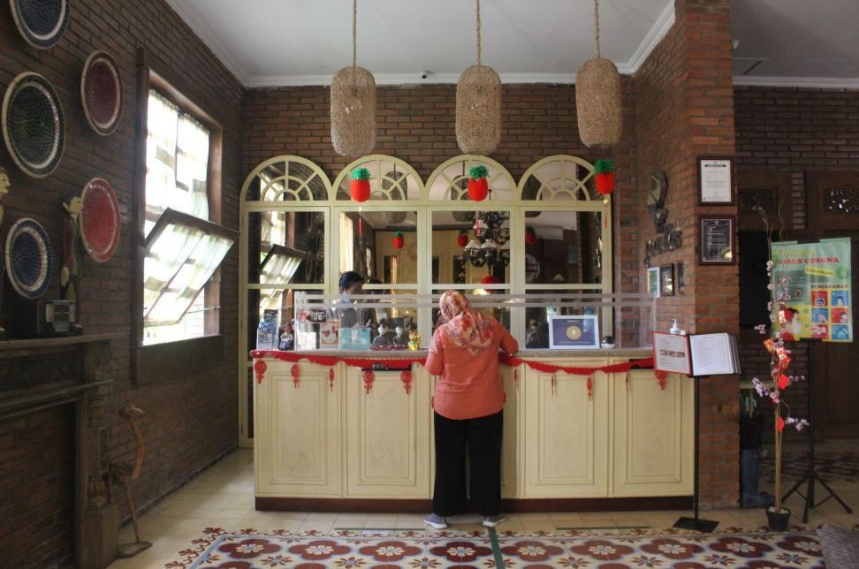This photo was taken when I was doing an internship as a Front Office staff and was in a position to welcome guests who came in front of the entrance of Java Villas Boutique Hotel and Resto. Every guest who comes will be greeted and opened by the staff of Java Villas Boutique Hotel and Resto, and will be offered assistance if there is luggage to be brought to the room.

Picture 2. Front Office Java Villas Boutique Hotel and Resto

This second photo is the situation when the Front Office staff handles guest arrivals and checks all documents needed for guests to check in or check out. In addition, if someone comes to meet hotel guests, they must report here first.

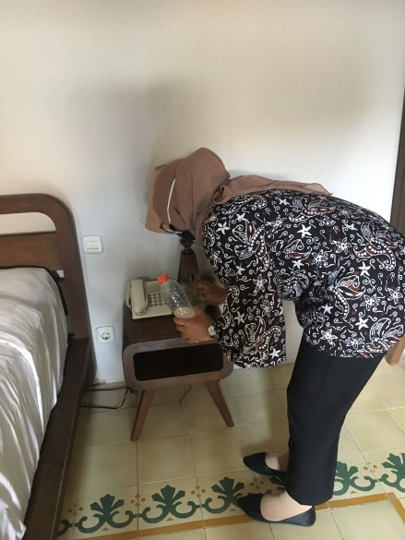

Picture 3. Checking and Cleaning Room

During the internship period, once every 2-3 days I was assigned by the intern supervisor to check the room, in checking the room I had to make sure that the facilities in the room were complete and good, such as checking the condition of the ac and television whether it was on properly or not. In addition, if in the process of checking the room is not clean enough, then I will help to clean it, such as wiping the glass that is still not clean or cleaning the dust in the room furniture.

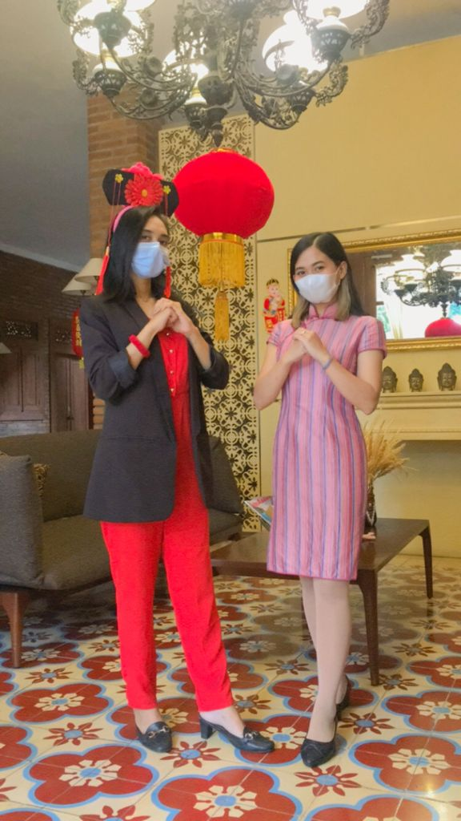

Picture 4. Staff of Java Villas Boutique Hotel and Resto Celebrate Chinese New Year

I took this photo when the Java Villas Boutique Hotel and Resto staff wore special clothes to celebrate Chinese New Year. Every big day Java Villas Boutique Hotel and Resto will celebrate by changing the theme in the hotel and will hold special events and promoted for that day.