CREATING A BILINGUAL TOURISM BOOKLET TO PROMOTE TUBAN TOURISM ATTRACTION



PROPOSAL OF FINAL ASSIGNMENT
A Partial Fulfilment of the Requirements for the Applied Foreign Language Bachelor Degree

by
Ajeng Noer Olivia (40020519650020)

BACHELOR OF APPLIED FOREIGN LANGUAGE

VOCATIONAL SCHOOL
UNIVERSITAS DIPONEGORO 2026

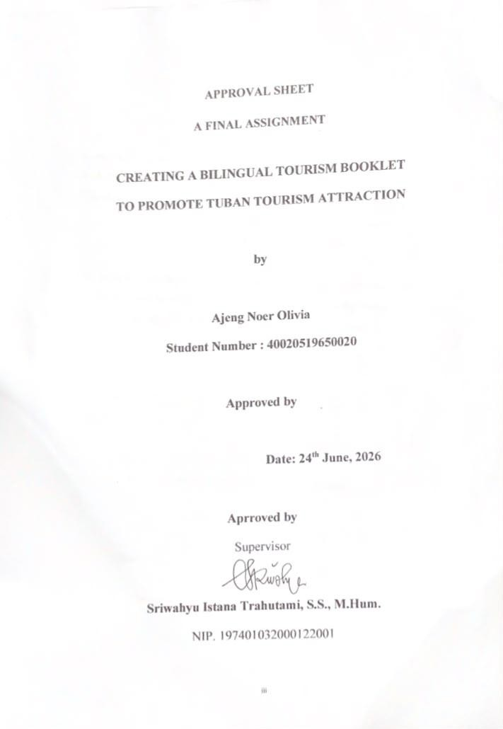

STATEMENT OF ORIGINALITY

This is to certify that thesis definitely my original work. I am completely responsible for the content of this thesis. Other writers opinion or finding include in this project are quoted or cited in accordance with ethnical standard. I understand the full consequences if I took somebody else’s ideas, phrases, or sentences without proper references.

Name : Ajeng Noer Olivia Student’s ID Number : 40020519650020 Signature :

Dates : June 24th June, 2026

APPROVAL SHEET A FINAL ASSIGNMENT

CREATING A BILINGUAL TOURISM BOOKLET TO PROMOTE TUBAN TOURISM ATTRACTION

by

Ajeng Noer Olivia
Student Number : 40020519650020

Approved by

Date: 24th June, 2026

Aprroved by
Supervisor

Sriwahyu Istana Trahutami, S.S., M.Hum.
NIP. 197401032000122001

ACCEPTENCE

Name : Ajeng Noer Olivia

Srudent’s ID Number 40020519650020

Study Program : Applied Foreign Languages

Final Project/Bachelor Thesis Title : CREATING A BILINGUAL TOURISM
BOOKLET TO PROMOTE TUBAN TOURISM ATTRACTION

This study has been examined and is accepted for in partial fulfillment of the requirement for the degree of Applied Bachelor in Applied Foreign Languages of Vocational Collage Diponegoro University.
Examiners Board:

- Sriwahyu Istana Trahutami, S.S., M.Hum. (Chairman)

- Aditya Nur Patria, S.Hum., M.App.Ling. (Member)

- Girindra Putri Ardana Reswari, S.Pd., M.Sc., Ph.D. (Member)

Semarang, 24th June 2026

Head of Applied Foreign Languages Study Program

Sriwahyu Istana Trahutami, S.S., M.Hum.

NIP. 197401032000122001

ACKNOWLEDGEMENT

In the name of Allah, the Entirely Merciful, the Especially Merciful. All praise is due to Allah, Lord of the words. He has allowed me to accomplish the entire works, including this research study.
I would like to sincerely thank those who have helped and guided the writer during the preparation of this thesis, namely to:
- Sriwahyu Istana Trahutami, S. S., M.Hum. as the supervisor. I am grateful for all of your support, guidance, and warmth given to me.
- All lecturers of the Applied Foreign Languages Bachelor Program who have guided me during my study, to the faculty, Applied Language Bachelor Program staff, and librarians who have helped and provided me with all of the necessary materials.
- To my beloved family who has always been willing to be good listeners, advisers, given joy, and encouragement in every situation in the process of this research study
May Allah Ta'ala give abundant rewards for all forms of assistance that have been given to the author. In addition, the writer also hopes that this thesis can be useful for readers from various circles. The author then apologizes if during the process of preparing the thesis there were many mistakes, both verbal and written, which were made intentionally or unintentionally.
Semarang, 24th June 2026

ABSTRACT

Tuban Regency is one of the regencies located in East Java. Located approximately 106 kilometers from the city of Surabaya. Tuban Regency has many choices of tourist attractions that can be presented to tourists such as Akbar Cave, Ngerong Cave, Nganten Cave, Boom Beach, Semilir Beach, Nglirip Waterfall, Al Maghribi, Sunan Bonang, Kwan Sing Bio, Grand Mosque, Kambang Putih Museum, and Tuban City Square. In addition, Tuban Regency is famous for its culinary delights that have spicy and savory flavors such as Spicy Eel, Spicy Manyung Head Soup, and also Palm Fruit Juice. The purpose of creating this bilingual booklet is to promote tourist attractions in Tuban Regency so that tourists will be more interested after reading this bilingual booklet. This booklet contains two languages, namely Indonesian and English. The research in making this product uses the Research and Development meth od from Borg and Gall, including (1) Research and Information Collection, (2) Planning, (3) Development of Initial Product Form, (4) Initial Field Trial, (5) Main Product Revision, (6) Main Field Trial, (7) Operational Product Revision, (8) Operational Field Trial, (9) Final Product Revision, (10) Dissemination and Implementation. The research instrument uses a questionnaire with a Likert scale.

Keywords : Tuban, Tourism, Booklet.

TABLE OF CONTENTS

STATEMENT OF ORIGINALITY ii
APPROVAL SHEET A FINAL ASIGNNMENT iii
ACCEPTENCE iv
ACKNOWLEDGEMENT v
ABSTRACT vi
TABLE OF CONTENTS vii
LIST OF TABLES ix
LIST OF FIGURES x
INTRODUCTION 1
- 1. Backgroud of the Study 1
- 2. Statement of Problem 3
- 3. Scope of Problems 4
- 4. Aims of the Study 4
- 5. Advantages of the Study 4
- 6. Output 5
LITERATURE REVIEW 6
- 1. Definition of Tourism 6
- 2. Forms of Tourism 7
- 3. Definition of Tourist Attraction 10
- 4. The Role of English in Tourism 11
- 5. Definition of Book 12
- 6. Form and Type of Book 13
- 7. Procedure for Designing the Book 14
- 8. Booklet 15
- 9. Information Media 16
- 10. Advantages and Disadvanteges Booklet 17
RESEARCH METHODS 19
- 1. Types of Research Methods 19
- 2. Development Procedure 20
- 3. Place and Time of Research 24
- 4. Works Task 24
- 5. Budget 24
- 6. Research Subject 25
RESULTS AND DISCUSSION 26
- 1. Results 26
    - Research and Information Collecting 26
    - Planning 28
    - Develop Preliminary Form Product 29
    - Preliminary Field Testing 49
    - Main Product Revision 50
    - Main Field Testing 53
    - Operational Product Revision 53
    - Operational Field Testing 56
    - Final Product Revision 62
    - Dissemination and Implementation 66
- 2. Discussion 66
- 3. The Effectivness of Bilingual Booklet 67
CLOSING 68
- 1. Conclusion 68
5. 2. Suggestion 69
REFERENCES 70
APPENDIX 73

LIST OF TABLES

Table 3.1 Entarnce Ticket Prices Tourism Object 22

Table 3.2 Detail Budget Funds 23
Table 3.3 Assessment Score Guideliness 24
Table 3.4 Score Percentage 25
Table 4.1 Example of English Translation 45
Table 4.2 Main Product Revision 51
Table 4.3 Opeartional Product Revision 54

Table 4.4 Final Product Revision 63

LIST OF FIGURES
Figure 3.1 Procedures Step Reasearch and Development Borg and Gall’s 20
Figure 4.1 Draft Making a Booklet 29
Figure 4.2 Cover Display Booklet 32
Figure 4.3 Display Tuban District Maps 33
Figure 4.4 Display Table of Content 33
Figure 4.5 Display Introducing 35
Figure 4.6 Display Transportation Access 36
Figure 4.7 Display Fun Fact 37
Figure 4.8 Display Tourism Object 38
Figure 4.9 Display Lodging 39
Figure 4.10 Display Culinary 40
Figure 4.11 Display Other Destination 41
Figure 4.12 Display Shopping Destination 42
Figure 4.13 Display Hidden Gem and Product 43
Figure 4.14 Display Closing 44
Figure 4.15 Result of Checking Grammar 48
Figure 4.16 Result of the Picture of the Booklet Display Diagram 57
Figure 4.17 Result of the Image of the Information Diagram In the Booklet 58
Figure 4.18 Result of the Drawing of Writing Diagram Used in the Booklet 58
Figure 4.19 Result of the Diagram of the Contents of The Booklet Material are Appropriate 59

Figure 4.20 Result of Drawing a Diagram of the Use of Language Can be Understood 60
Figure 4.21 Result of the Picture Presentation Diagram of the picture In the Booklet 61
Figure 4.22 Result of Drawing a Diagram of the Contents of the BBoklet Can Add Insight/Knowledge 62

