CHAPTER 2
INTRINSIC THEORETICAL FRAMEWORKS

2.1 Narrative Elements
The narrative elements are important since they lead the development of the story and how meaning is delivered to the audience. Narrative associated from an event to another event. “Such poems, however, typically incorporate verbal formulas—set words, word patterns, refrains, and set-pieces of description—which help a performer to improvise a narrative,” (Abrams & Harpham, 2013, p. 265). Furthermore, narrative components are the literature basic elements that also could be involved in film elements since film is one of literature works.

2.1.1 Theme
Theme is described as the major idea or some general meaning that a literary piece embodies, and it differs from plot and cannot merely be reduced to subject matter. “Theme is a general concept or doctrine, whether implicit or asserted, which an imaginative work is designed to incorporate and make persuasive to the reader,” (Abrams & Harpham, 2013, p. 230). This definition generally points out that theme tends to exist on a conceptual stage and cannot just explicitly proclaim its meaning through moral messages rather it can exist on an implicit level through some literary structures.

2.1.2 Character & Characterization
Characters are central to narrative analysis because they embody the moral, emotional and conceptual aspects of a story. Characters are defined as "The persons represented in a dramatic or narrative work, who are interpreted by the reader as possessing particular moral, intellectual, and emotional qualities," (Abrams &
Harpham, 2013, p. 48).

2.1.3 Settings
The setting places the characters and their conflicts into a larger cultural and social context. “Some writers followed Walpole’s example by setting their stories in the medieval period; others set them in a Catholic country, especially Italy or Spain” (Abrams & Harpham, 2013, p. 152) . In addition to creating time, location, social context, and mood, settings can occasionally operate separate from characters that impact events.

2.1.4 Conflicts
Conflict is the force behind behind all narratives, providing the dynamic that supports story and character development. Conflict is indicated in the concept of narrative as cause-and-effect where characters generate causes and register effects. “Where the protagonist gains a new perspective on the complexities, frustrations, and conflicts of the social world,” (Abrams & Harpham, 2013, p. 269). So conflict is the tension or opposition between forces, characters, or desires that drives the cause-andeffect chain.

2.1.5 Plot
The structure of the action and events in a work of narrative or fiction is called the plot. The plot is a structure that gives the story as a whole meaning, sequence, and power rather than a list of happenings. According to Abrams, “The plot in a dramatic or narrative work is constituted by its events and actions, as these are rendered and ordered toward achieving particular artistic and emotional effects”
(Abrams & Harpham, 2013, p. 293).

2.2 Cinematic Elements
The technical and visual components of a film which affect how a story is presented and how the viewer is given meaning are known as cinematic elements. “The recording process opens up a new area of choice and control; cinematography,” (Bordwell and Thompson, 2020, p. 159).

2.2.1 Camera Distance
Camera distance deals with the distance of the camera from the subject. Camera distance determines how a person will interpret a particular environment or figure. It is very essential since it determines emphasis and psychological proximity. “The framing of the image stations us relatively close ti the subject or farther away. This aspect of framing is usually called camera distance” (Bordwell et al, 2020, p. 189).

2.1.1.1 Long Shot
A long shot typically frames the human body from head to toe, allowing viewers to see both the character and significant portions of the surrounding space. Long shots balance the presence of a character with the environmental context. “In the long shot, figures are more prominent but the background still dominates,” (Bordwell et al, 2020, p. 189).

2.2.1.2 Medium Long Shot
Medium long shot is used to frame the body from the knees upwards. It allows for an amalgamation between spatial consciousness and detail. “Shots in which the human figure is framed from about the knees up are called medium long shot” (Bordwell et al, 2020, p. 189). This type of shot is commonly used in scenes involving dialogues.

2.2.1.3 Medium Shot
Medium shot generally frames the subject from the waist up, closely aligning with everyday social distance and thereby making the framing particularly common in conversation scenes. This frame allows the viewer to observe facial expression while still registering body language. “The medium shot frames the human body from the waist up” (Bordwell et al, 2020, p. 189)

2.2.1.4 Medium Close-Up
In a medium close-up shot, the subject is framed from the chest up, and this provides a good mix of the intimate feeling of a close-up shot and the sense of awareness of the medium shot. The reason this shot stands out for dialogue shots is that it provides the audience with a chance to see the facial expressions of the person while also realizing the restricted body language. “The medium close-up frames the body from the chest up” (Bordwell et al, 2020, p. 189).

2.2.1.5 Close Up
A close-up isolates a face, object, or detail and intensifies emotional expression, directing the viewer's focus. It is one of the strongest devices for psychological emphasis in film. “The close-up is traditionally the shot showing just the head, hands, feet, or a small object. It emphasizes facial expression, the detais of a gesture, or a significant object,” (Bordwell et al, 2020, p. 189).

2.2.1.6 Extreme Close Up
An extreme close-up enlarges a very small detail that may include an eye, a hand, or sometimes an object that it is often out of context. The shot heightens intensity and may create tension, symbolism, or discomfort. “The extreme close-up singles out a portion of the face or isolates and magnifies an object,” (Bordwell et al, 2020, p. 189).
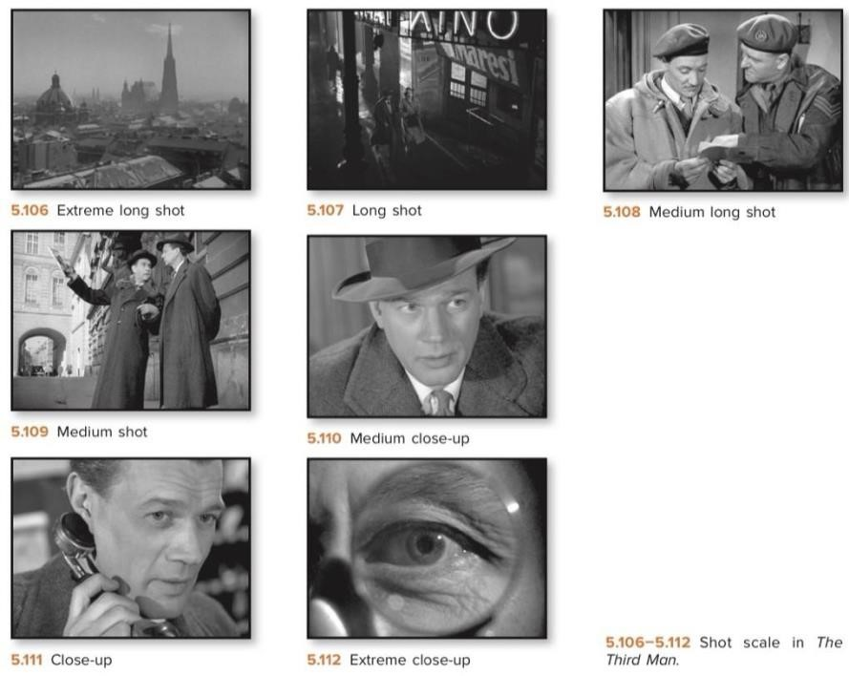
Picture 1 The Visual of Camera Distance
(Bordwell et al, 2020, p. 189)

2.2.2 Sounds
In movies, sound is important for the audience to understand the emotion, mood and plot of the scene, “filmmaker judges what to pursue based on how they fit the overall form of the film and how they shape the viewer’s experience,”
(Bordwell et al, 2024, p. 263). A film-maker can use a combination of speech, background music and other noises to create atmosphere, build suspense and help the audience understand the scenario. “Sound is often treated as a lesser partner to the images, but we need to recognize that it can actively shape how we understand them” (Bordwell et al, 2024, p. 265). Thus music in film is not only an accompaniment to the visuals but also a storytelling device.

