CHAPTER IV RESULTS AND DISCUSSION

Result
The results of the research that has been carried out regarding semiotic analysis in an Islamic film would be presented in this chapter. after repeated careful viewing of the four films that are the source of research data, namely “Sang Pencerah, Bulan Terbelah di Langit Amerika, Ajari Aku Islam, and 172 Days”, several signs have been found in these films. These signs can then be used as aspects of determining a film can be said to be an Islamic film. These signs are then categorized into five points, namely Story, Movie Poster, Symbol, Dialogue and Narration, and Depicted Scene.

Story
This point is the main point that becomes an assessment of how a film can be categorized as an Islamic film or not. At this point, the content of the story and the moral message contained in a film are the benchmarks for assessing the categorization of a film. A movie will be called an Islamic film if it tells stories about God or religion, or highlights things related to divinity. the following signs are found in this study:

Sang Pencerah
Representation on the sign contained in this film is a film that tells the story of the journey and struggle of an Islamic figure, K.H. Ahmad Dahlan in straightening the teachings of Islam in his environment and in his efforts to establish an Islamic organization, namely Muhammadiyah. In this movie, there are many things related to Islamic moral values, both morals, worship, and faith.
This Islamic moral value is then used as an object in this sign. Moral values are reflected in the behavior shown such as doing good deeds, being polite, helping each other, being patient, respecting each other, being gentle and forgiving. The value of worship is seen from how the actors in the movie who carry out their worship wholeheartedly. The value of faith is illustrated by how the filmmaker

wants to convey that the act of associating partners with Allah SWT is prohibited and is a big sin that should not be tolerated.
Through the two aspects that have been conveyed, it can be interpreted that both what is told and depicted in the film and what the audience wants to convey are things that are closely related to Islamic values, which shows that this film is an Islamic film.

Bulan Terbelah di Langit Amerika
What becomes a Representation in the sign contained in the movie Bulan Terbelah di Langit Amerika is that this movie told about how a Muslim's effort to maintain his belief in an environment that discriminates against his religion which is a minority. It also shows how a Muslim tries to show the truth of a tragedy that makes Islam accused of being a religion that brings destruction.
The object of the sign here can be seen through the values that want to be conveyed to the audience. The moral values contained in this movie include the value of tolerance between religious communities and the value of justice that wants to be shown to the audience. How messages such as despite having different beliefs every human being must remain tolerant and willing to help other humans as well as messages about how good deeds will always produce good fruit in the end. In addition, this movie also shows how a person is steadfast in maintaining his beliefs despite the many trials that arise in his life.
Through these signs, it can be interpreted that this movie is an Islamic movie when viewed from the story and the problems described in it. In addition, through the moral message that wants to be conveyed to the audience, it can also be a point that is considered as an Islamic film.

Ajari Aku Islam
Representation in the sign contained in this movie is that this movie tells about the struggle of a man who wants to fight for a woman who has different beliefs. Although on his way there is a lot of opposition from both families and other parties that also intersect, Kenny, who is the male actor in this film, is still

trying to fight for his love. On the other hand, Kenny has also been interested in Islam for a long time and began to want to explore Islam since meeting Fidya. And in the end Kenny chose to convert to Islam at the end of his life.
The moral values that then become objects on the signs contained in this film are the value of tolerance, mutual assistance, and the value of never giving up in trying something. This movie depicts the figure of Kenny who tries to explore Islam to convince himself of the religion he wants to believe in and his efforts in fighting for his love. The interpretation depicted in this film shows that this film is an Islamic film because clearly the filmmaker wants to convey the efforts of someone who wants to convince himself of the religion he will embrace, whether the religion that was passed down from his birth or the Islamic religion that brings peace to him.

172 Days
Representation in the sign in this movie is that this movie tells a story of the hijrah of someone who was far from God and began his turning point to become a person who wants to fix himself and return to walk on the right path and explore Islam again. From that he began to find his love who was fought with Islamic religious law despite getting many tests in his story.
What is then identified as an object in the sign contained in this film is the moral value that is presented such as constancy in facing the trials given by Allah SWT, resilience in living life as described in a person's efforts in returning to the right path after experiencing downturns and doubting God in his life. From these points, it can be interpreted that this film is an Islamic film because it tells the story of a Muslim's journey and contains a message of Islamic moral values in the film.

Poster
At this point the assessment is based on the elements or signs found on a movie poster to determine whether the film is an Islamic film or not. The signs found on each movie poster that is the object of this research are as follows:


Sang Pencerah
Title
Mosque as background

Figure 4. 1 Sang Pencerah movie poster
Clothes worn
The last sign
According to figure 4.1, the Representation in the first sign that appears at this point is the title of the movie “Sang Pencerah - K.H. Ahmad Dahlan”. The object of this sign, namely the sentence “Sang Pencerah” found on this movie poster, refers to the nickname of a figure who brings good things or someone who justifies something deviant. This sentence or nickname is also closely related in a religious context. The sentence “K.H. Ahmad Dahlan” refers to the name of one of the Islamic figures and “K.H.” itself is an abbreviation of “Kyai Haji” which is a title given to Islamic religious figures. From these points, it can be concluded that the interpretant of this sign is that this sign shows that this movie will tell the story of an Islamic figure who brings enlightenment to the people around him.
The next sign is shown through the Representation in the form of depicting a character wearing clothes in the form of a turban, robe, and hijab. The object is that the clothing used is clothing that becomes an identity or is identical to Muslims as

its users. These clothes are used as a form of obedience of a servant to his god. This poster interprets that through the depiction of the characters, this movie will tell the story of an Islamic figure who will bring enlightenment to Muslims at that time.
The third sign is shown in the Representation in the form of the background on the poster which shows the depiction of the mosque at that time. The object of this sign is that the background shown is a depiction of the mosque at that time which shows that the film will discuss topics related to Islam or specifically present conflicts originating from the mosque. This is also the interpretant that implicitly shows that the main topic in this movie has to do with the mosque itself specifically or will discuss Islam in general because the mosque is a place of worship for Muslims.
The last sign shows the Representation in the form of the sentence “Lebaran 2010”. The object of this sign is an indication of the time of the release of this film, namely on Eid, which is a Muslim holiday precisely on Eid in 2010. This sign interprets the release of the movie which is done during the celebration of this Muslim holiday, showing that this movie is intended for Muslims in particular.

Bulan Terbelah di Langit Amerika

Clothes worn

Hijab with American flag motif
The last sign

Figure 4. 2 Bulan Terbelah di Langit Amerika movie poster
According to figure 4.2, the Representation of the first sign on the Bulan Terbelah di Langit Amerika movie poster is the depiction of a character wearing a hijab. The object is the hijab itself, which is a garment that is required to be used by Muslim women to cover their aurat as a command from Allah SWT. From this, it can be interpreted as this movie will contain a message conveyed through the characters and the storyline presented in it, therefore this movie is an Islamic movie.
The second sign is shown with a Representation in the form of a hijab that is depicted with an American flag motif. The object in this sign shows that this sign reinforces the relevance of the title of the film which describes the condition of Muslims in America where Islam is a minority in a large country with conflicts and bad stigma about Muslims or Islam itself. This sign can then be interpreted as a depiction of the main topic of this film which will tell how Islam or a Muslim maintains his beliefs and beliefs in a large country as a minority.
The last sign is shown through the sentence “after that day, their world had changed”. The object in this sign shows that this sentence refers to the event that underlies the conflict or the main topic in this film, namely the attack on the World Trade Center. It is interpreted that after the incident, the life lived as a Muslim

changed to be more difficult because of the bad stigma that arose due to misunderstanding in the tragedy.

Ajari Aku Islam

Clothes worn
Title
Depiction of mosque

Figure 4. 3 Ajari Aku Islam movie poster
According to figure 4.3, the first sign that appears on this movie poster is the representation of the movie title itself, “Ajari Aku Islam”. The object of this sign shows that the title of this movie describes this movie will tell the story of someone who wants to know more about Islam so he asks to be taught about Islam. This sign interprets this film as an Islamic film by explicitly using the word “Islam” in the title and making Islam the main topic in this film.
The second sign shows the depiction of a female character wearing a hijab. The object of this sign is that the clothes used are a depiction that the character is a Muslim. This sign can then be interpreted as this movie is an Islamic movie because the character is a Muslim and the message to be conveyed contains Islamic moral values.
The last sign is shown with a Representation in the form of the appearance of a mosque image on this movie poster. The depiction of the mosque, which is a place of worship for Muslims, then becomes the object of this sign. This sign interprets that this movie will tell the story of Muslims with the depiction of a mosque that strengthens the impression of “Islam” on this movie poster.

172 Days

Clothes worn
Depiction of
husband- wife

Figure 4. 4 172 Days movie poster
According to figure 4.4, the Representation on the first sign in the 172 Days movie poster is a depiction of a character wearing a hijab. The object is a hijab which is a garment used as an obligation to cover the aurat of a Muslim woman, aurat refers to parts of the body that must be covered and not seen by people who are not mahram. The interpretation of this sign is that this film will tell the story of Muslims and make this film an Islamic film.
The Representation on the second sign is that there are two characters who appear on the poster of this film. The object on this sign is the characters who appear on this poster are a depiction of a husband and wife who are the main characters in this film. This sign can be interpreted as this film tells the story of a husband and wife who from the beginning of their meeting until they live their husband and wife life and face the tests that are present in their lives.

Symbol
      - Male Clothing
At this point, the main concern is the clothes worn by the male characters in the film. From this point, it can be determined how a film becomes an Islamic film through the aspect of the clothes worn by the male characters in a film. The first sign of this point is seen in the film ‘Sang Pencerah’.
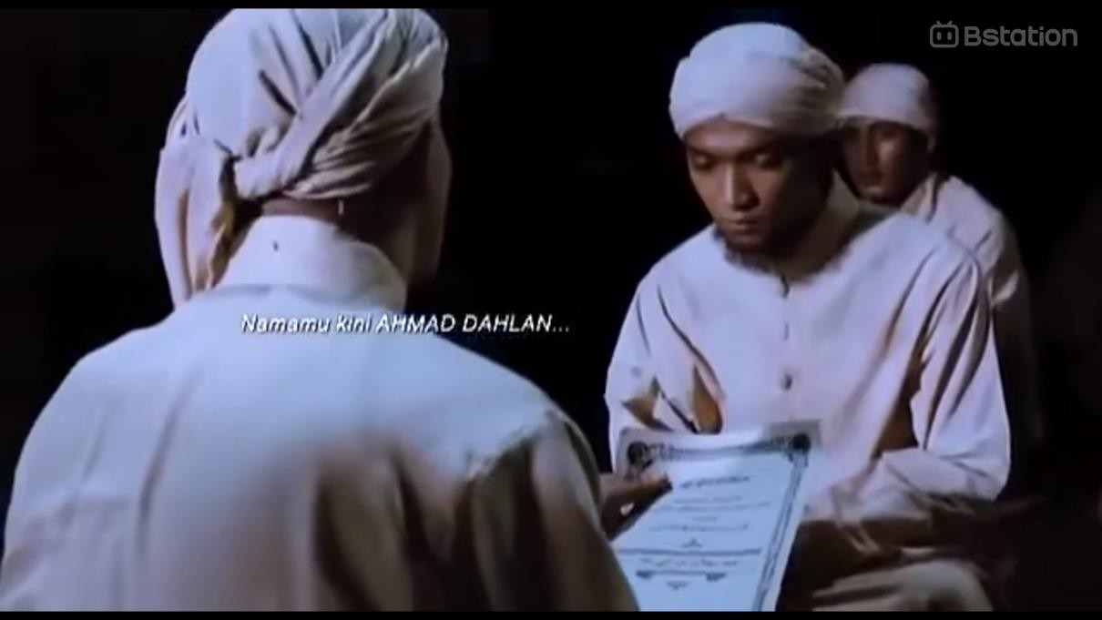
Figure 4. 5 Male actor's outfit in the movie Sang Pencerah
According to figure 4.5, the Representation of this sign is the use of clothing in the form of turbans and robes by male actors who are considered religious experts. The object is that these clothes are clothes that identify Muslims as their users because of the recommendations or teachings of their role model, the Prophet Muhammad SAW. This interprets that this film contains elements that are closely related to the Islamic religion and depicts Islamic teachings during the time when this film was intended.
In the Sang Pencerah film, although the men's clothing worn contains Islamic elements, it is still thick with Javanese cultural elements because at that time religious figures still held fast to the beliefs or teachings of Javanese culture that

came from their ancestors or predecessors. Signs at this point are also seen in the movies ‘Bulan Terbelah di Langit Amerika, Ajari Aku Islam, and 172 Days’.


Figure 4. 6 Male actor's outfit in the movie Bulan Terbelah di Langit Amerika
According to figure 4.6, the Representation of this sign is the peci worn by the film's main character. The object is a peci which is a clothing attribute used because it follows the teachings and habits of the Prophet Muhammad SAW in dressing during his lifetime. It can be interpreted that this film contains Islamic elements because it brings Islamic teachings in the film through the depiction of the main character.
In the film ‘Bulan Terbelah di Langit Amerika’, a sign that shows that this film is an Islamic film can also be seen through the clothes worn by the male actors in the film. The clothes used look more modern, adjusting to the time setting of the film and also adjusting to the setting of the place depicted in the film, where this film is set in America, a country with Muslims as a minority.



Figure 4. 7 Male actor's outfit in the movie Ajari Aku Islam
According to figure 4.7, the Representation of the sign in the scene of the film ‘Ajari Aku Islam’ is the use of Muslim clothing, namely koko shirts and peci. The object of this sign is the clothing worn by the actors in this film, which is clothing that is identical to Islam. It can be interpreted that this sign shows that this film carries the message and teachings of Islam in depicting life in it.
Although in this film there are also male actors' clothes that depict other cultures or beliefs, there can also be found male actors' clothes that can be identified as clothes worn by a Muslim.
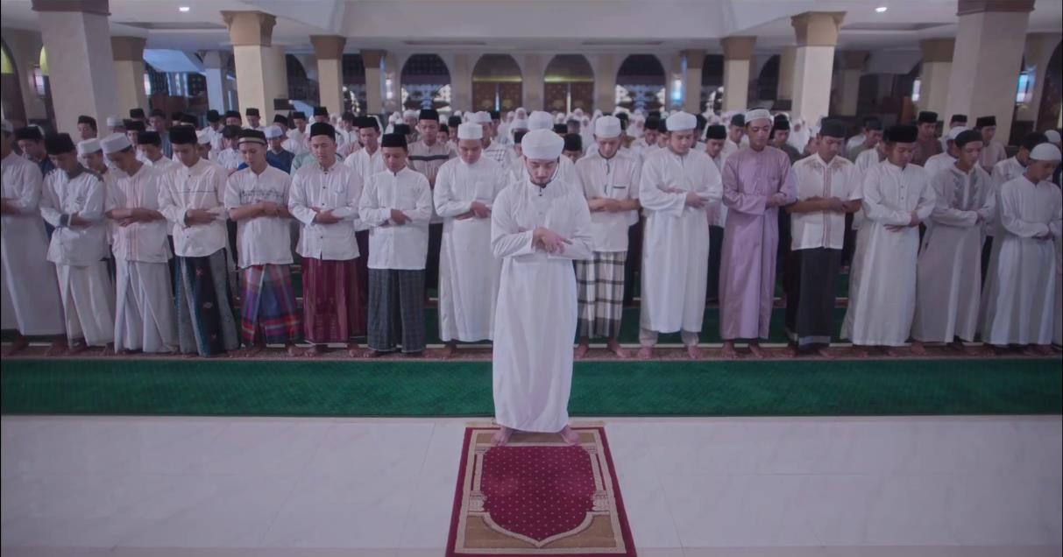
Figure 4. 8 Male actor's outfit in the movie 172 Days

According to figure 4.8, the Representation of this sign is seen in the clothes worn by the male actors in this film in the form of koko shirts, gamis, turbans, peci and sarongs. The object of this sign is the clothes, the clothes are clothes that are characterized by Islam as the user, both in the form of obligations and recommendations taught by the prophet. This sign interprets that this film contains Islamic elements because it contains things that are identical to Muslims, both teachings and obligations as a Muslim.
The signs found in this film are the same as the signs found in the previous film, the difference is that in this film the clothes worn look the most modern compared to the three previous films. In addition, the clothes worn also look very characteristic of a religious figure that is usually shown in Indonesian society.

Female Clothing
In addition to the signs identified from the male clothing worn by the actors in the film, an Islamic film can also be identified through the clothing worn by the female actors in the film. Signs related to Islamic films that are related to the clothing worn by the female actors are found in the films that are the objects of this study. The signs found are as follows:

Figure 4. 9 The female character's outfit in the movie Sang Pencerah

According to figure 4.9, the Representation in this scene is the use of clothing depicted as a hijab worn by women at that time, hijab is a term that refers to a manner of dress that is appropriate and covers the aurat in accordance with Islamic law, especially for Muslim women. The object is that the clothing is clothing that identifies Muslims as its users because of the command and obligation of Allah SWT. This interprets this film as providing a picture of the implementation of the obligations or orders of Allah SWT at that time which indicates that this film is one of the Islamic films.

Figure 4. 10 Female character's outfit in movie Bulan Terbelah di Langit Amerika According to figure 4.10, the Representation of this sign is the hijab worn by
the female actor. The object is the use of the hijab by a woman which is a command
to cover the aurat from Allah SWT. This interprets that this film teaches that even though it is in a place where Islam is a minority, there is no reason to ignore the command of Allah SWT which indicates that this film contains Islamic elements.



Figure 4. 11 The female character's outfit in the movie Ajari Aku Islam
The next sign Representation according to figure 4.11 is the use of hijab as clothing worn by the female actors in this film. Hijab is a term that refers to a manner of dress that is appropriate and covers the aurat in accordance with Islamic law, especially for Muslim women which is an obligation to be used by a Muslim woman because it is a command from Allah SWT becomes the object of this sign. This sign interprets this film as bringing moral values in the form of obedience to the commands of Allah SWT and shows that this film is an Islamic film.

Figure 4. 12 The female character's outfit in the movie 172 Days

According to figure 4.12, the Representation of the sign in this film is the use of hijab by the female actor in the film. The object is the use of hijab which is required for Muslim women as a form of obedience to Allah SWT and as a servant's obedience to the command of his God. This is what then becomes the interpretant that this film is an Islamic film because in its story this film brings moral values in the form of Islamic teachings that it wants to convey to its audience.
Of the four signs found in the object of this research, although the signs found show the same sign, namely the clothes worn by the female actor in each film that is used as the object of research, there are also slight differences found. In the ‘Sang Pencerah film’, the clothes worn by the female actor are clothes that still have strong traditional elements in them. This is because the depiction of Islamic teachings in the film is still strongly influenced by traditional culture or culture brought by ancestors. Unlike the signs found in the other three films, the depiction of Muslim women's clothing worn in these films looks much more modern. Even the sign found in the film ‘172 Days’ can be seen that the clothes worn seem very modern and much different from the depiction in the Sang Pencerah film even though they have the same meaning.

Attribute
At this point, the main point to identify a film whether it is an Islamic film or not is from the attributes contained in the film. These attributes are completeness or symbols that can define Islam itself. These signs are found in the films that have been analyzed as follows:
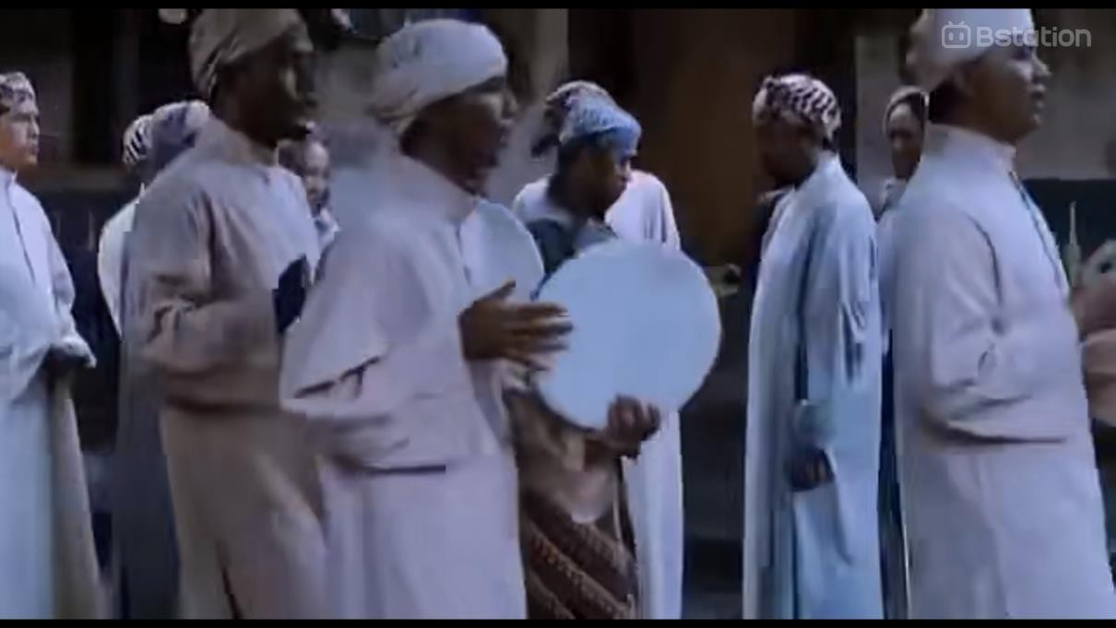
Figure 4. 13 Hadroh accompaniment in the movie Sang Pencerah
According to figure 4.13, the Representation in this scene is hadroh. The object, hadroh is an Islamic art in the form of chanting sholawat accompanied by traditional musical instruments such as tambourines and other supporting musical instruments. This scene interprets that this film contains Islamic values because it presents Islamic art in the scenes it depicts.

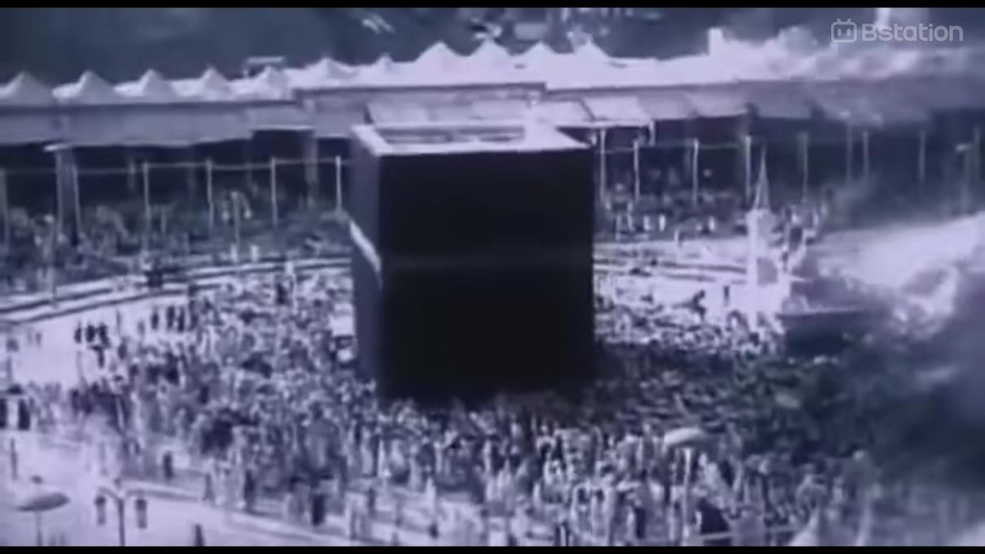
Figure 4. 14 Depiction of the Kaaba in the movie Sang Pencerah
According to figure 4.14, the Representation in this scene is the Kaaba, the object is the Kaaba is the qibla or direction aimed at by Muslims when performing prayers and is the main center of worship in Islam, the Kaaba is also a symbol of the unity of Muslims from various parts of the world. The interpretation in this scene is the depiction of a symbol of Muslims in the world as a sign that this film contains Islamic values and will tell a story about Muslims.

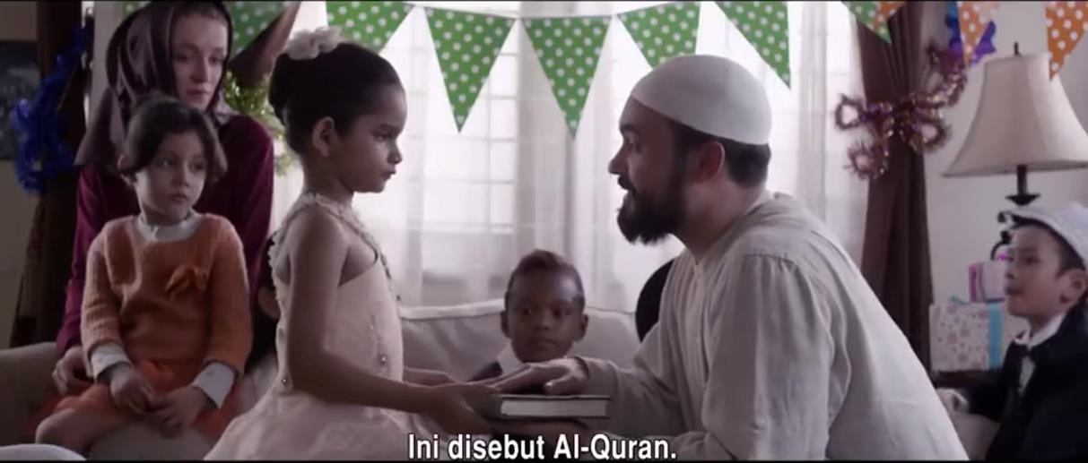
Figure 4. 15 Depiction of Quran in the movie Bulan Terbelah di Langit Amerika According to figure 4.15, the Representation in this sign is the Quran given
as a gift by a father to his daughter. The object is the Quran, the holy book of
Muslims which contains all the commands and guidance from Allah SWT to Muslims. From here it can be interpreted as a father who wants his daughter to know and learn Islam through the Quran he gave.


Figure 4. 16 Depiction of goods that are identical to Islam in movie Ajari Aku Islam
According to figure 4.16, the Representation in this sign is the goods given by Fidya in the form of koko shirts, peci and iqra books. The objects, the goods given are goods used by Muslims as equipment for worship and media for learning

to read the Qur'an. This sign can be interpreted as someone who gives the goods wants the recipient to be able to learn more about Islam.

Figure 4. 17 The depiction of gravestones in the movie 172 Days
According to figure 4.17, the Representation in this sign is a tombstone depicted in the film 172 Days. The object is the tombstone depicted in this film is a tombstone used to mark the grave of a Muslim because it contains the words "Innā lillāhi wa innā ilaihi rāji'ūn" which is a sentence recommended by the Prophet Muhammad SAW to be said when knowing that someone has died. This is then used as an interpretation that this film contains Islamic elements because it conveys the teachings of the Prophet Muhammad SAW.
At this point it can be seen that the attributes used as signs are a symbol or depiction that is very identical to the Islamic religion. These attributes are either in the form of the holy book of Muslims, the Qibla or a place that is used as the direction for all Muslims to worship, or items that have Islamic elements and can be easily identified as Islamic attributes easily.

Setting
At this point the research refers more to the setting of the scene depicted in the scenes in the film. The setting can be a benchmark for a film to be included in a certain genre, as well as a film with an Islamic title. The following are signs found in the film that has been analyzed:
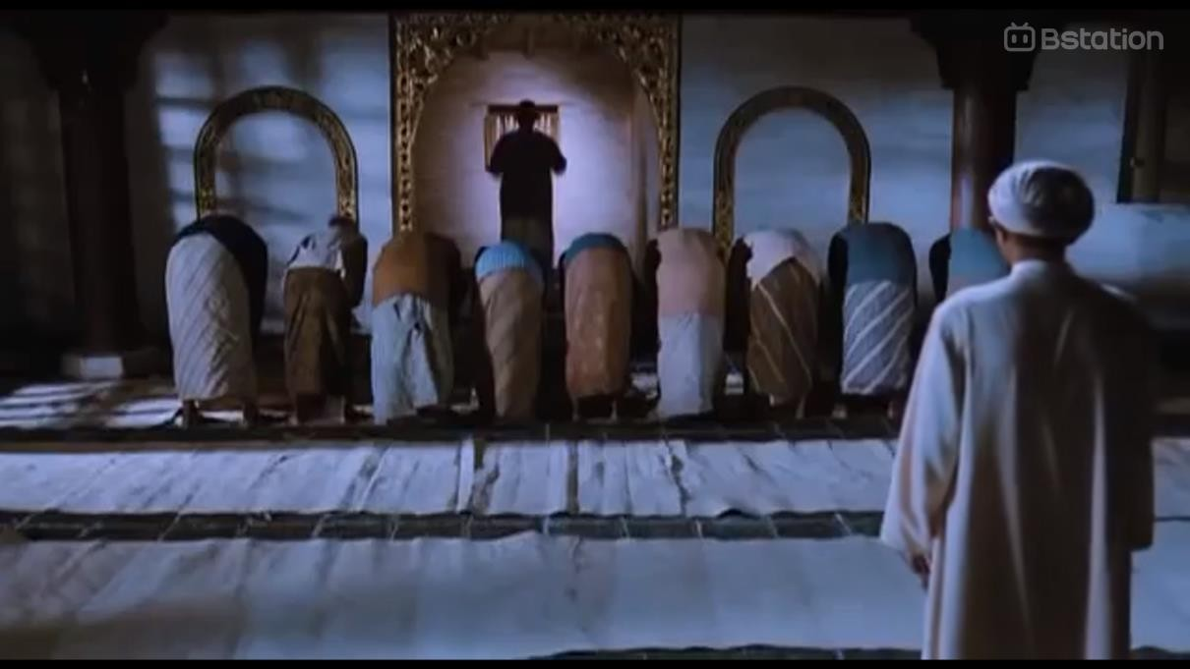
Figure 4. 18 The setting that depicts the mosque in the movie Sang Pencerah
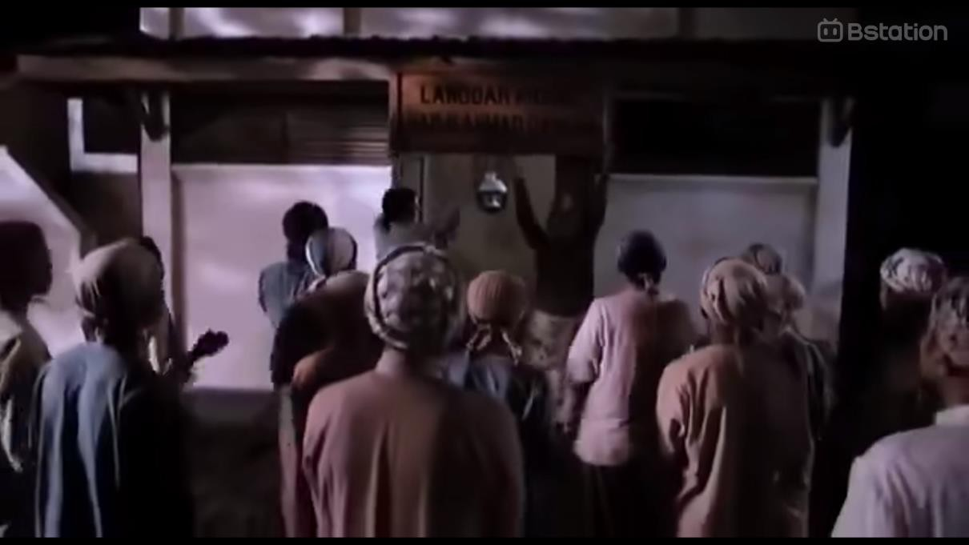
Figure 4. 19 The setting that depicts the langgar in the movie Sang Pencerah

According to figure 4.18 and figure 4.19, the Representation in this scene is the background of the scene which shows the mosque and the "langgar". The object is a mosque which is a place of worship for Muslims and a "langgar" which is a building which is intended to be like a mosque but with a smaller size for the purpose of worship and holding recitations to deepen Islamic religious knowledge. This sign interprets that the choice of setting in the form of a building that is characteristic of the Islamic religion makes this film an Islamic film.
These two settings are used as signs because one of the main conflicts in this movie is related to these two settings. besides that the scenes carried out in this film also take more settings in these two places.


Figure 4. 20 The setting that depicts the mosque in the movie Ajari Aku Islam
According to figure 4.20, the Representation of this sign is a mosque that is used as the background of the scene. The object is a mosque, a building used by Muslims as a place of worship. This sign interprets the selection of a background that is a place of worship for Muslims, making this film an Islamic film because it contains Islamic elements in it. This setting is used as a sign because the beginning of the conflict in this movie appears in the setting of this scene.


Figure 4. 21 Settings depict mosques and Islamic boarding schools in 172 Days According to figure 4.21, the Representation here is a mosque and an Islamic
boarding school that are used as the background of the scene. The objects are
building, these buildings are buildings that are the identity of Muslims such as mosques which are places of worship for Muslims and Islamic boarding schools which are educational institutions specifically for Muslims. This setting was chosen as a sign because many scenes in this movie are depicted in this place.
The setting presented and chosen as a depiction that has Islamic elements in the film is something that was identified during the research. Three of the four films that were the object of the research found signs in the form of settings that depict Islamic elements in the film. This setting more often appears in the form of a mosque which is a place of worship for Muslims and Islamic boarding schools which are a place to learn and deepen Islamic religious knowledge.
In the film ‘Bulan Terbelah di Langit Amerika’, there were no signs in the form of scene settings that refer to Islam or Islamic elements. One of the considerations why there were no signs in the form of settings in this film is because this film tells the story of Islam in a country where Islam is a minority so it is difficult to find signs in the form of settings that have Islamic elements in it.

Dialogue and Narration
At this point, the signs found are signs that come from the dialogue of the film's characters and the narration read in the film. The dialogue and narration that are then identified as signs that this film is an Islamic film are dialogues and narrations that contain Islamic elements. During the research, in the films analyzed, various dialogues and narrations were found such as prayer sentences, dhikr, terms that are identical to Islam to narrations that directly discuss Islam. The following are signs that have been found in the films that were used as research objects:

Sang Pencerah
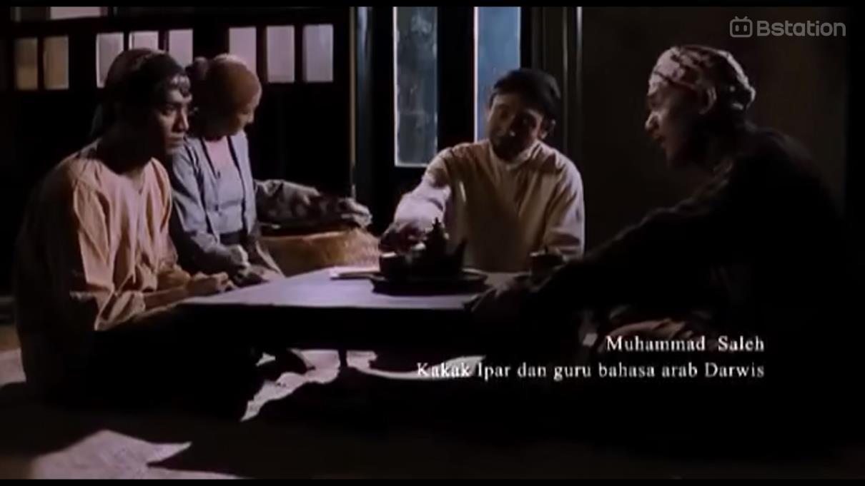

Mekkah itu pusatnya ilmu ilmu islam

Figure 4. 22 Darwis' dialog with his parents and teachers in Sang Pencerah movie According to figure 4.22, the Representation in this figure is the dialogue of
the Darwis who expresses his wishes to his parents and teacher. The object is the
desire expressed by Darwis, which is to go to Mecca with the aim of performing the Hajj pilgrimage and deepening the Islamic religion. From this scene, it can be interpreted that the dialogue of the Darwis contains his desire to deepen the Islamic religion to bring about a change for the Muslims around him, this indicates a desire that comes from the faith of a servant to his God.


Labaik Allahumma Labaik

Figure 4. 23 Scenes of Darwis performing the hajj pilgrimage
According to figure 4.23, the Representation of this scene is a Darwis who reads the talbiyah sentences when performing the Hajj. The object is that the talbiyah sentence is a sentence that is read when performing the Hajj and Umrah which contains an acknowledgment of the oneness and power of Allah SWT. The interpretation in this scene is that the Darwis who is performing the Hajj pilgrimage acknowledges the oneness and power of Allah SWT on his journey.

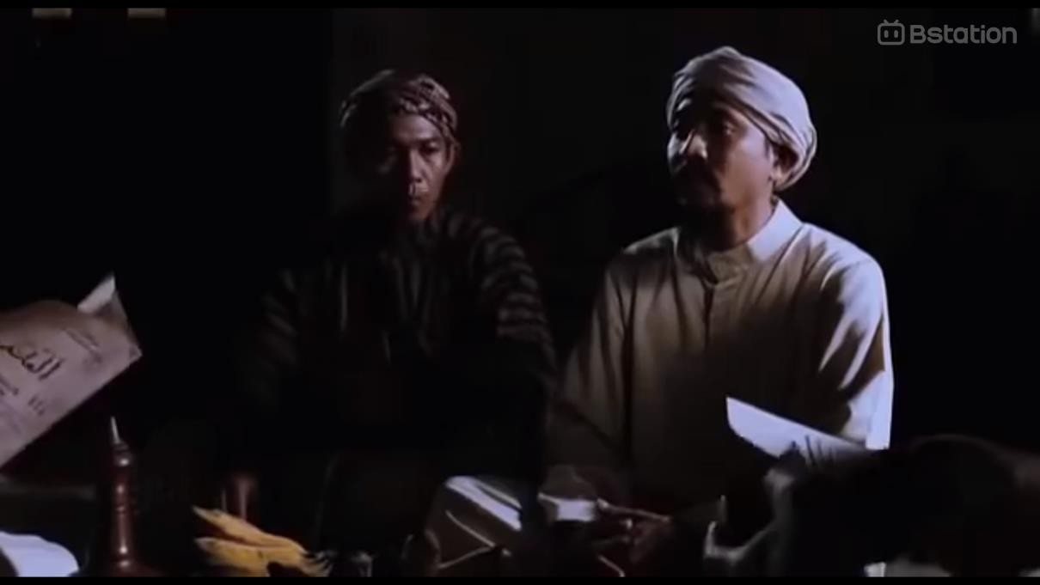
Insyaallah le, Insyaallah

Figure 4. 24 Dialogues that use Islamic expressions
According to figure 4.24, Representation in this scene and several other scenes is the use of Islamic terms in the dialogue used. The objects are the terms used in the form of greetings spoken by Muslims, sentences of dhikr which are one of the worships for Muslims and terms that are identical to Muslims such as the use of the word “insyaallah”, "bismillah" which can be interpreted as intending to do something in the name of Allah SWT, the word "kyai" which is a title given to Islamic religious figures and the term "kafir" which in Islam refers to people who do not believe in Allah SWT. From here it can be interpreted by the use of these sentences and terms, this film is a film that contains Islamic teachings and becomes an Islamic film.
“Inshallah” is used to express hope or a promise that is attempted to be fulfilled. As in the figure above where when Darwis asked his father for permission to use the name Ahmad Dahlan and the father gave permission by saying ‘Inshallah’.

Bulan Terbelah di Langit Amerika

Figure 4. 25 Pronunciation of dhikr in movie Bulan Terbelah di Langit Amerika

Figure 4. 26 Muslim greetings in the movie Bulan Terbelah di Langit Amerika According to figure 4.25 and figure 4.26, Representation in those figures and
several scenes in the film Bulan Terbelah di Langit Amerika is the use of Islamic
sentences and terms in its dialogue. The objects are such as the use of greeting sentences for Muslims, then the use of dhikr sentences spoken by the characters which are included in worship in Islam, for example in figure 4.25 where the sentence “astaghfirullah” is uttered in a state of surrender and begging for forgiveness to Allah SWT. And the use of terms such as halal and haram which are commonly used by Muslims to express something that is permitted or prohibited to do. The interpretation in this sign is with the use of sentences and terms that are

identical and are teachings of Islam, this film is an Islamic film that shows the life of a Muslim.
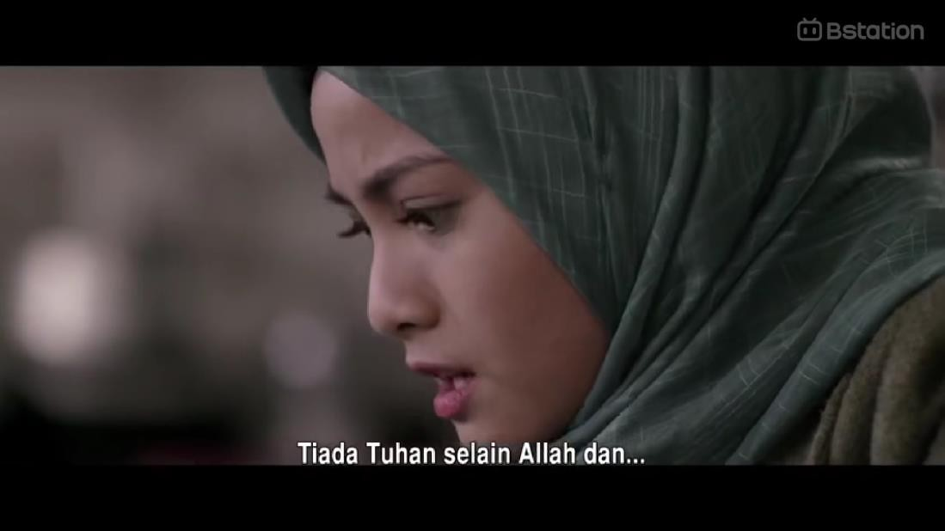

Figure 4. 27 Dialog in the sound recording in Bulan Terbelah di Langit Amerika According to figure 4.27, Representation in this figure is the pronunciation of
the two sentences of the shahada in Ibrahim Hussein's last voice message. The
object is the two sentences of the shahada are the first pillar of Islam where everyone who wants to embrace Islam will read it as a form of their belief in Allah SWT and his messenger, Prophet Muhammad SAW. With the pronunciation of the two sentences of the shahada in this scene, it can be interpreted that this film brings the story of a Muslim who tries to maintain his faith even to the end of his life.



Figure 4. 28 Conference scene in the movie Bulan Terbelah di Langit Amerika
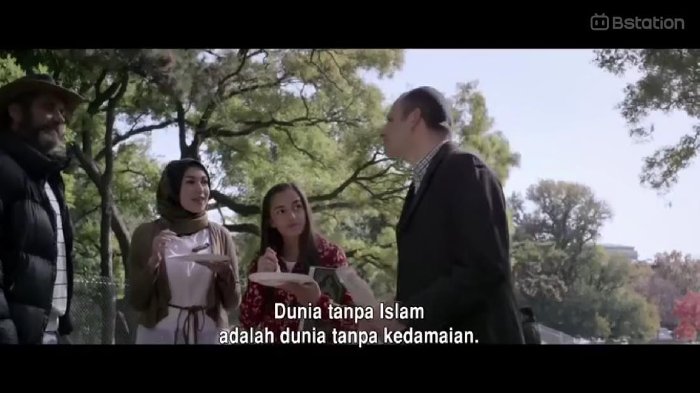

Figure 4. 29 Narratives about Islam
According to figure 4.18 and figure 4.29, Representation in those figures is the main topic of discussion brought in the film Bulan Terbelah di Langit Amerika and its conclusion expressed in a narrative. The object is "akankah dunia lebih baik tanpa islam?" and the narrative that is the conclusion of the topic is "islam adalah kedamaian, dunia tanpa islam adalah dunia tanpa kedamaian". This sign interprets

that this film brings a story about how Islam and Muslims survive where Islam is a minority and with the misunderstanding that Islam brings destruction.

Ajari Aku Islam

Assalamu’alaikum Bang

Figure 4. 30 Dialog on the use of Islamic expressions in movie Ajari Aku Islam According to figure 4.30, Representation in in this figure and several scenes
in the film Ajari Aku Islam is the use of Islamic terms. The object is the term used
in the form of greetings for Muslims, there is also the use of dhikr sentences spoken by the characters, there is also the use of terms such as "insyaallah" which is an expression in the Islamic religion that is said to express hope or promise but it is not certain that it can be fulfilled. This sign interprets that this film contains Islamic elements because it uses terms and expressions in Islam which make this film an Islamic film.


Abang tau kan aku islam

Figure 4. 31 Dialogue between Kenny and Fidya in the movie Ajari Aku Islam According to figure 4.31, Representation in this figure is the dialogue Fidya
who asked Kenny “you know I'm Muslim” to avoid misunderstanding that they
have different religions. The object is Kenny asking Fidya to introduce Islam and make him fall in love with Islam. This scene interprets that the dialogue between the two actors tells the desire to be introduced to Islam in order to fall in love with Islam.


Figure 4. 32 The scene of trying to read Quran in the movie Ajari Aku Islam
According to figure 4.43, Representation in this figure is Kenny who is trying to read the holy verses of the Quran. The object is that what Kenny is trying to read is a fragment of the holy verses of the Quran which is the holy book of Islam. This

scene interprets that Kenny is trying to read the holy verses of the Quran in his efforts to get to know Islam.
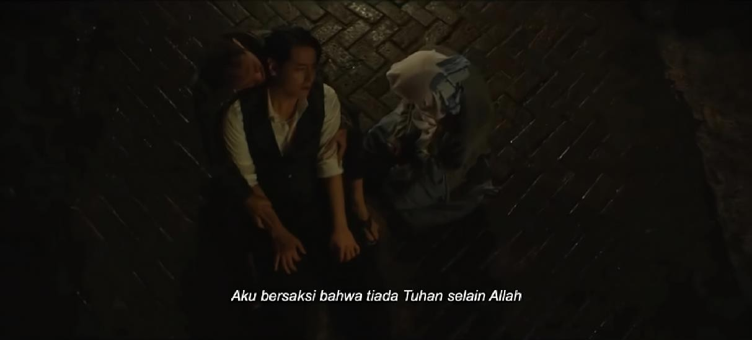
Figure 4. 33 Pronunciation two sentences of shahada in the movie Ajari Aku Islam According to figure 4.32, Representation in this figure is Kenny who recites
the two sentences of the shahada. The object is the two sentences of the shahada, a
sentence uttered by someone who wants to convert to Islam, which means believing in the oneness of Allah SWT and his messenger. The interpretation in this scene is Kenny who wants to die in a state of Islam and asks to be guided to recite the two sentences of the shahada.

172 Days

Masyaallah

Figure 4. 34 Dialogues that use Islamic expressions in the movie 172 Days

According to figure 4.33, Representation in this figure is the use of terms and expressions in the Islamic religion. The object is the use of terms such as Muslim greetings, the use of dhikr sentences, terms such as "insyaallah" to indicate the hope of fulfilling a promise to someone and also the term "masyaallah" which is an expression spoken to show awe of the will of Allah SWT. This interprets that this film can be categorized as an Islamic film because it contains Islamic elements that are shown through the depiction of the daily life of a Muslim.

Depicted scene
At this point, the things that are considered to identify a film as an Islamic film are through the scenes depicted in the film. The scenes shown contain images that refer to worship activities or images that refer to Islamic elements. The following are signs found during the study:
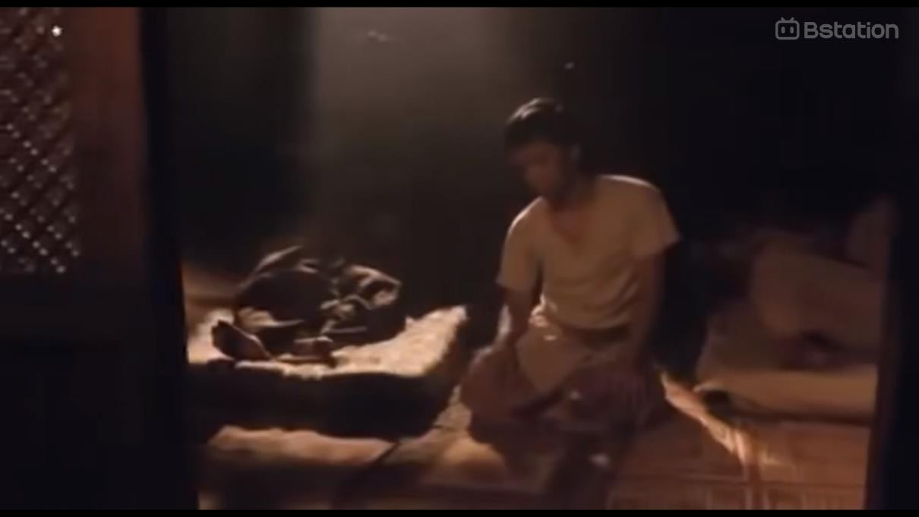
Figure 4. 35 Prayer scene in the movie Sang Pencerah

Figure 4. 36 Hajj scene in the movie Sang Pencerah
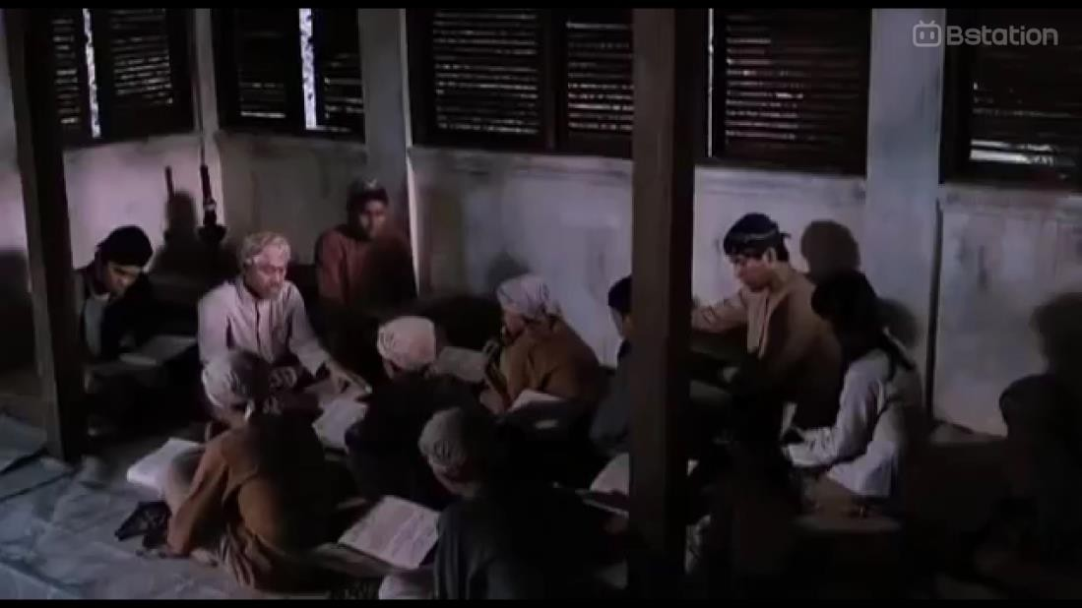

Figure 4. 37 The scene of reading the Quran in the movie Sang Pencerah
According to figure 4.34, figure 4.35 and figure 4.36, Representation in those signs is the worship activities shown in several scenes. The object is the worship activities including prayer, performing the pilgrimage, reading the Qur'an which are worship services carried out by Muslims as an obligation and a form of obedience to Allah SWT. The interpretation in this sign is by presenting scenes of worship

carried out by Muslims showing that this film contains the story of an Islamic figure which can then be interpreted that this film is an Islamic film.

Figure 4. 38 Prayer scene in the movie Bulan Terbelah di Langit Amerika
According to figure 4.37, Representation in this figure is Hanum's gesture shown in the scene at ground zero. The object is what Hanum shows is a prayer gesture that is identical to the gesture when Muslims pray to Allah SWT. This scene interprets that Hanum is a Muslim and this film tells the story of Muslims.

Figure 4. 39 praying scenes in the movie Ajari Aku Islam
According to figure 4.38, Representation in this figure is Fidya who is performing the prayer. The object is that prayer is a mandatory worship carried out by every Muslim as a form of obedience to the command of Allah SWT. This

interprets that Fidya who performs the prayer is a Muslim who is obedient to the obligations that must be carried out.
Figure 4. 40 Prayer scene in the movie 172 Days
According to figure 4.39, Representation in this figure is the implementation of worship carried out in congregation. The object is the worship carried out is a mandatory worship for Muslims, namely prayer. This scene interprets that this shows Muslims who are obedient in carrying out their obligations which are commands from Allah SWT.
The signs found in the scenes above have one thing in common in each sign. The scene depicted is a depiction of the implementation of worship as a form of obedience of a servant in carrying out the commands and obligations to Allah SWT or a depiction of a servant praying to his God. Signs with interpretations like this are found in every film that is the object of this research. There are also signs with different descriptions. The next signs found in this study have depictions of activities that have Islamic elements in them. The signs in the activities depicted next are activities that are identical and easily identified as activities that are usually carried out by Muslims.

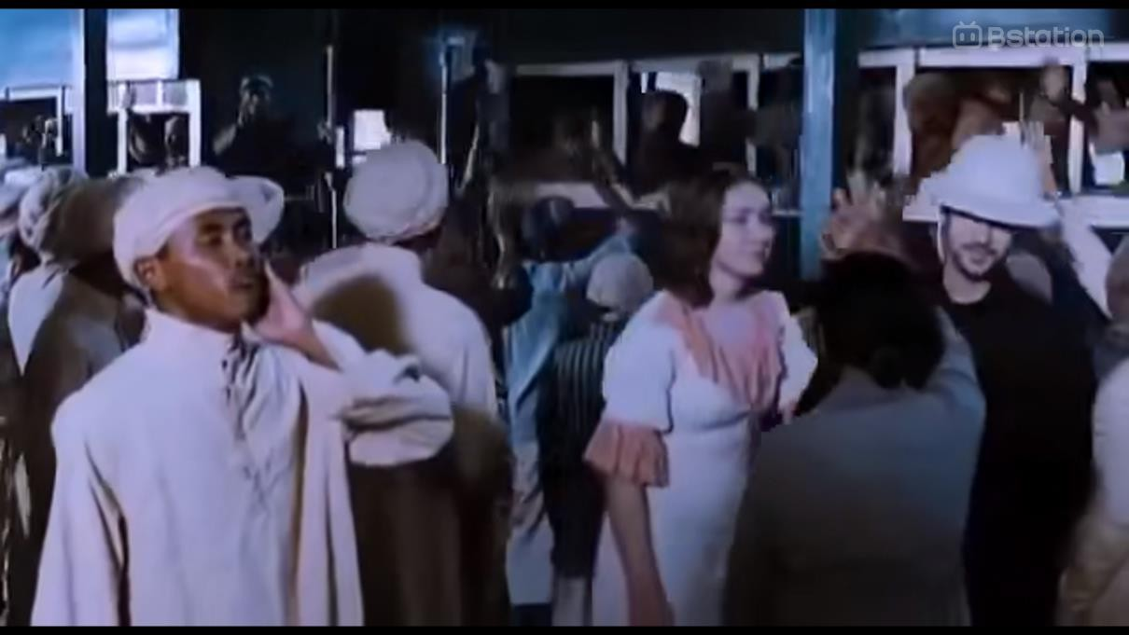
Figure 4. 41 Depiction of adhan in the movie Sang Pencerah
According to figure 4.40, the Representation of this sign is adzan and the person who calls it. The object is adzan which is a call and a sign that it is time for Muslims to carry out worship. This sign interprets that by depicting adzan when it is time for Muslims to carry out worship, this film contains Islamic elements.


Figure 4. 42 Preaching scene in the movie Sang Pencerah

According to figure 4.41, Representation in this figure is Ahmad Dahlan who is preaching in front of his congregation. The object is in his sermon Ahmad Dahlam conveys things related to Islam and how the true religion of Islam is. This scene interprets that the topic or core story of this film is something about Muslims at that time which indicates that this film is an Islamic film.

Figure 4. 43 Scene of reading a book about Islam in the movie Ajari Aku Islam According to figure 4.42, Representation in this sign is Kenny who reads and
studies the books given by Fidya. The object is the book given by Fidya is a book
about Islam which indicates that Kenny is studying Islam. In this scene, it interprets Kenny who is a non-Muslim is learning to know Islam through the books he reads.
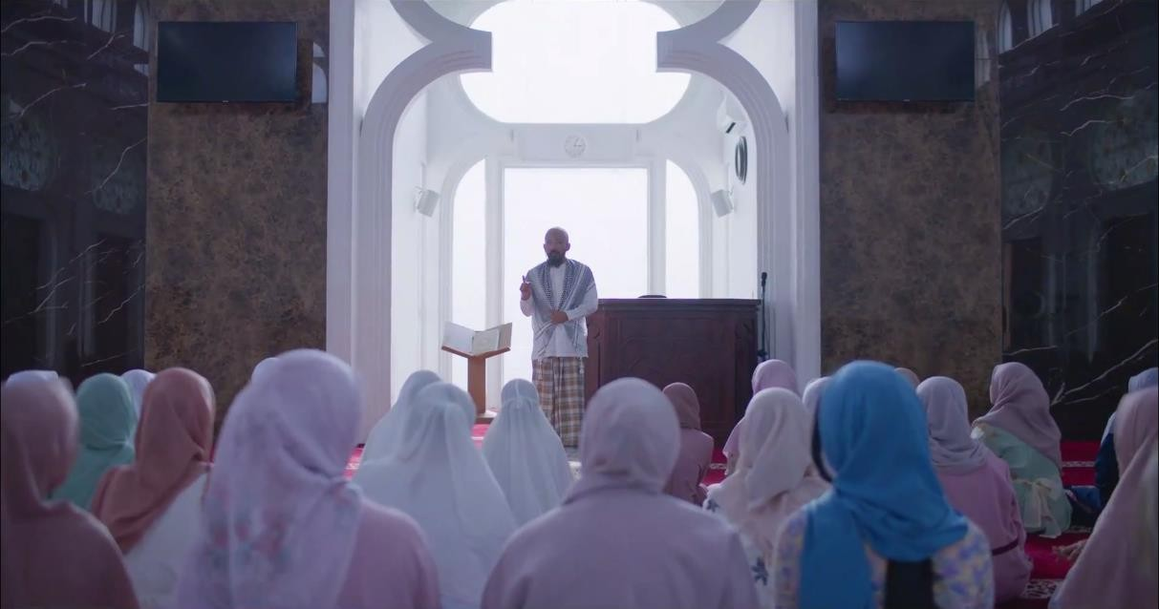
Figure 4. 44 The scene of attending an Islamic recitation in the movie 172 Days

According to figure 4.44, Representation in this figure is Nadzhira who attends Islamic study. The object is that this Islamic study is an activity aimed at deepening a person's knowledge of Islam with the aim of strengthening his faith as a Muslim. This scene interprets a Muslim who wants to deepen his religious knowledge by attending study groups to strengthen his faith and return to the right path.
In addition, in this point, signs are also found in the form of scenes depicting Islamic guidance or teachings that are implemented in daily activities both in socializing or carrying out a procession. The following signs were found:


Figure 4. 45 The scene of refusing to shake hands in the movie Ajari Aku Islam According to figure 4.45, Representation in this figure is the gesture shown
by Fidya and Salma. The object is that this gesture shows Fidya and Salma refusing
to shake hands with Kenny and using a movement of hands joined together in front of the chest. This scene interprets Fidya and Salma as implementing one of the teachings of Islam where men and women who are not believers are prohibited from touching.


Figure 4. 46 The proposal procession scene in the movie 172 Days

Figure 4. 47 Wedding procession scene in the movie 172 Days
According to figure 4.46 and figure 4.47, Representation in those figures is a procession of a man proposing to a woman and a wedding procession in the film 172 Days. The object is the procession that is carried out and depicted in this film using Islamic procedures. This sign interprets this film as an Islamic film because many scenes are depicted based on how a Muslim is in real life.

Discussion
In this research, a semiotic approach is used to analyze Islamic films based on the story points presented in the film. Semiotics, as the study of signs and meanings, allows researchers to understand how symbols, narratives, and visuals in films contribute to the delivery of Islamic values.
In this analysis, an Islamic movie is defined as a movie that not only features Muslim characters or an Islamic cultural background, but also conveys moral messages, Islamic values, and principles that are in accordance with Islamic teachings. Therefore, this research focuses on the narrative structure, visual symbols, and dialog that reinforce Islamic values in films. During the research, it was found that a movie can be said to be an Islamic film if there are main factors and strengthened by supporting factors in the film. The factors in the film can be analyzed in the form of the story told as the outline of the film, posters used as film promotional media, symbols seen in the film, dialogue and narration used by the characters in the film, and scenes depicted in the film.
The main point used in determining a movie as an Islamic movie is the story told. Islamic films generally have main themes related to Islamic teachings, such as faith, piety, honesty, justice, compassion, or the struggle to uphold goodness. This theme becomes the basis for building a narrative that reflects Islamic principles. This theme is also what is then developed to bring up the conflict and resolution that will be depicted in the film. Conflicts in Islamic films are usually centered on moral or social dilemmas that are then resolved with an Islamic approach. The conflict resolution in the movie shows how Islamic values become guidelines in dealing with life's problems.
In addition to the story presented in the film which is the main point, there are also supporting factors that can be a sign that the film can be categorized as an Islamic film. Another factor that can be used as a supporter of a film is an Islamic film, among others, from the movie poster which is used as one of the promotional media for the film itself. The use of visual symbols such as the appearance of characters in Islamic films often reflects modesty and adherence to Islamic

teachings in actions taken or in dress, such as the use of hijab for women and clothes that cover the aurat for men and women. The use of settings that are related to Islamic culture, such as mosques, Islamic boarding schools, or Muslim neighborhoods that help build an Islamic atmosphere in the film. And the use of dialog that contains Islamic values such as quotations from the Qur'an or Islamic terms is one of the supporting elements that strengthen the identity of Islamic films.
The previously mentioned points or supporting factors are not mandatory in every film categorized as an Islamic film. In addition to the main factor of a film being said to be an Islamic film, namely the story factor presented in the film, other supporting factors are only as an identity booster to categorize the film as an Islamic film. Vice versa, even though the supporting factors mentioned in this study can be found in a film, it does not mean that the film is an Islamic film if the story presented in the film does not focus on Islamic values or on Islam itself.
For example, it can be seen in the films ‘Pengabdi Setan (2017) dan Pengabdi Setan 2: Communion (2022)’ which was written and directed by Joko Anwar and entered the list of the best-selling Indonesian films of all time and is the best-selling film directed by Joko Anwar or in most horror films in Indonesia that there are always scenes depicting the procession of prayer or worship. Film settings that are in places of worship or in a pesantren environment and dialogue that includes Islamic terms, but these films cannot be categorized as Islamic films. The film cannot be categorized as an Islamic film because the main focus of the story is not what contains Islamic values or Islamic teachings but rather wants to make the audience feel a scary feeling from the scenes described or the ghost figure presented in the film.
In previous studies, semiotic analysis was used as a way to analyze the signs that can be found in a film to determine what representations are found or want to be conveyed through the film. As with the research conducted by Ramadhani (2014), who similarly used Pierce's semiotic theory to find representations of nationalism in the film ‘5 CM’ and describe its relevance to the realities that occur in society, especially the younger generation, or research conducted by Masdiana, Syahminan

and Rasyid who wanted to find signs of tolerance and Islamic values in the movie Ajari Aku Islam which also used Pierce's semiotic theory. Therefore, the results found in this study support the findings of previous studies that represent aspects in films through signs found using Peirce's semiotic analysis theory. This can be seen through findings in previous studies that the signs found are also the result of analysis through character depictions, dialogue or narrative used, setting, and scenes depicted in a film. But in this study, the signs analyzed are not only meant to represent certain aspects of a film, the results found are signs that can be used as indicators to determine whether a film can be categorized as an Islamic film or not. The findings in this study have important implications for the Islamic film industry, both in terms of production and audience acceptance. By understanding the semiotic elements that determine Islamic films, filmmakers can be more conscious in building narratives that are in accordance with Islamic values without losing their cinematic appeal. In addition, the results of this study can also help audiences in recognizing and evaluating films based on the content of Islamic values conveyed.

