SEMIOTIC ANALYSIS OF REDEFINING ISLAMIC FILM



FINAL PROJECT

A Partial Fulfilment of the Requirements for the Applied Foreign Language Bachelor Degree
by
Dimas Yuda Kusuma 40020520650013

BACHELOR OF APPLIED FOREIGN LANGUAGE VOCATIONAL COLLEGE
UNIVERSITAS DIPONEGORO 2025

STATEMENT OF ORIGINALITY
This is to certify that thesis definitely my original work. I am completely responsible for the content of this thesis. Other writers’ opinions or findings included in this project are quoted or cited in accordance with ethical standard. I understand the full consequences if I took somebody else's ideas, phrases, or sentences without proper references.


Name : Dimas Yuda Kusuma Student ID 40020520650013
Signature: :

Date : June 20, 2025

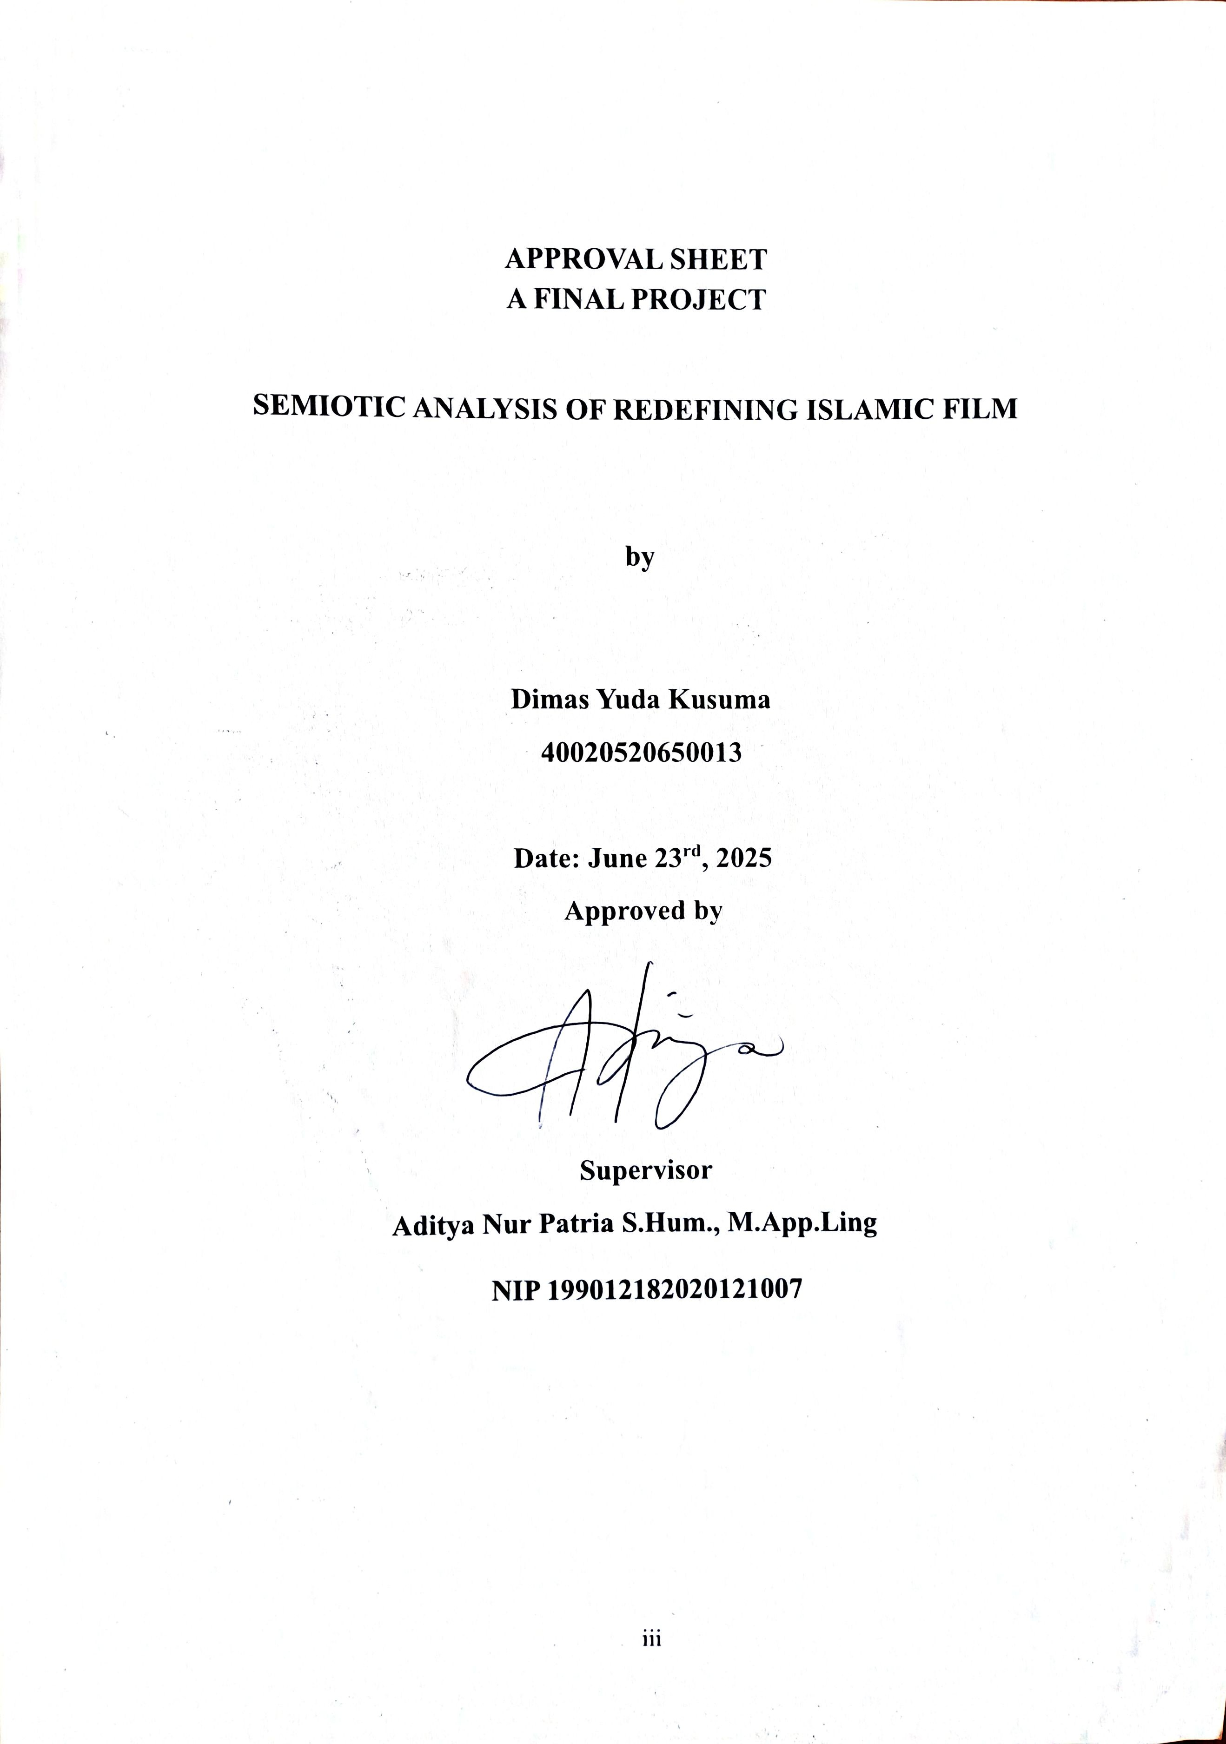

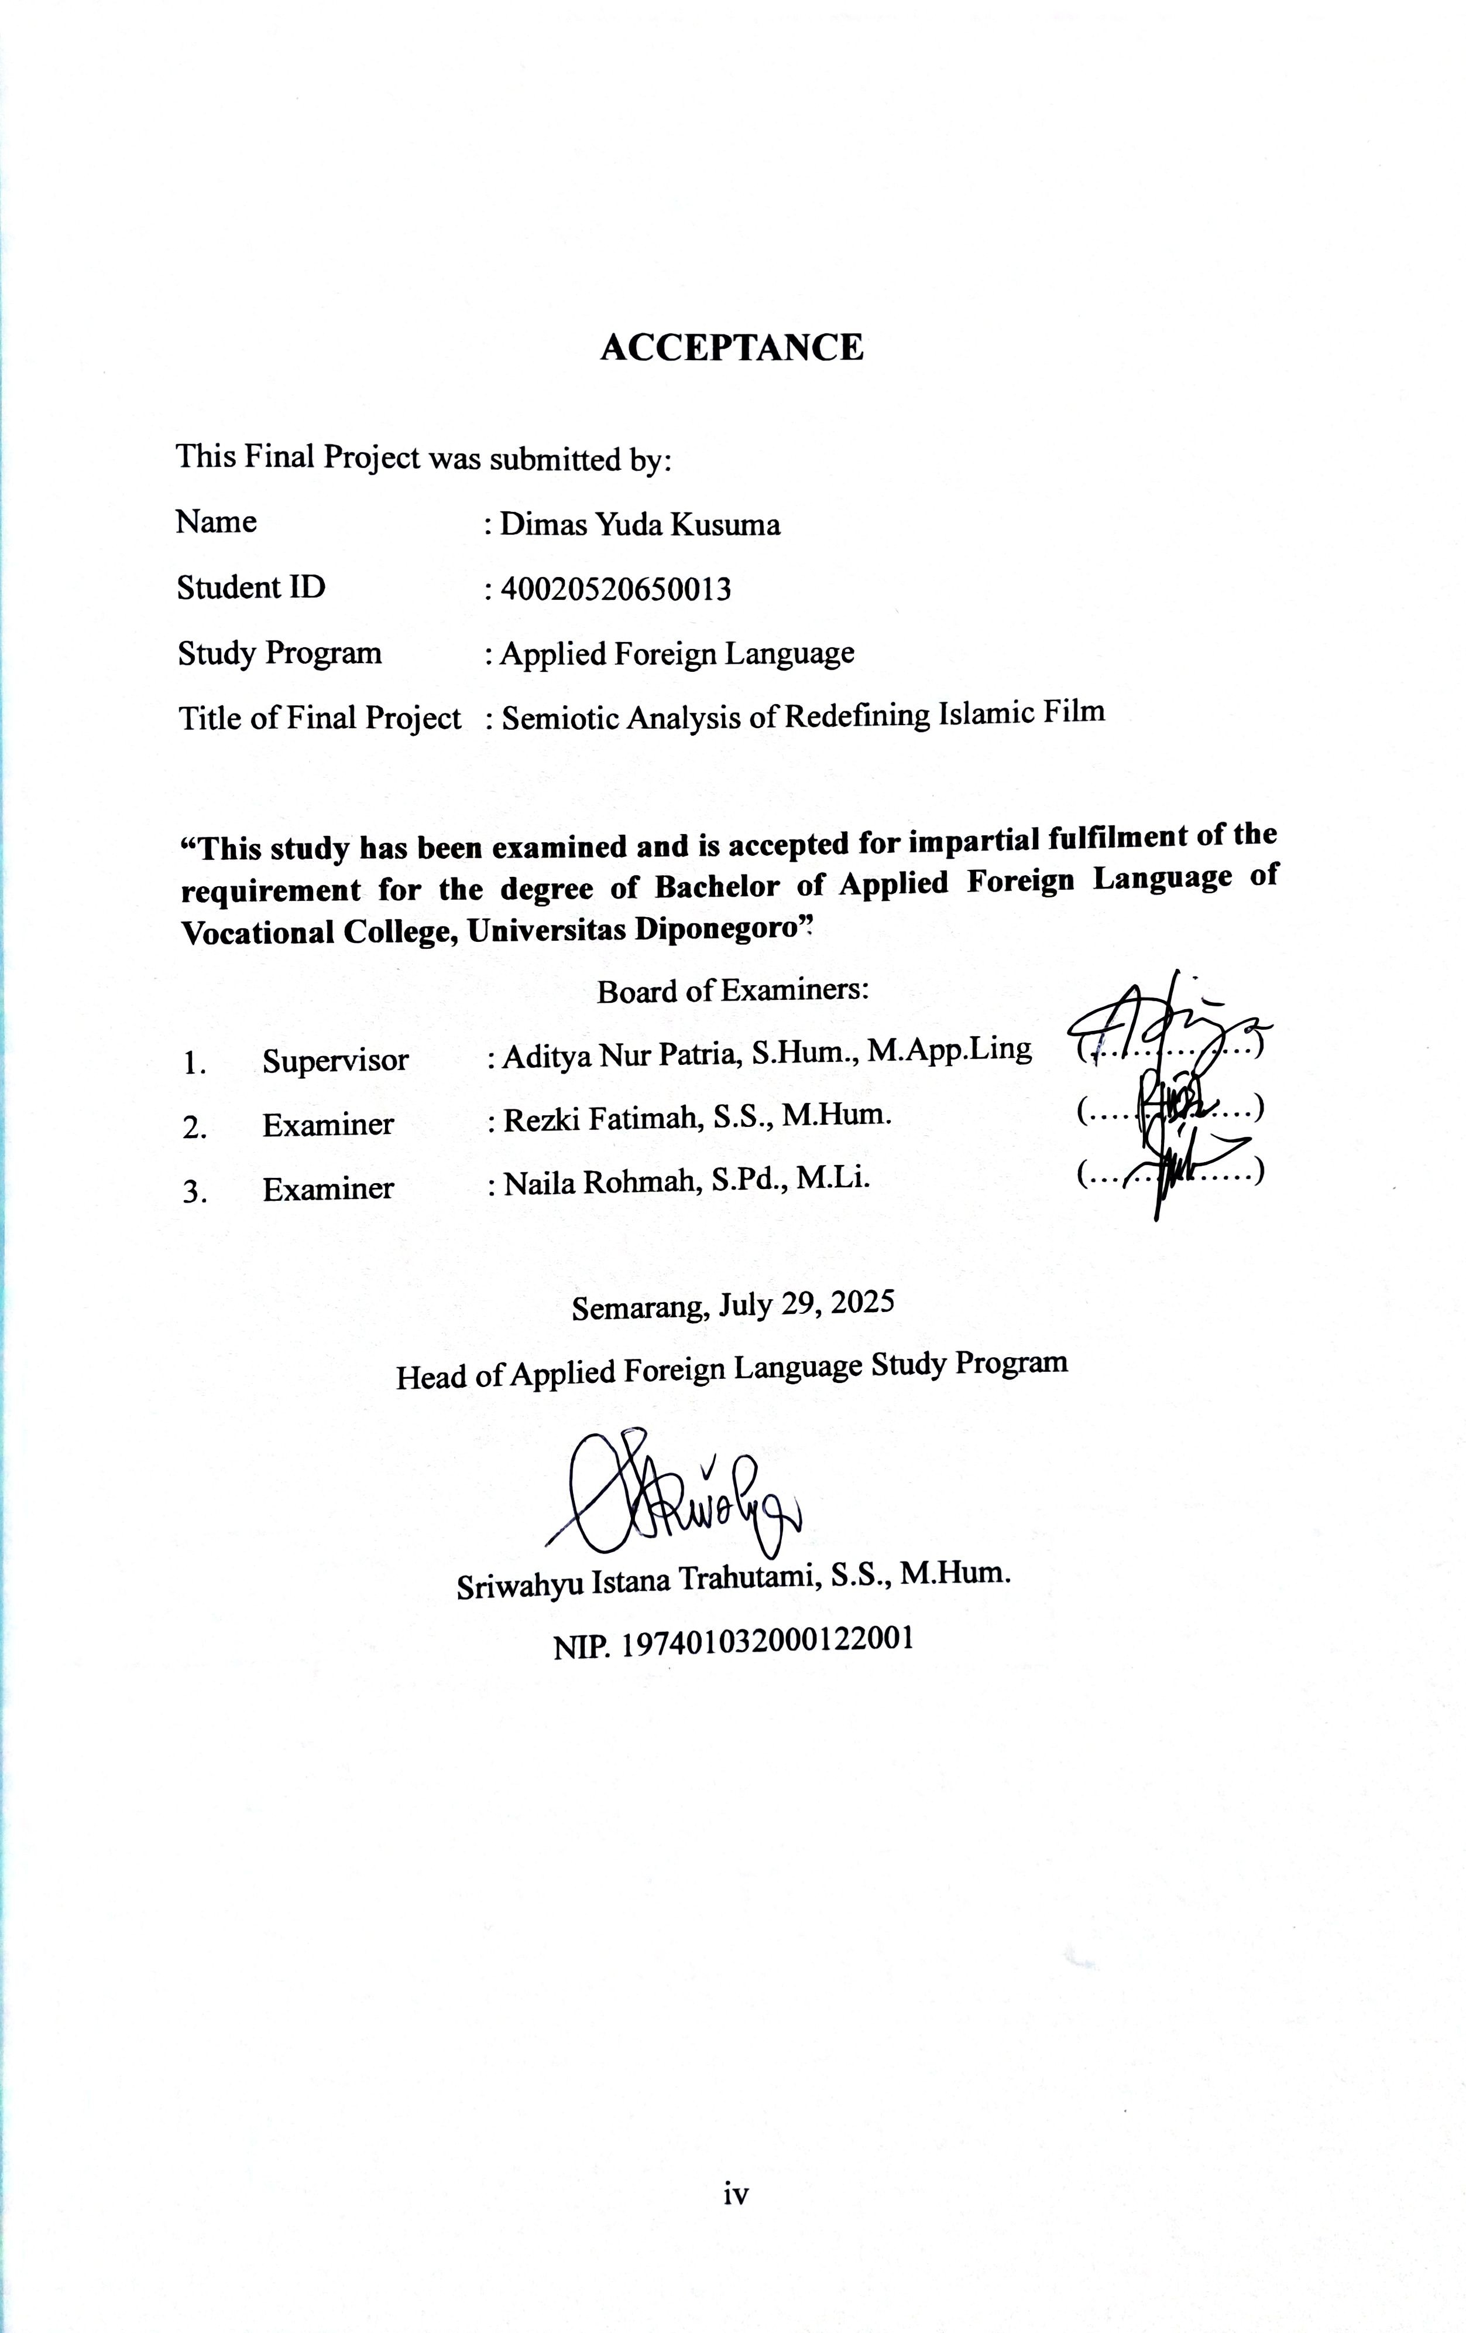

ACKNOWLEDGEMENTS
All praise and gratitude are extended to Allah SWT, for His abundance of grace and blessings, so that the researcher can complete the final project entitled Semiotic Analysis of Redefining Islamic Film.
In making this final project as a requirement for completing an applied bachelor's degree, the researcher received a lot of help both guidance, advice, prayers, encouragement and support from various parties. for that the researcher expresses his appreciation and gratitude to:
- Fitri Alfarisy, S.Pd., M.Hum. and Aditya Nur Patria, S.Hum., M.App.Ling as the supervisor who always gave guidance, advice, support in this final project until it was completed.
- Sriwahyu Istana Trahutami, S.S., M.Hum., as the Head of the Applied Foreign Language Study Program.
- Prof. Dr. Ir. Budiyono, M.Si., as the Dean of the Vocational School of Diponegoro University.
- My beloved family, Father, Mother, and My Sisters, my biggest support system who have always provided love, support, prayers, and encouragement given with sincerity.
- Andina and Deva, my best friends who have provided support and encouragement.
- Special thanks to Inna Familia, Alvin Rusli, Rizqi Nouvada, Satria Suseno, and Issa Atana who have provided help, moral support and laughter until this final project is completed.
- For Elysia Kartika who has also given emotional support and encouraged the researcher to complete this final project.

Semarang, June 20, 2025

Dimas Yuda Kusuma

ABSTRACT
This research is entitled “Semiotics Analysis of Redefining Islamic Film” which aims to find out how a film is represented through various aspects contained therein so it can be categorized as an Islamic film. Apart from being a medium of entertainment, movies are also one of the media for conveying messages that are starting to develop. The development of the film industry in Indonesia presents films in various categories, one of which is Islamic films. The definition and criteria of a film can be said to be an Islamic film is still debatable and still needs analysis to determine its categorization. This research uses Pierce's semiotic theory which explains three important things in semiotics called the triadic model, namely Representation, Object, and Interpretant. Qualitative descriptive method is used in this research. The research presented the data from the analysis conducted through audio and visual in Islamic films. The results show that a film is said to be an Islamic film if there is one main point, namely the story presented along with other supporting points such as film posters, symbols, dialog and scenes depicted in it.

Keywords: Semiotic Analysis, Charles Sanders Pierce Theory, Film, Islamic Film

ABSTRAK
Penelitian ini berjudul “Analisis Semiotika Redefinisi Film Islami” yang bertujuan untuk mengetahui bagaimana sebuah film direpresentasikan melalui berbagai aspek yang terkandung di dalamnya sehingga dapat dikategorikan sebagai film Islami. Selain sebagai media hiburan, film juga menjadi salah satu media penyampai pesan yang mulai berkembang. Perkembangan industri perfilman di Indonesia menghadirkan film dalam berbagai kategori, salah satunya adalah film Islami. Definisi dan kriteria sebuah film dapat dikatakan sebagai film Islami masih menjadi perdebatan dan masih membutuhkan analisis untuk menentukan kategorinya. Penelitian ini menggunakan teori semiotika Pierce yang menjelaskan tiga hal penting dalam semiotika yang disebut dengan model triadik, yaitu Representation, Object, dan Interpretant. Metode deskriptif kualitatif digunakan dalam penelitian ini. Penelitian ini menyajikan data dari hasil analisis yang dilakukan melalui audio dan visual dalam film Islami. Hasil penelitian menunjukkan bahwa sebuah film dikatakan sebagai film Islami apabila terdapat satu poin utama yaitu cerita yang disajikan beserta poin-poin pendukung lainnya seperti poster film, simbol-simbol, dialog dan adegan-adegan yang digambarkan di dalamnya.
Kata Kunci: Analisis Semiotika, Teori Charles Sanders Pierce, Film, Film Islami

TABLE OF CONTENTS

STATEMENT OF ORIGINALITY ii
APPROVAL SHEET iii
ACCEPTANCE iv
ACKNOWLEDGEMENTS v
ABSTRACT vi
ABSTRAK vii
TABLE OF CONTENTS viii
FIGURES x
APPENDICES xiii
CHAPTER I 1
  - Background 1
  - Problem statement of the study 4
  - Objective of the study 5
  - Advantage of the study 5
  - Outputs 5
CHAPTER II 6
  - Previous Research 6
  - Film 7
  - Islamic Movies 8
  - Movie Synopsis 9
    - Synopsis of Film Sang Pencerah 9
    - Synopsis of Film Bulan Terbelah di Langit Amerika 10
    - Synopsis of Film Ajari Aku Islam 11
    - Synopsis of film 172 Days 12
  - Semiotic 13
  - Charles Sanders Pierce's Semiotic Theory 14
CHAPTER III 17
  - Research Method 17
  - Research Object 17
  - Data Collection Technique 19
    - Observation 19
    - Documentation 20
  - Data Analysis 20
CHAPTER IV 22
  - Result 22
    - Story 22
    - Poster 25
    - Symbol 30
    - Dialogue and Narration 44
    - Depicted scene 53
  - Discussion 61
CHAPTER V 64
  - Conclusion 64
  - Suggestion 65
REFERENCES 66
APPENDICES 71

FIGURES
Figure 1. 1 Hijrah Cinta movie poster 4
Figure 1. 2 Ayat-Ayat Cinta movie poster 4
Figure 2. 1 Sang Pencerah movie poster 9
Figure 2. 2 Bulan Terbelah di Langit Amerika movie poster 10
Figure 2. 3 Ajari Aku Islam movie poster 11
Figure 2. 4 172 Days movie poster 12
Figure 3. 1 Triangle meaning of semiotic theory by Charles Sanders Pierce 16
Figure 3. 2 Sang Pencerah movie poster 19
Figure 3. 3 Bulan Terbelah di Langit Amerika movie poster 19
Figure 3. 4 Ajari Aku Islam movie poster 19
Figure 3. 5 172 Days movie poster 19
Figure 4. 1 Sang Pencerah movie poster 25
Figure 4. 2 Bulan Terbelah di Langit Amerika movie poster 27
Figure 4. 3 Ajari Aku Islam movie poster 28
Figure 4. 4 172 Days movie poster 29
Figure 4. 5 Male actor's outfit in the movie Sang Pencerah 30
Figure 4. 6 Male actor's outfit in the movie Bulan Terbelah di Langit Amerika 31
Figure 4. 7 Male actor's outfit in the movie Ajari Aku Islam 32
Figure 4. 8 Male actor's outfit in the movie 172 Days 32
Figure 4. 9 The female character's outfit in the movie Sang Pencerah 33
Figure 4. 10 Female character's outfit in movie Bulan Terbelah di Langit Amerika
. 34
Figure 4. 11 The female character's outfit in the movie Ajari Aku Islam 35
Figure 4. 12 The female character's outfit in the movie 172 Days 35
Figure 4. 13 Hadroh accompaniment in the movie Sang Pencerah 37
Figure 4. 14 Depiction of the Kaaba in the movie Sang Pencerah 38
Figure 4. 15 Depiction of Quran in the movie Bulan Terbelah di Langit Amerika39 Figure 4. 16 Depiction of goods that are identical to Islam in movie Ajari Aku Islam
. 39
Figure 4. 17 The depiction of gravestones in the movie 172 Days 40

Figure 4. 18 The setting that depicts the mosque in the movie Sang Pencerah 41
Figure 4. 19 The setting that depicts the langgar in the movie Sang Pencerah 41
Figure 4. 20 The setting that depicts the mosque in the movie Ajari Aku Islam 42
Figure 4. 21 Settings depict mosques and Islamic boarding schools in ] 172 Days
. 43
Figure 4. 22 Darwis' dialog with his parents and teachers in Sang Pencerah movie
. 44
Figure 4. 23 Scenes of Darwis performing the hajj pilgrimage 45
Figure 4. 24 Dialogues that use Islamic expressions 46
Figure 4. 25 Pronunciation of dhikr in movie Bulan Terbelah di Langit Amerika 47 Figure 4. 26 Muslim greetings in the movie Bulan Terbelah di Langit Amerika . 47 Figure 4. 27 Dialog in the sound recording in Bulan Terbelah di Langit Amerika48 Figure 4. 28 Conference scene in the movie Bulan Terbelah di Langit Amerika . 49 Figure 4. 29 Narratives about Islam 49
Figure 4. 30 Dialog on the use of Islamic expressions in movie Ajari Aku Islam 50 Figure 4. 31 Dialogue between Kenny and Fidya in the movie Ajari Aku Islam . 51 Figure 4. 32 Pronunciation two sentences of shahada in the movie Ajari Aku Islam
. 52
Figure 4. 33 Dialogues that use Islamic expressions in the movie 172 Days 52
Figure 4. 34 Prayer scene in the movie Sang Pencerah 53
Figure 4. 35 Hajj scene in the movie Sang Pencerah 54
Figure 4. 36 The scene of reading the Quran in the movie Sang Pencerah 54
Figure 4. 37 Prayer scene in the movie Bulan Terbelah di Langit Amerika 55
Figure 4. 38 praying scenes in the movie Ajari Aku Islam 55
Figure 4. 39 Prayer scene in the movie 172 Days 56
Figure 4. 40 Depiction of adhan in the movie Sang Pencerah 57
Figure 4. 41 Preaching scene in the movie Sang Pencerah 57
Figure 4. 42 Scene of reading a book about Islam in the movie Ajari Aku Islam 58 Figure 4. 43 The scene of trying to read Quran in the movie Ajari Aku Islam 51
Figure 4. 44 The scene of attending an Islamic recitation in the movie 172 Days 58 Figure 4. 45 The scene of refusing to shake hands in the movie Ajari Aku Islam 59

Figure 4. 46 The proposal procession scene in the movie 172 Days 60
Figure 4. 47 Wedding procession scene in the movie 172 Days 60

APPENDICES
Appendix 1 Turnit in result 71
Appendix 2 Article Journal Submission 72
Appendix 3 Letter of Acceptance Publication 73

